**Capstone project review**

# Exemplar: Capstone project - Part 1

## Overview

In the first three Capstone project exercises, you were asked to help Tailwind Traders prepare and configure its data for analysis and then utilize the refined data to design and develop a data model.

Your tasks in these three exercises were to:

* Prepare Sales Excel data.
* Configure data sources.
* And design and develop the data model.

This reading provides you with a step-by-step guide for completing these tasks. It also includes screenshots that you can compare against your work.

You can also review the learning materials provided in this course for more guidance.

## Exercise 1: Prepare the Sales Excel data

### Step 1: Download the file

* Launch Power BI desktop and open the **Sales** worksheet from the Excel workbook **Tailwind Traders Sales.xlsx**.

Locate the file named **Tailwind Traders Sales.xlsx** and download it to your working directory. Once opened, verify that you're on the **Sales** worksheet, which will be the source of the data you'll be working with.

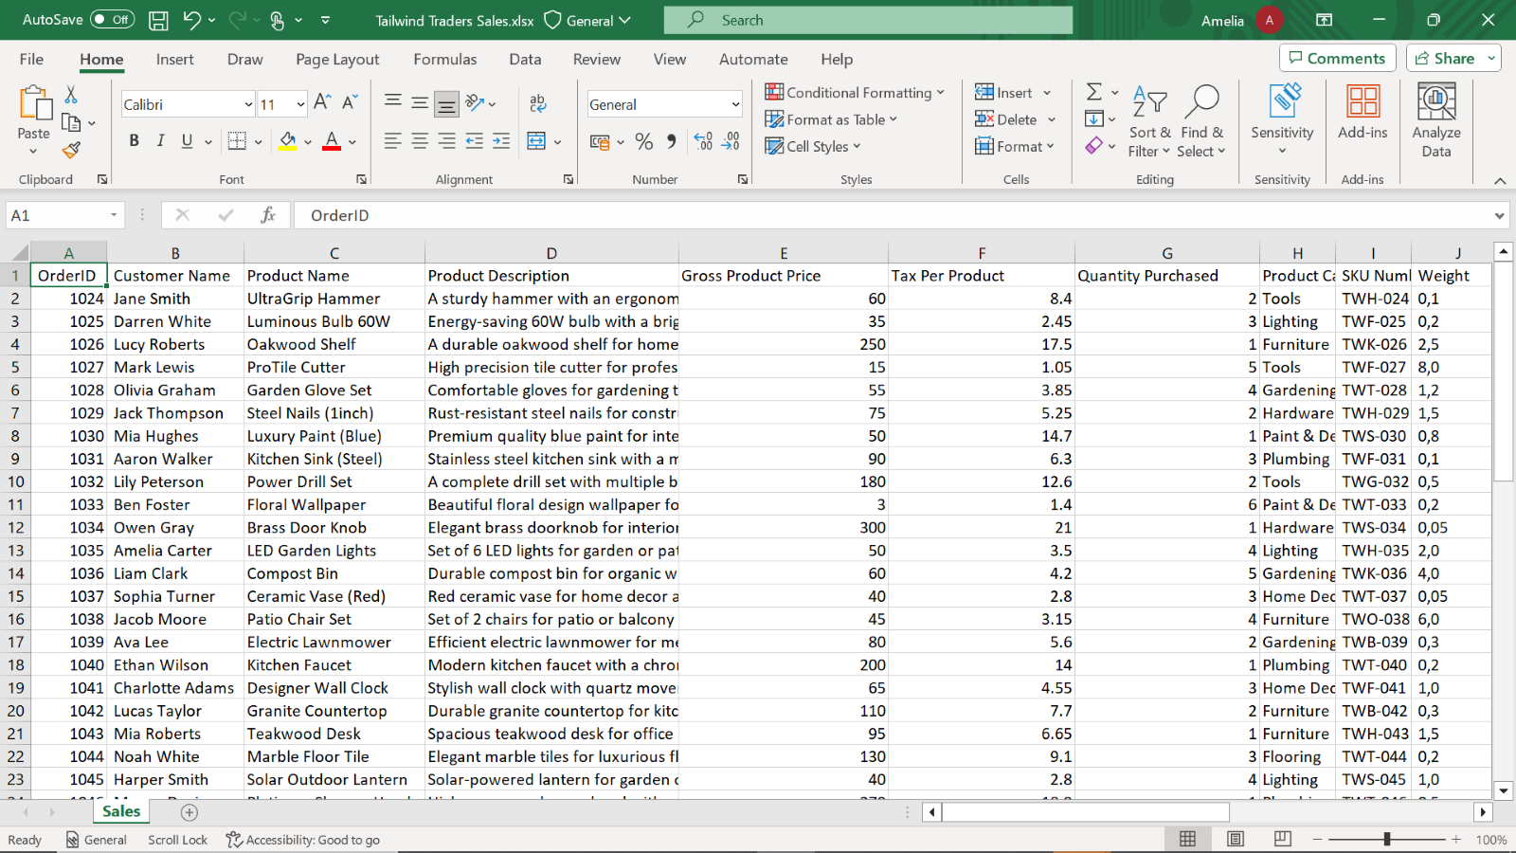

### Step 2: Calculate Gross Revenue

1. Insert a column after **Quantity Purchased** and label it **Gross Revenue**.

Identify the **Quantity Purchased** column.Right-click on the column header immediately to the right of the **Quantity Purchased** column to insert a new column. Label this new column as **Gross Revenue**. This will serve as the placeholder for your calculations.

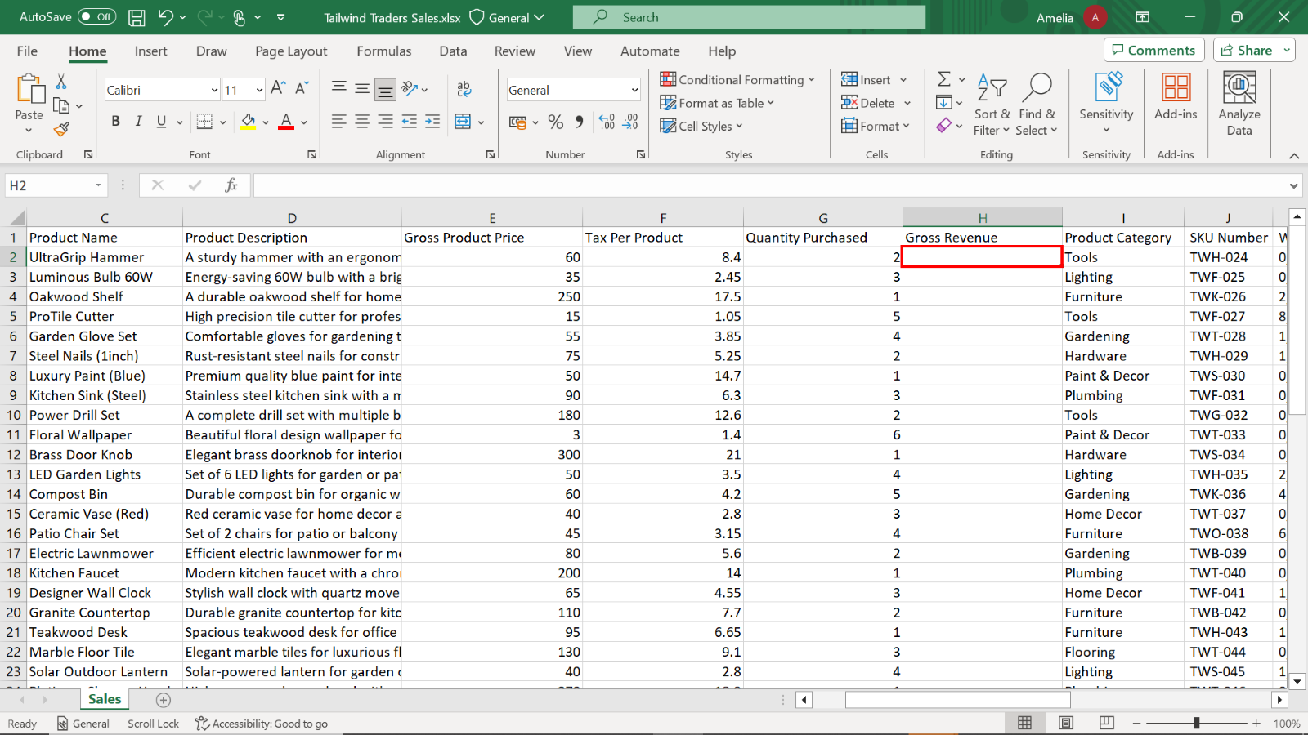

1. Use the formula **=E2*G2** to calculate the revenue from each product.

Select the first cell under the **Gross Revenue** column. Enter the formula **=E2*G2** and press **Enter** to apply the formula to this first cell.

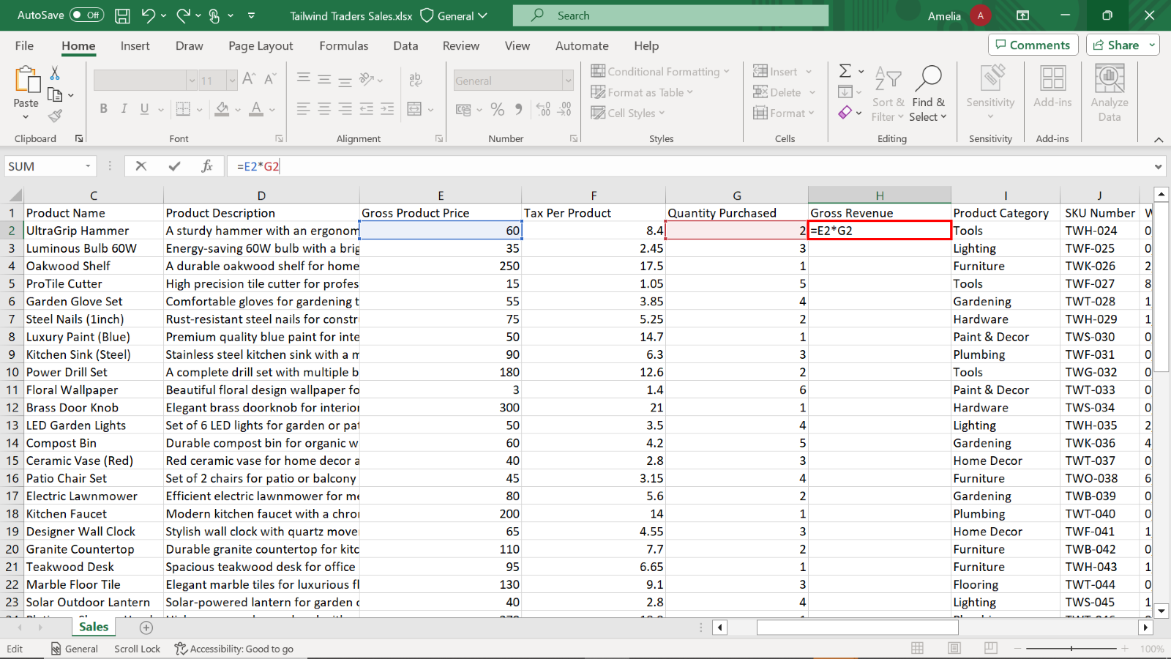

Then, using either the fill handle or the double-click shortcut, extend the formula to the entire column to calculate the revenue for each product.

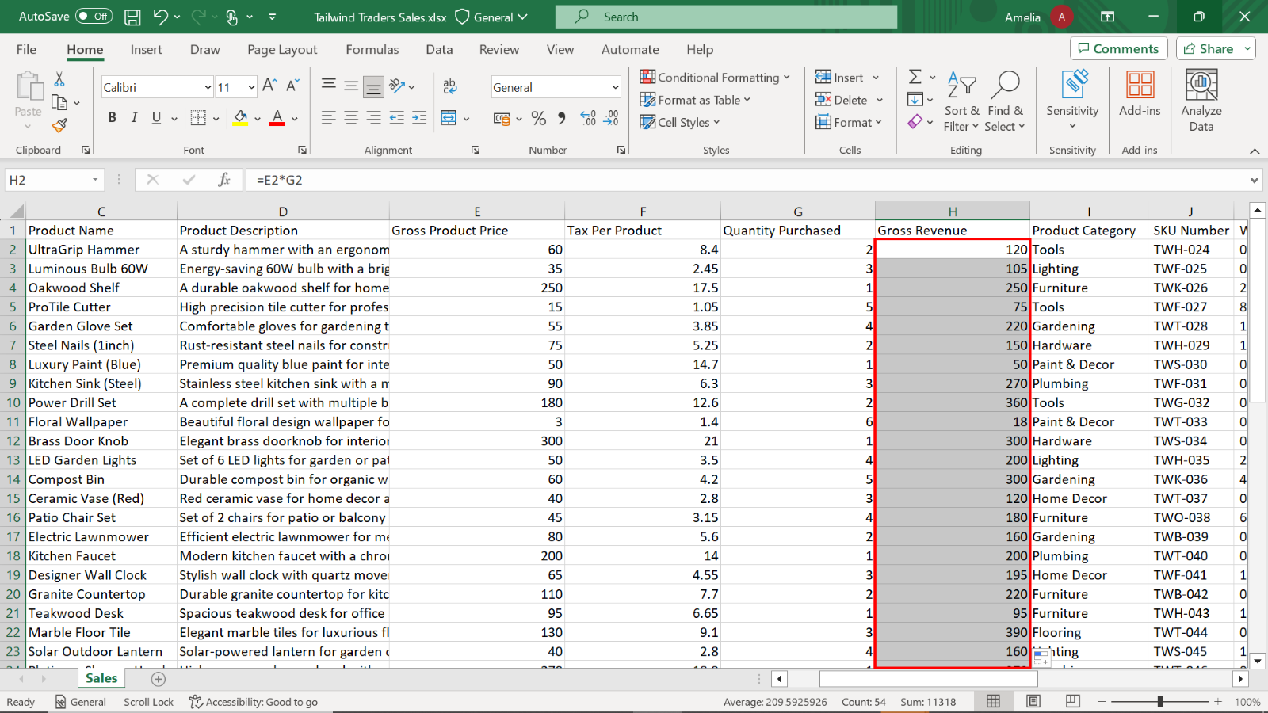

### Step 3: Calculate Total Tax:

1. Create a **Total Tax** column next to **Gross Revenue**.

Insert a new column to the right of **Gross Revenue** and label it **Total Tax**.

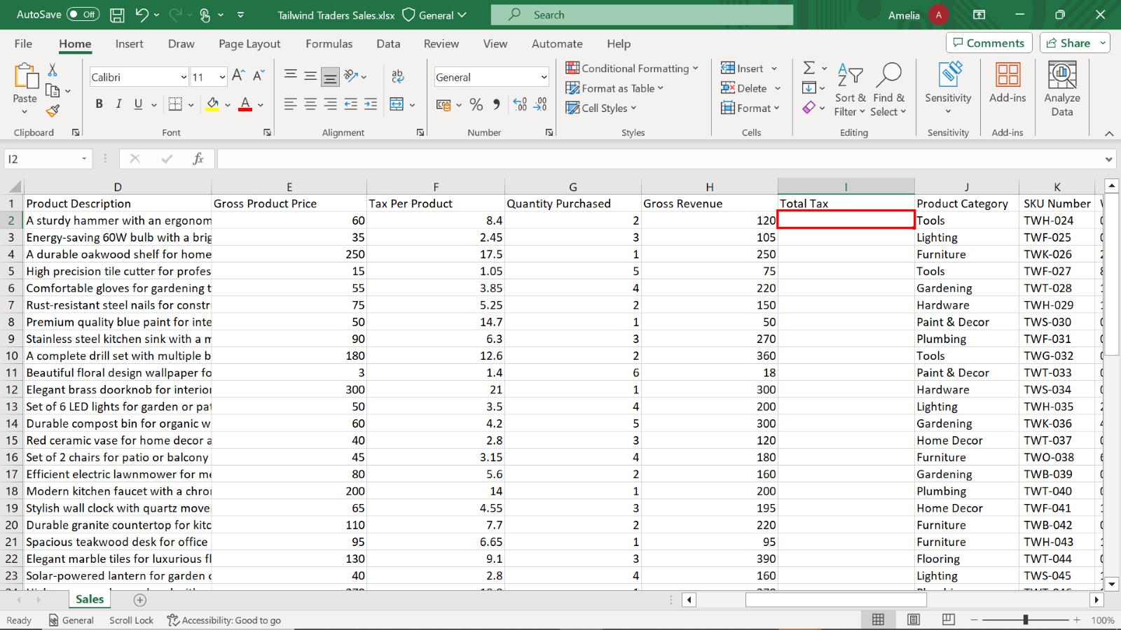

1. Input the formula **=F2*G2** to calculate the tax for each product.

Select the first cell under **Total Tax**. Input the formula **=F2*G2** and press **Enter** to confirm the formula.

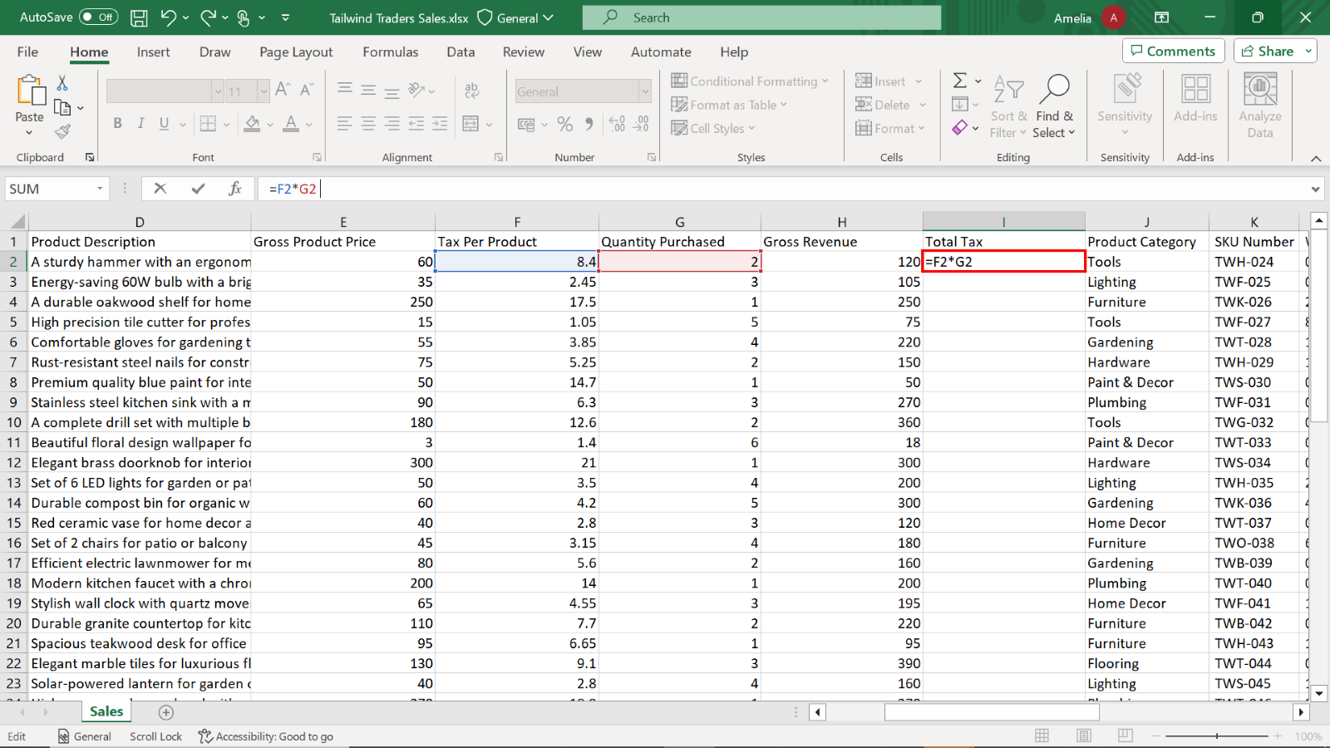

Drag down or double-click the fill handle to copy the formula down the column, calculating the tax for each item.

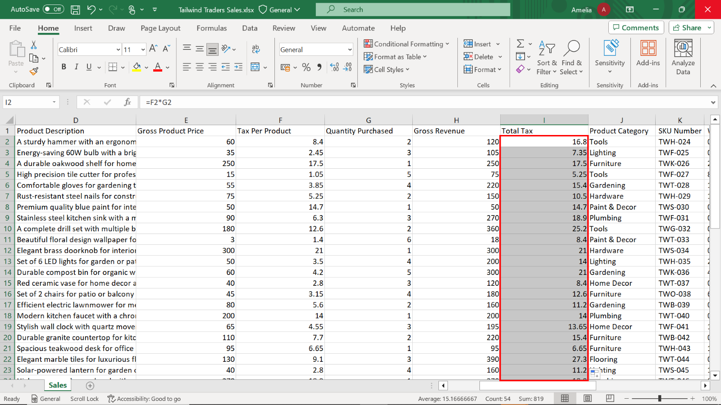

### Step 4: Calculate Net Revenue

1. Insert a **Net Revenue** column next to **Total Tax**.

Insert a new column to the right of **Total Tax** and label it **Net Revenue**. Net Revenue is a critical metric for Tailwind Traders as it reflects the real financial contribution of each product to the company's bottom line.

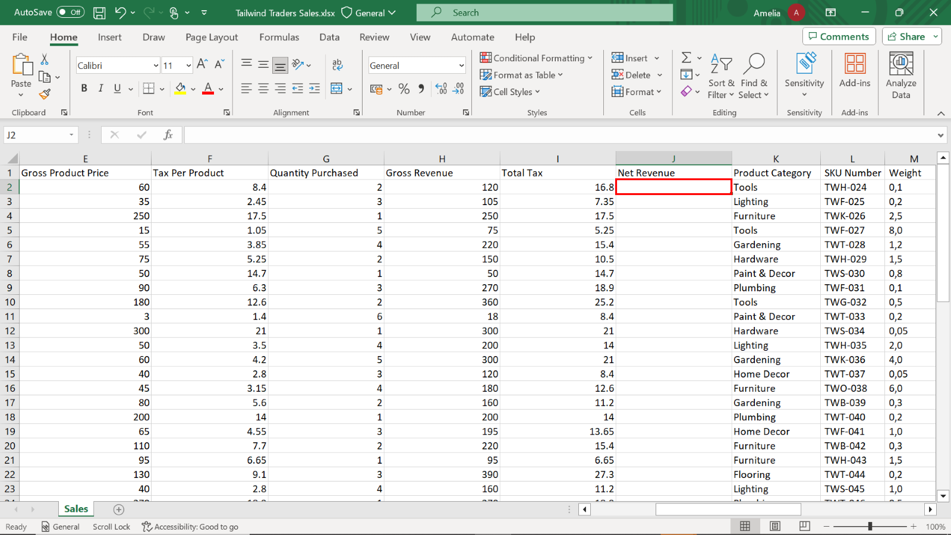

1. Use the formula **=H2-I2** to determine the actual earnings post-tax for each product.

In the first cell under **Net Revenue**, input the formula **=H2-I2** and press **Enter** to compute the net revenue for the first product.

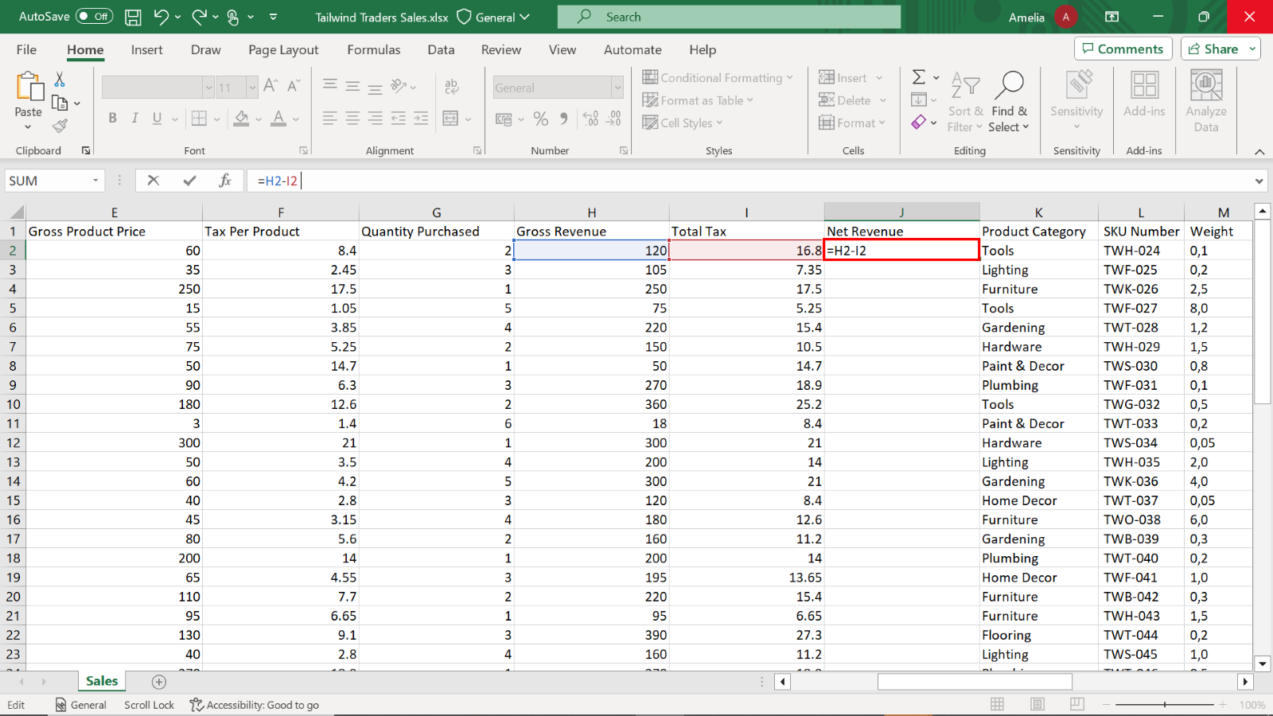

1. Then, double-click shortcut on cell **J2** or drag this formula down to cater to all products on your list. Repeat this action for the formulas in **H2** and **I2**.

Drag down or double-click the fill handle to copy the formula down the column, calculating the net revenue for each product.

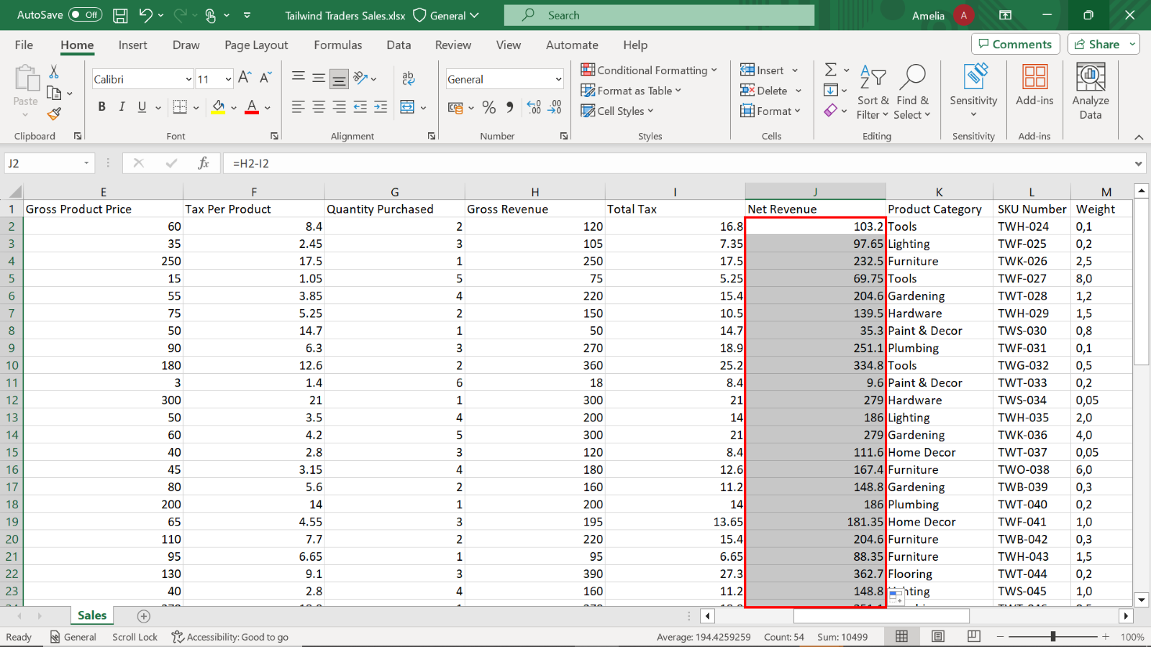

1. Observe the first ten records and note the highest and lowest values for **Net Revenue**, **Quantity Purchased**, and **Total Tax**. In conjunction, observe neighboring columns like **Sales Rep** for trends.

The product **Power Drill Set** priced at **334.8USD**, is the highest among the first ten listed orders. **Floral Wallpaper**, priced at **3 USD** and with a quantity of **6**, generated the lowest net revenue of **9.6 USD**.

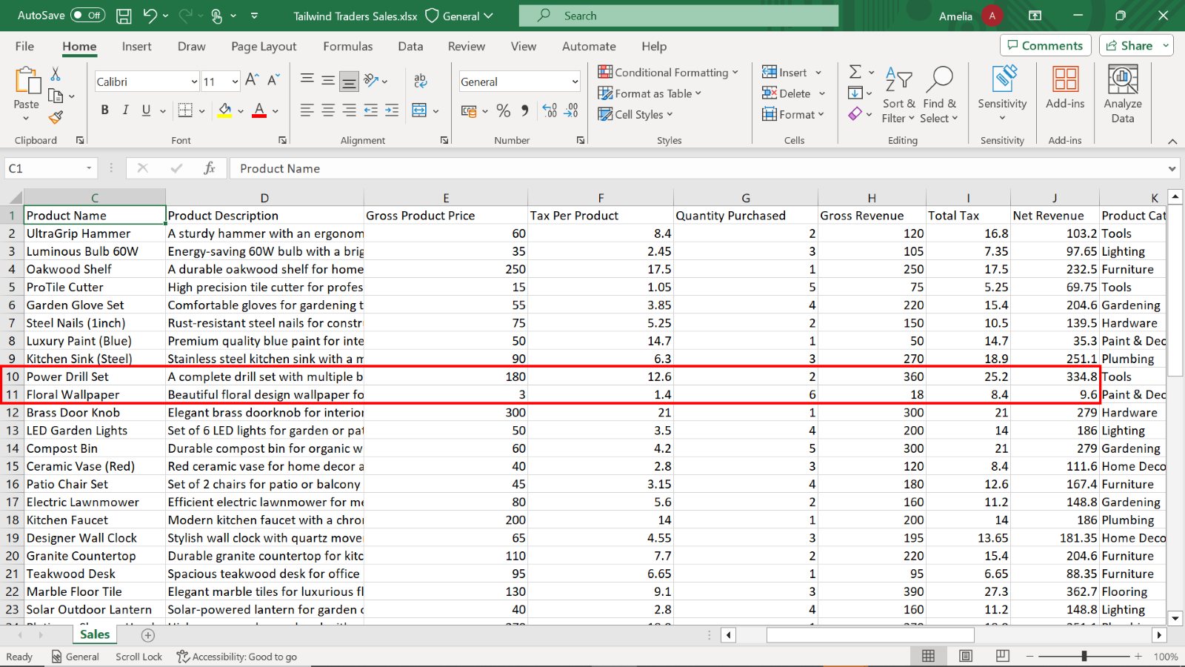

Alice, the sales rep, managed sales transactions for the **UltraGrip Hammer**, **Oakwood Shelf**, **Garden Glove Set**, and **Kitchen Sink (Steel)**, making **4** transactions, the most among the listed orders.

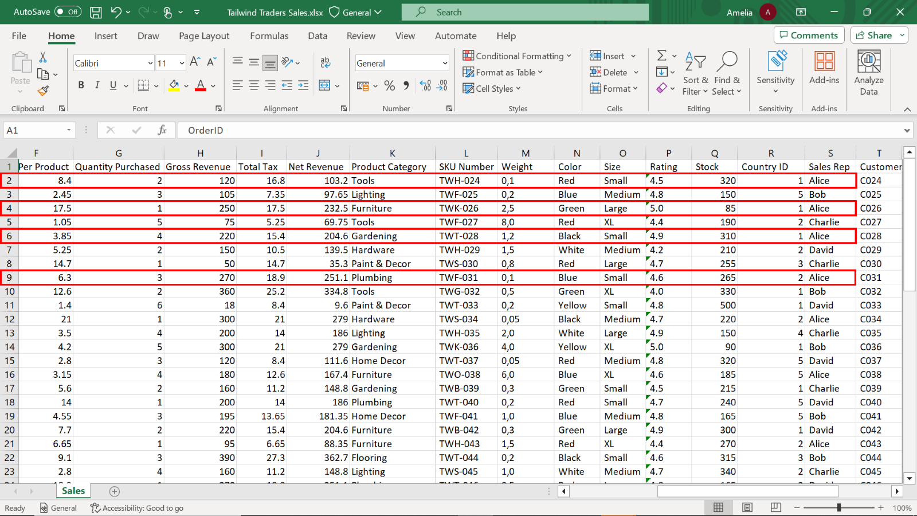

## Exercise 2: Configure data sources

### Step 1: Load the Sales data

1. Load the **Tailwind Traders Sales** file into Power BI and select **Transform**.

Begin by loading the **Tailwind Traders Sales** data file into Power BI.

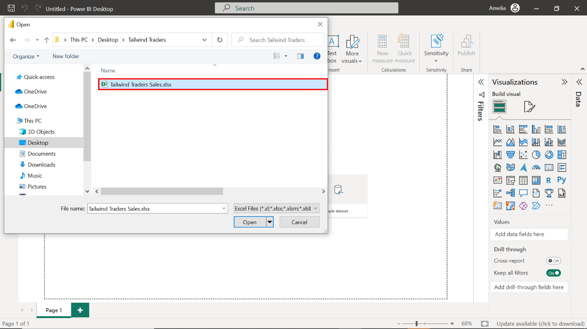

Once loaded, select the **Transform Data** option to enter the Power Query Editor.

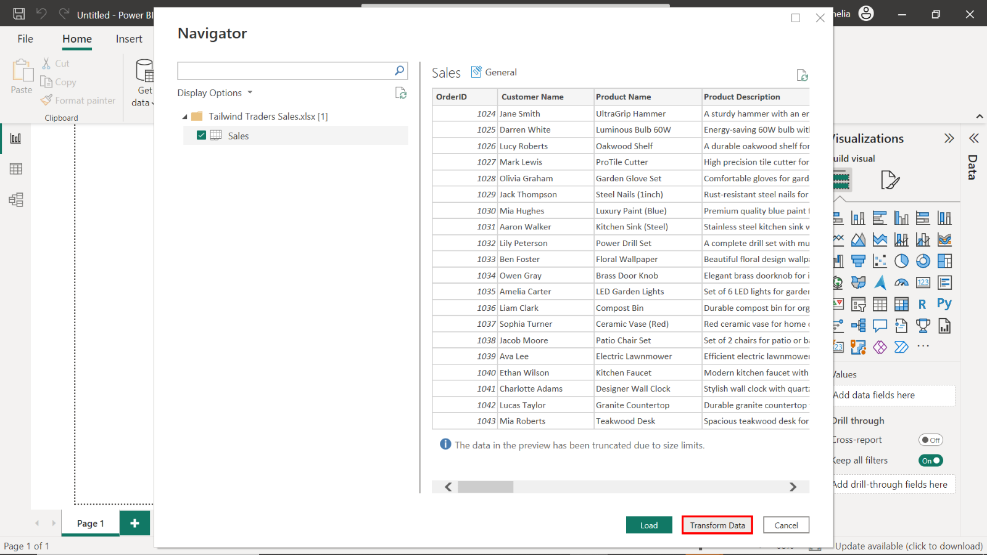

1. Within Power Query, find the **OrderID**column and set the data type to **Whole Number**.

In Power Query, locate the **OrderID** column and set its data type to **Whole Number**. This ensures that transactions are treated as unique numeric values, not as text or any other format, which could lead to incorrect sorting or calculations.

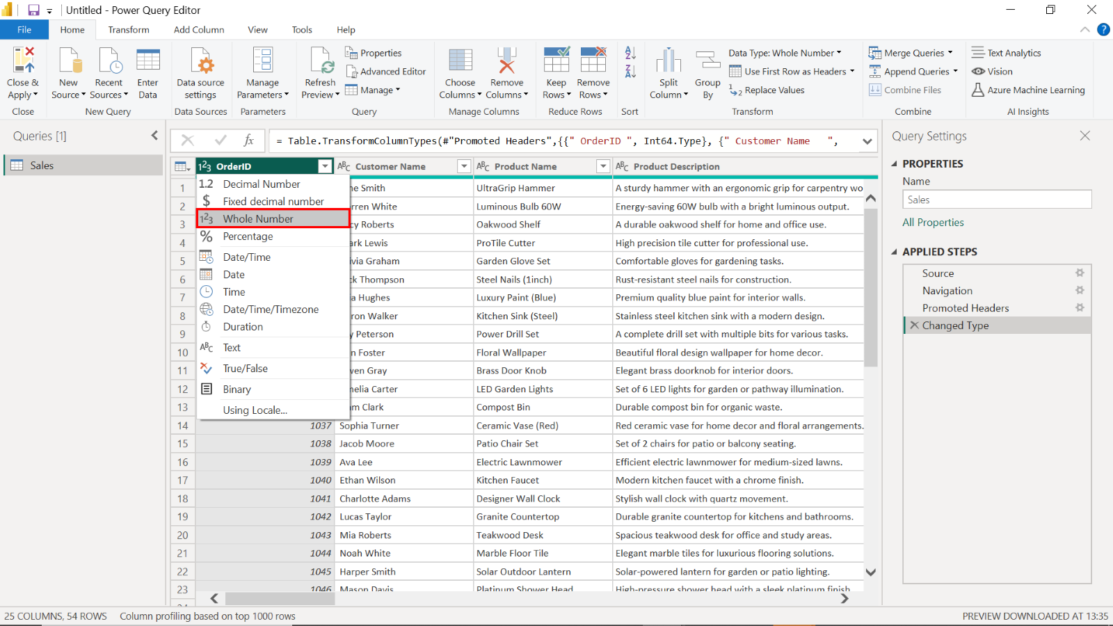

1. To complete optimization, assign the following data types for the columns:

* **Gross Product Price = Fixed Decimal Number**
* **Tax Per Product = Fixed Decimal Number**
* **Quantity Purchased = Whole Number**
* **Loyalty Points = Whole Number**
* **Stock = Whole Number**
* **Product Category = Text**
* **Rating = Fixed Decimal Number**

Select the title of each column to view the list of available data types. Select the required data type to assign it to its respective column.

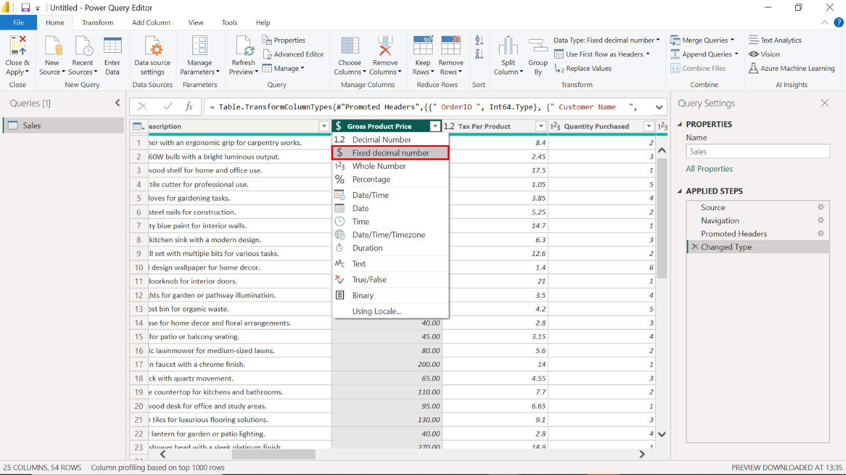

1. In the **View** tab, upon selecting the **Column Quality**, **Column Distribution**, and **Column Profile** boxes, ensure the **Valid** percentage is **100%** for the **OrderID** column.

Navigate to the **View** tab. Select the **Column Quality**, **Column Distribution**, and **Column Profile** checkboxes. Examining column quality, distribution, and profiles helps assess the data's health. It also allows for the early detection of issues, saving time and preventing errors in later stages of the analysis.

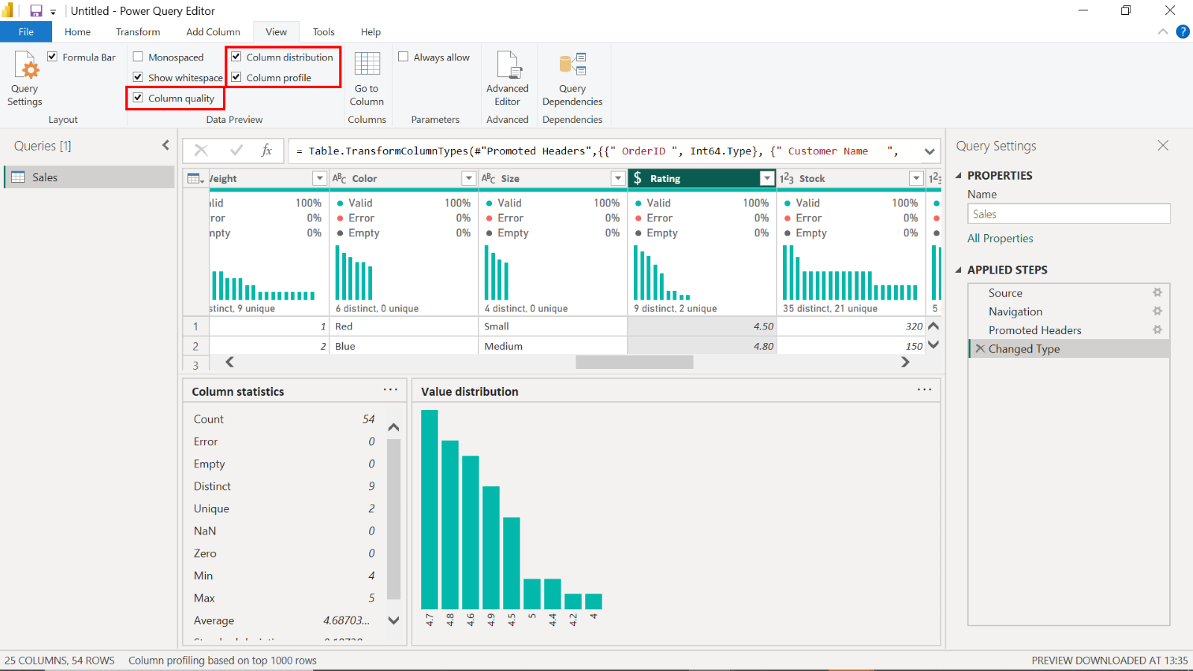

Validate that the **OrderID** column achieves a 100% **Valid** rate, reflecting its data integrity. This confirms that there are no nulls, duplicates, or erroneous entries in this crucial column, which is vital for tracking individual sales accurately.

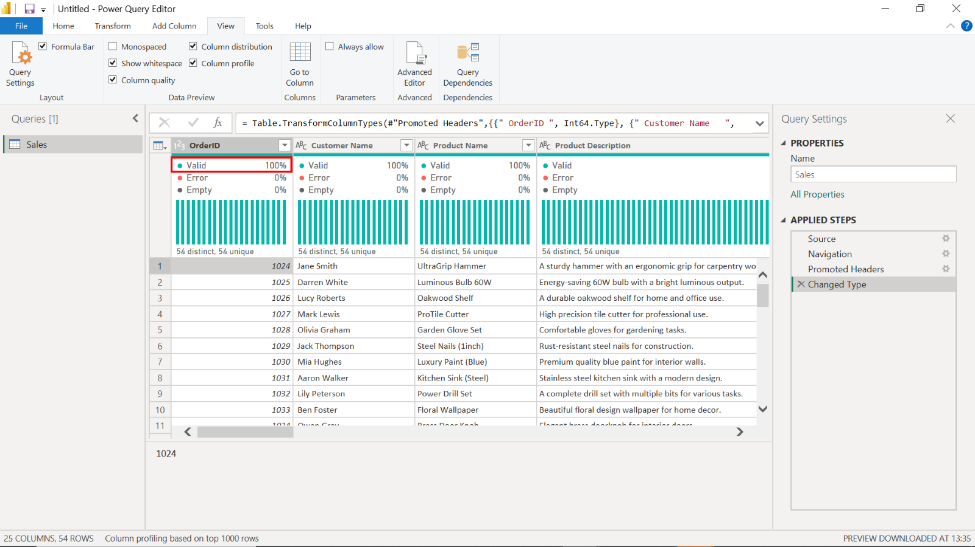

1. Select the **Gross Product Price** column and note down the histogram frequency of distinct and unique values.

Tailwind Traders offers products at 50 distinct price points for the **Gross Product Price** column.

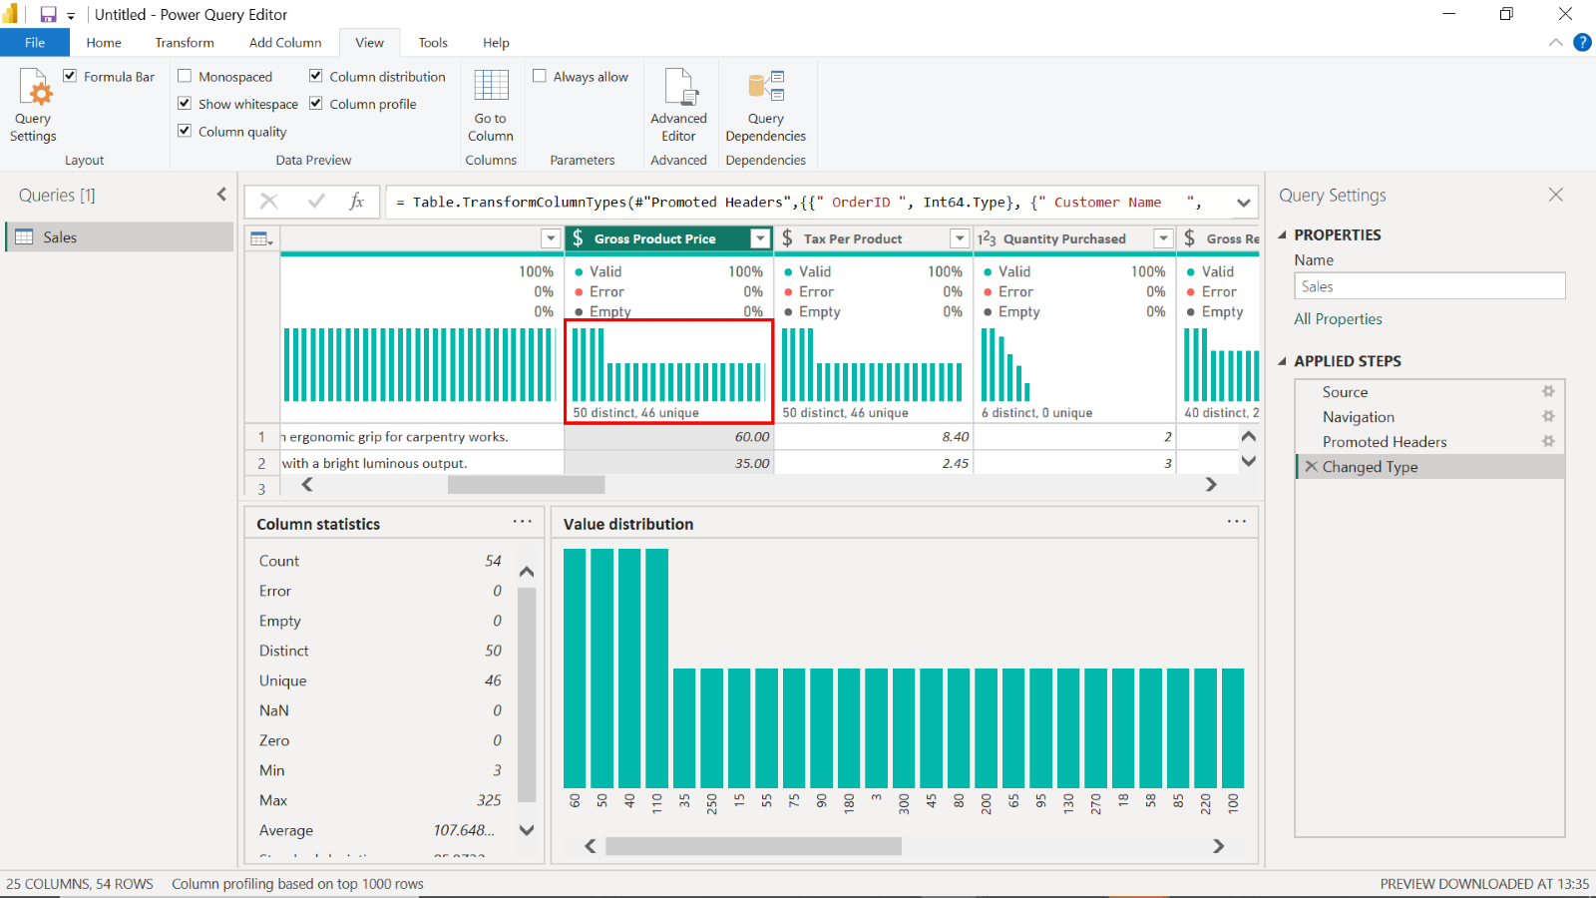

1. Select the **Quantity Purchased** column and note down the **MIN**, **MAX** and **AVERAGE** values displayed on the additional statistical pane.

In the Quantity Purchased column, the minimum value is **1**, the maximum value is **6**, and the average value is **2.8148**. These statistics are fundamental to understanding sales volumes.

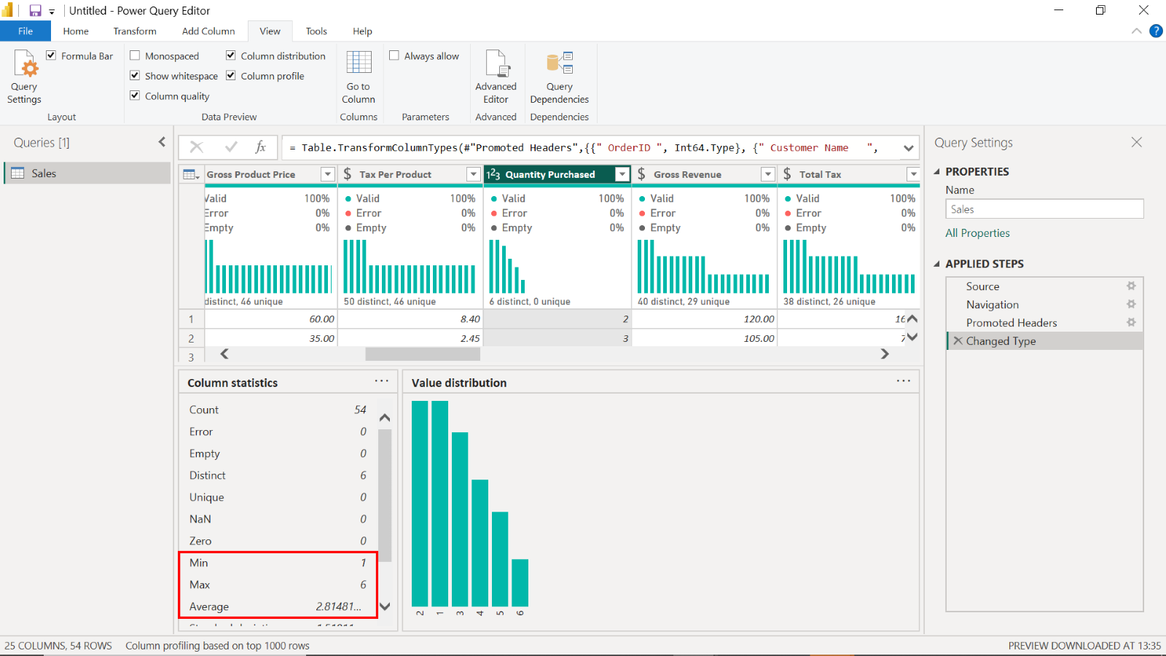

### Step 2: Load the Purchases data

1. Load the **Purchases** file into Power BI and select **Transform**.

Select the **Purchases** data file and then select **Load** to load it into Power BI. Select **Transform Data** to access Power Query.

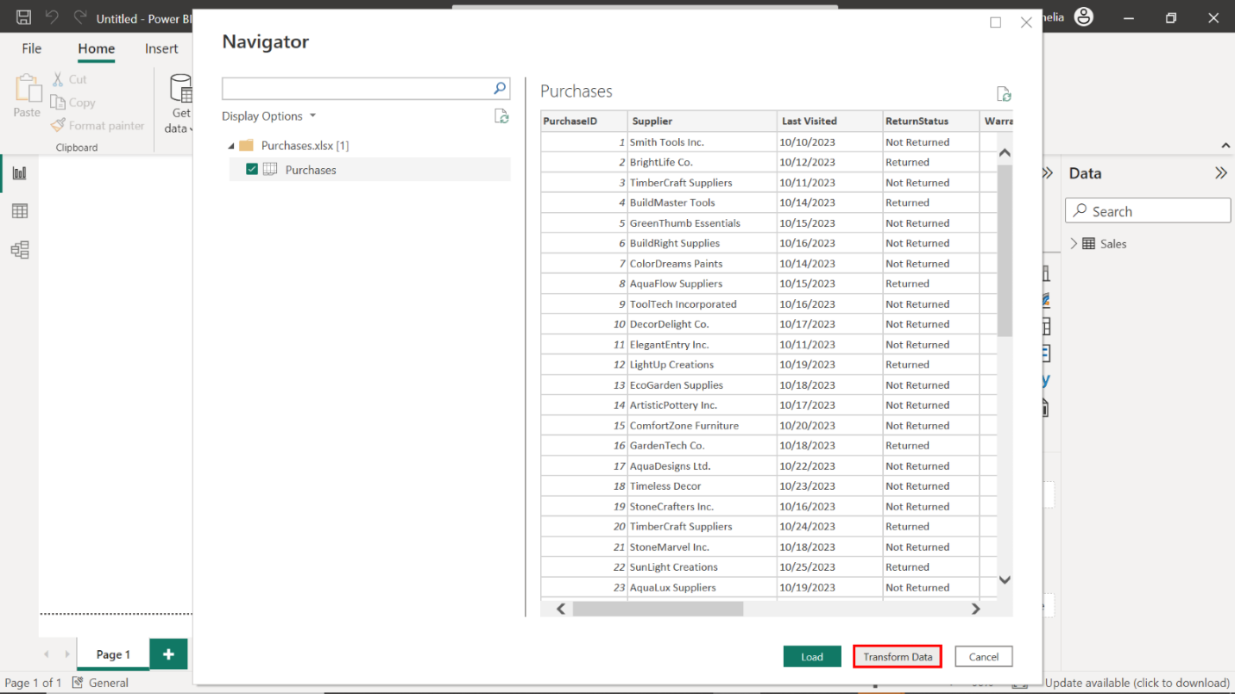

1. To complete optimization, assign the following data types for the columns:

* **PurchaseID = Whole Number**
* **OrderID = Whole Number**
* **Return Policy (Days) = Whole Number**
* **Purchase Date = Date**
* **Warranty (Months) = Whole Number**
* **Supplier = Text**
* **Last Visited = Date**
* **ReturnStatus = Text**

Carefully assign the appropriate data types for each column by selecting the column header and the correct data type from the list.

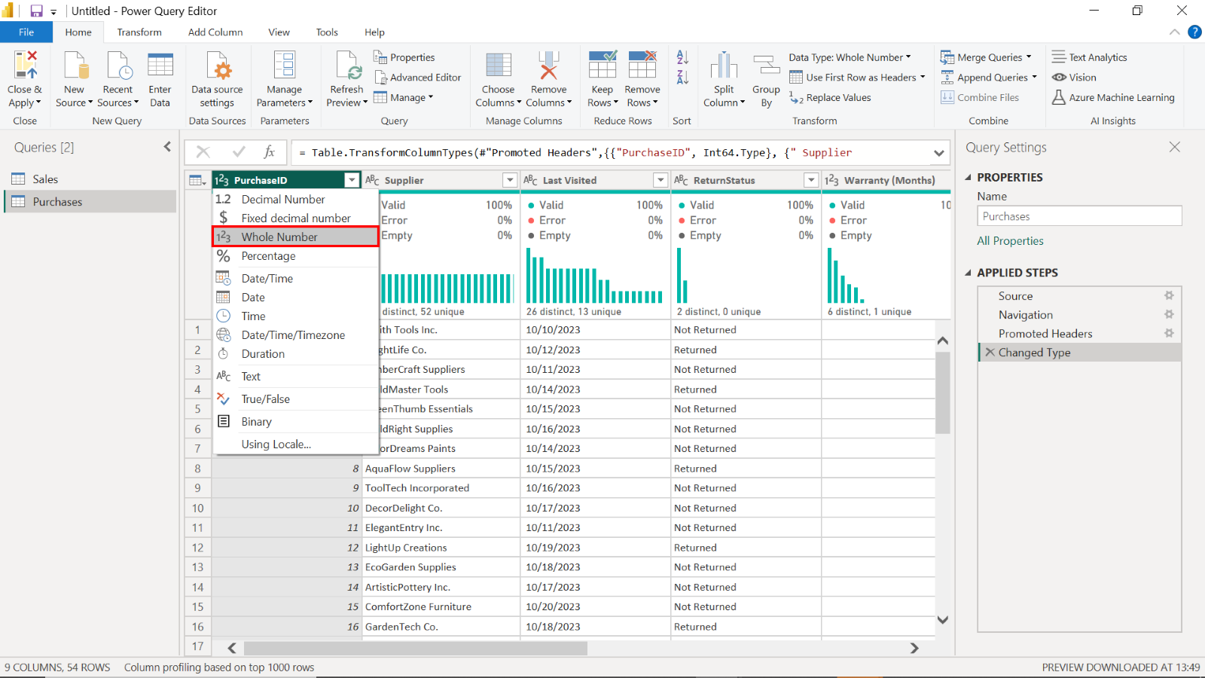

1. Select the **Warranty (Months)** column and note down the **MIN**, **MAX** and **AVERAGE** values displayed on the additional statistical pane.

Tailwind Traders offers a minimum warranty duration of **6 months**, a maximum of **48 months,** and an average of **18.88 months**.

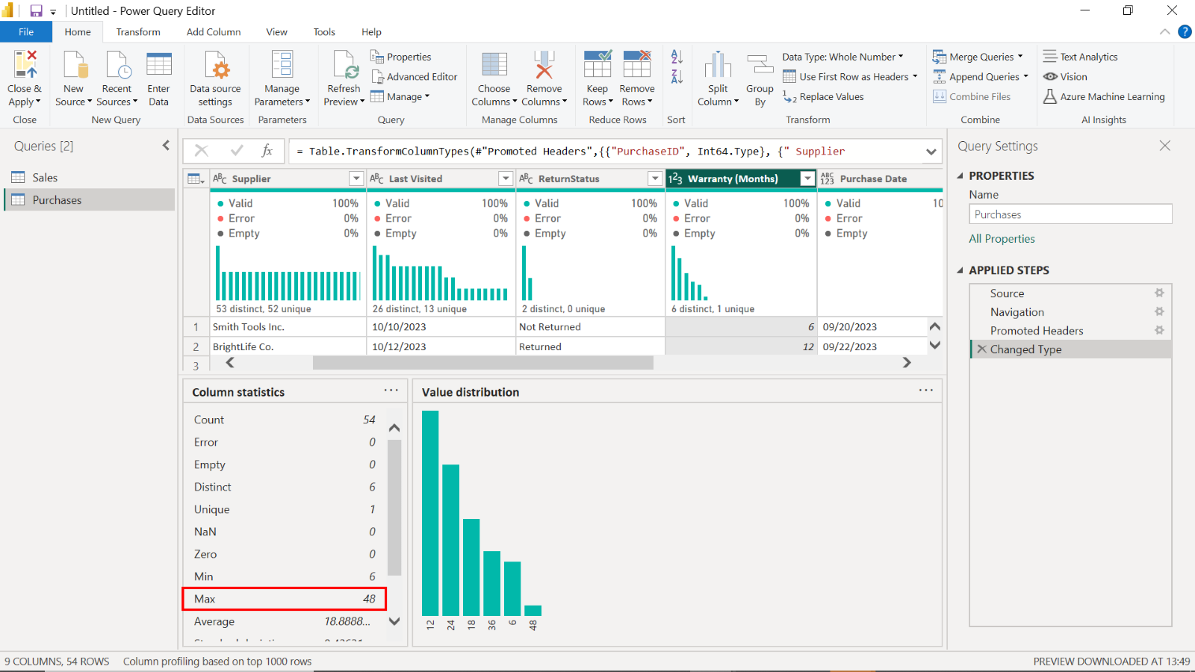

1. Select the **ReturnStatus** column and observe the **Column Quality** pane to ensure the **Valid** percentage is **100%**.

Observe the **ReturnStatus** column and confirm a 100% Valid rate via the **Column Quality** pane, indicating clean data. This is vital for financial reporting and understanding customer satisfaction.

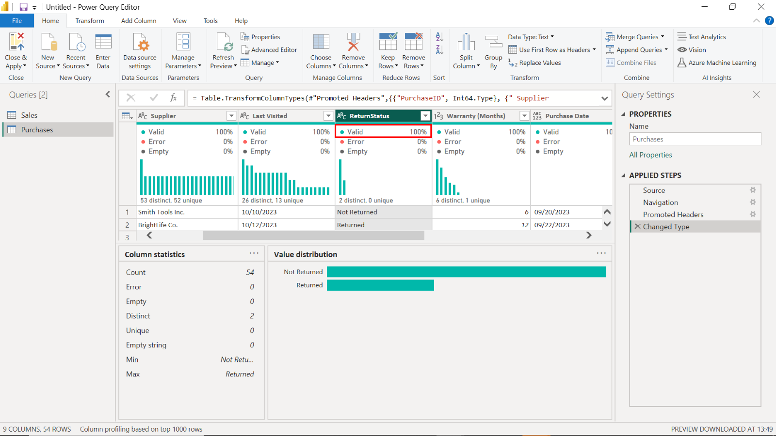

1. Filter the **ReturnStatus** column to ensure that only records with **Not Returned** are visible.

Select the **ReturnStatus** column header to access the filter options. Select **Not Returned** from the list of filter options to ensure visibility of only those records.

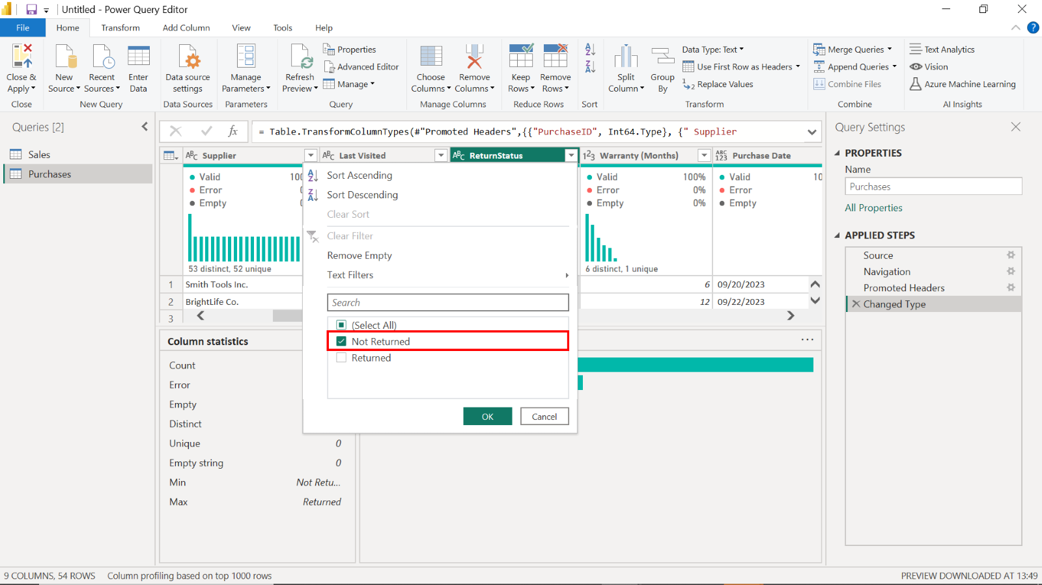

### Step 3: Load the Countries data

1. Load the **Countries** file into Power BI and select **Transform**.

Load the **Countries** data file into Power BI.Choose **Transform Data** to access the data manipulation tools in Power Query.

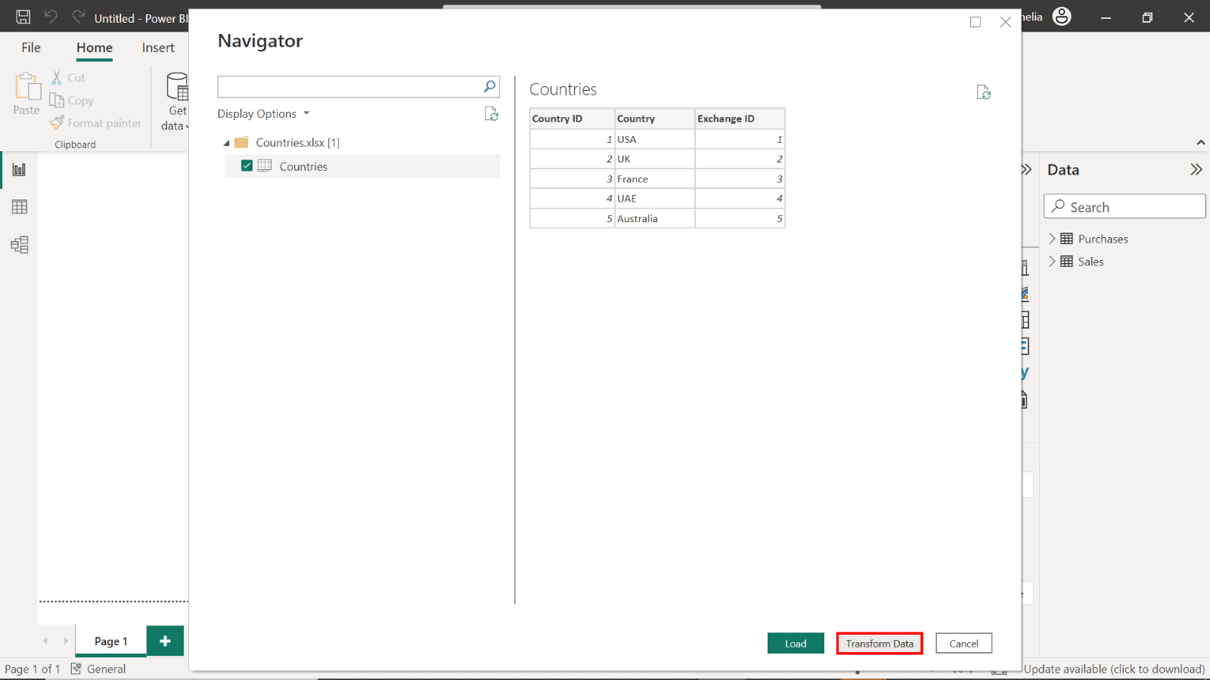

1. To complete optimization, assign the following data types for the columns:

* **Country ID = Whole Number**
* **Exchange ID = Whole Number**
* **Country = Text**

To assign data types, select each column header to open the list of options. Then, select the correct data type from the list.

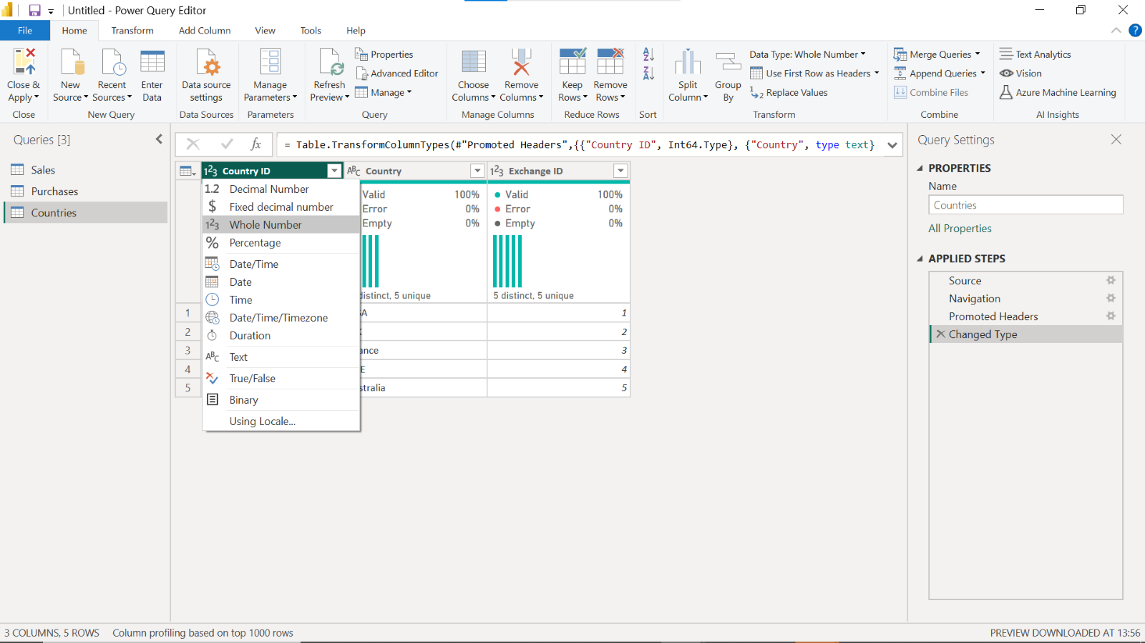

### Step 4: Load the Historical Currency Exchange data

1. Select **Get Data**, choose **Python** script, and then paste the following code into the script window in Power BI:

1

2

3

4

5

6

7

8

9

10

11

12

13

import pandas as pd

from io import StringIO

data = """Exchange ID;ExchangeRate;Exchange Currency

1;1;USD

2;0,75;GBP

3;0,85;EUR

4;3,67;AED

5;1,3;AUD"""

df = pd.read_csv(StringIO(data), sep=';')

# Return the transformed dataframe

df



Navigate to **Get Data** and select the **Python script** option.

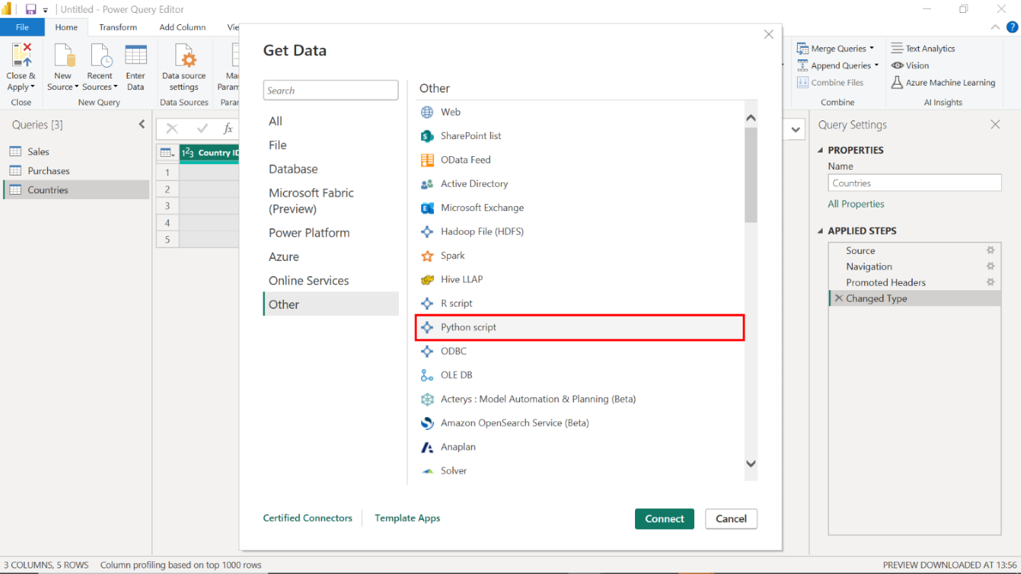

Input the Python code into Power BI’s script window.

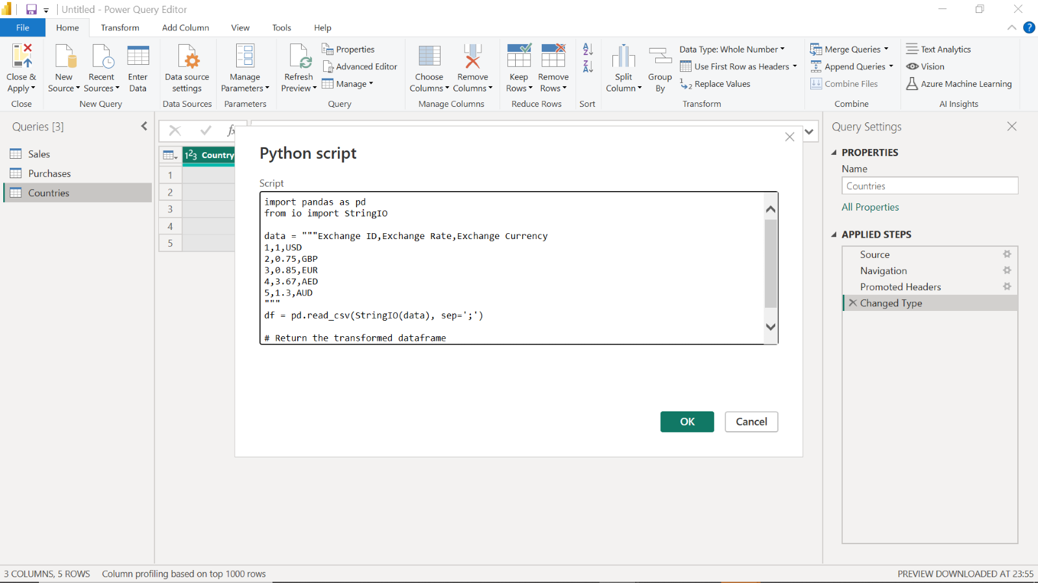

1. Integrate this data into your Power BI report.

Select the **OK** button to add this data to your Power BI report.

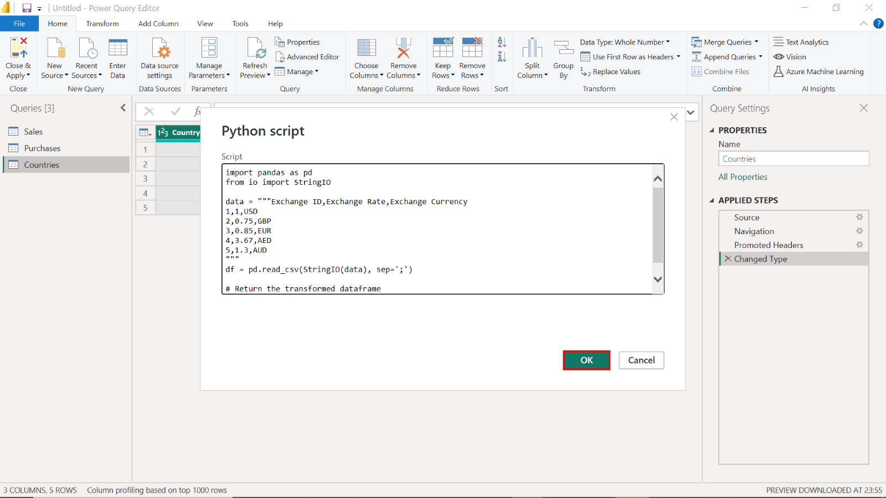

1. Save the Power BI project as **Tailwind Traders Report.pbix**.

Save your Power BI project with the name **Tailwind Traders Report.pbix**. This captures your progress and solidifies the analytical workflow, allowing for reporting and further analysis continuity.

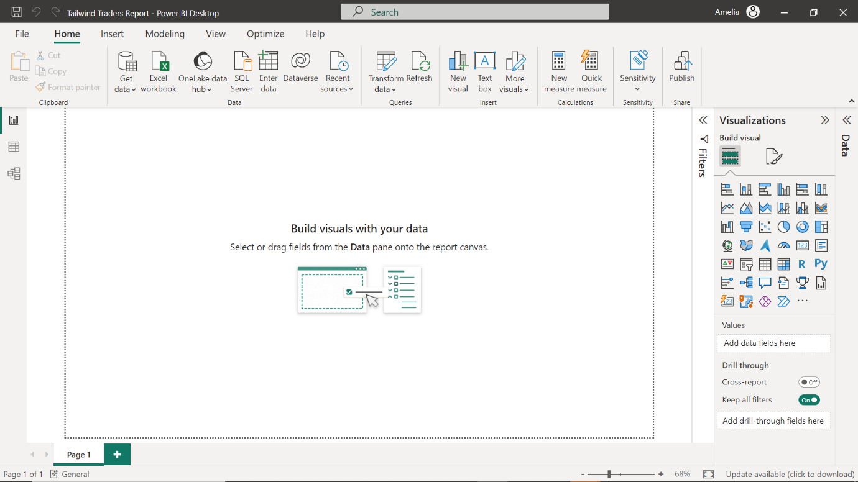

## Exercise 3: Design and develop the data model

### Step 1: Create a relationship between the Countries and Exchange Datatables

1. Create a relationship between the **Countries** and **Exchange Data** tables on the **Exchange ID** field.

Select the **Model view** option from the left-hand sidebar to view your data model.

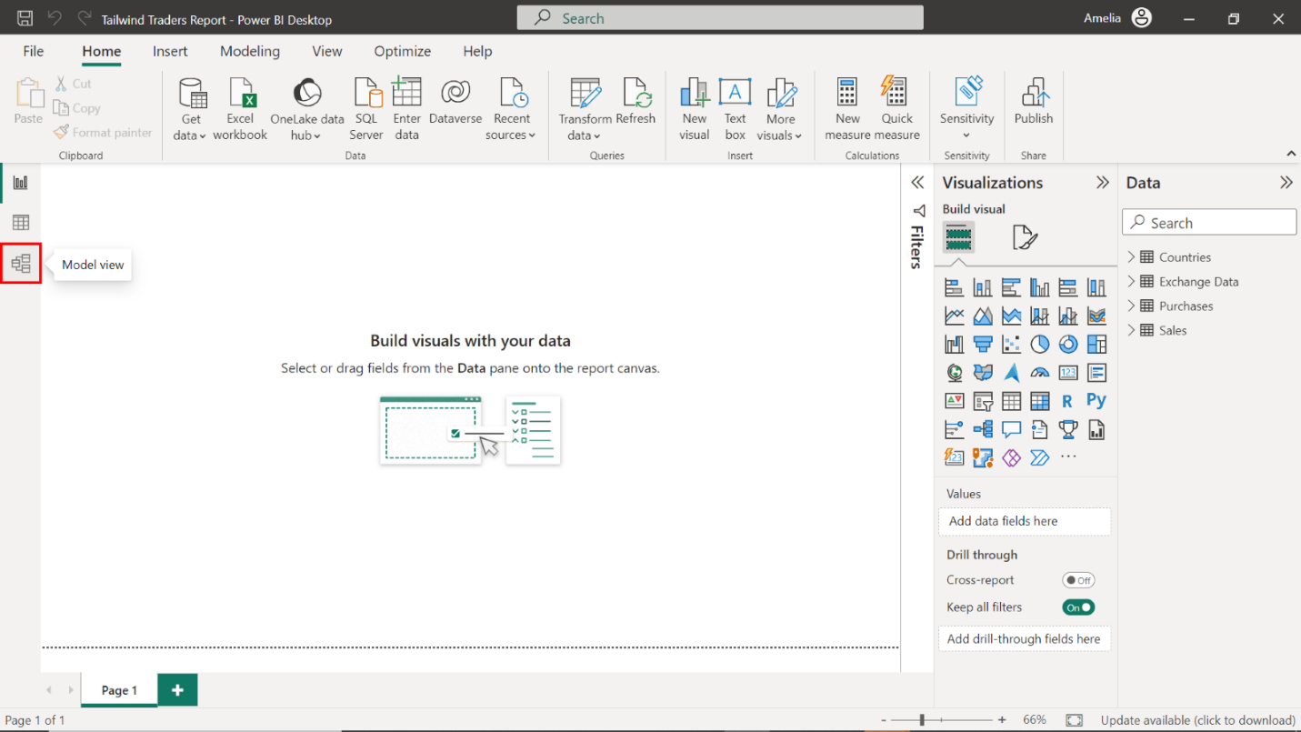

Begin by creating a relationship on the **Exchange ID** field that links the **Countries** table with the **Exchange Data** table, which forms the foundation of the currency translation mechanism.

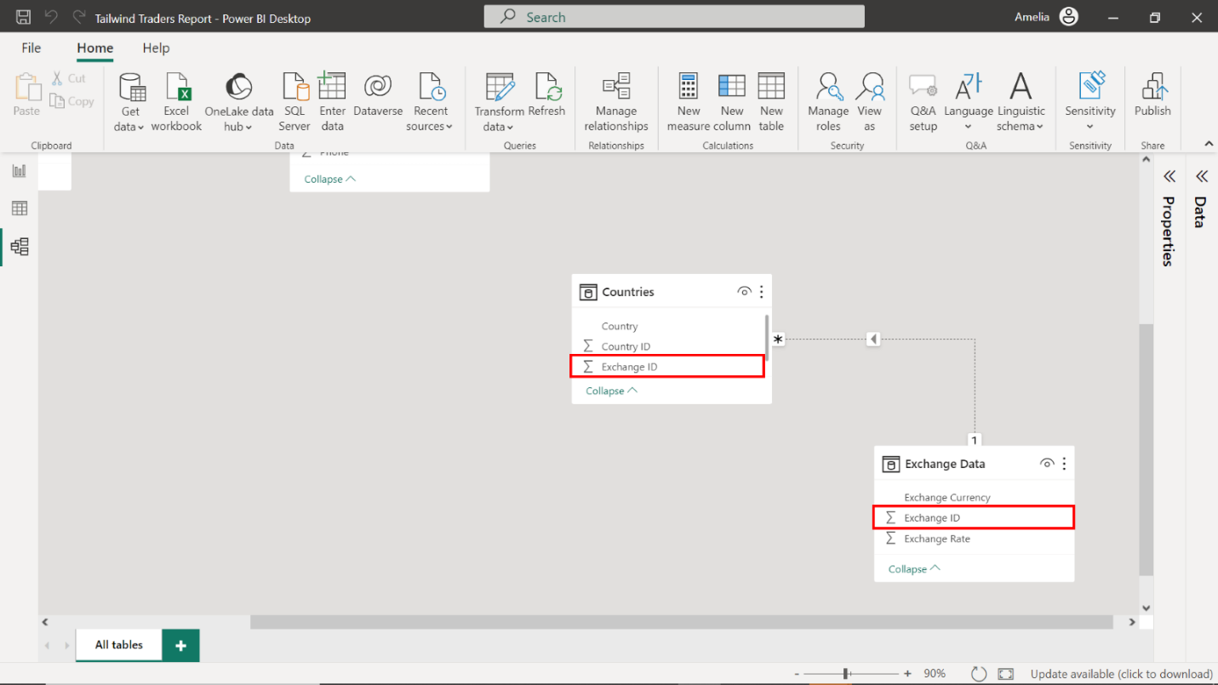

1. Set the **Cardinality** to **One to One (1:1).**

Right-click on the relationship that you just created to access the **Edit relationship** menu. Navigate to the **Cardinality** options and set the cardinality of this relationship to **One to One (1:1)**.

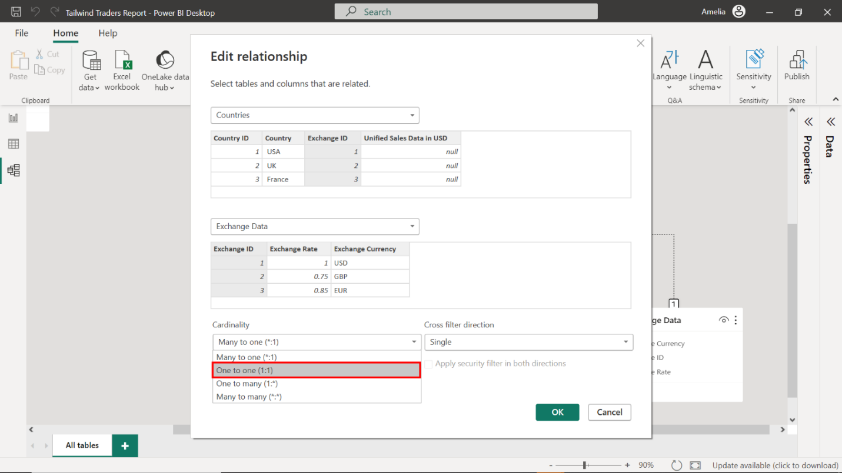

1. Set the **Cross filter direction** to **Both** to be bi-directional.

Navigate to the **Cross filter direction** options and select **Both** to enable a bi-directional flow.

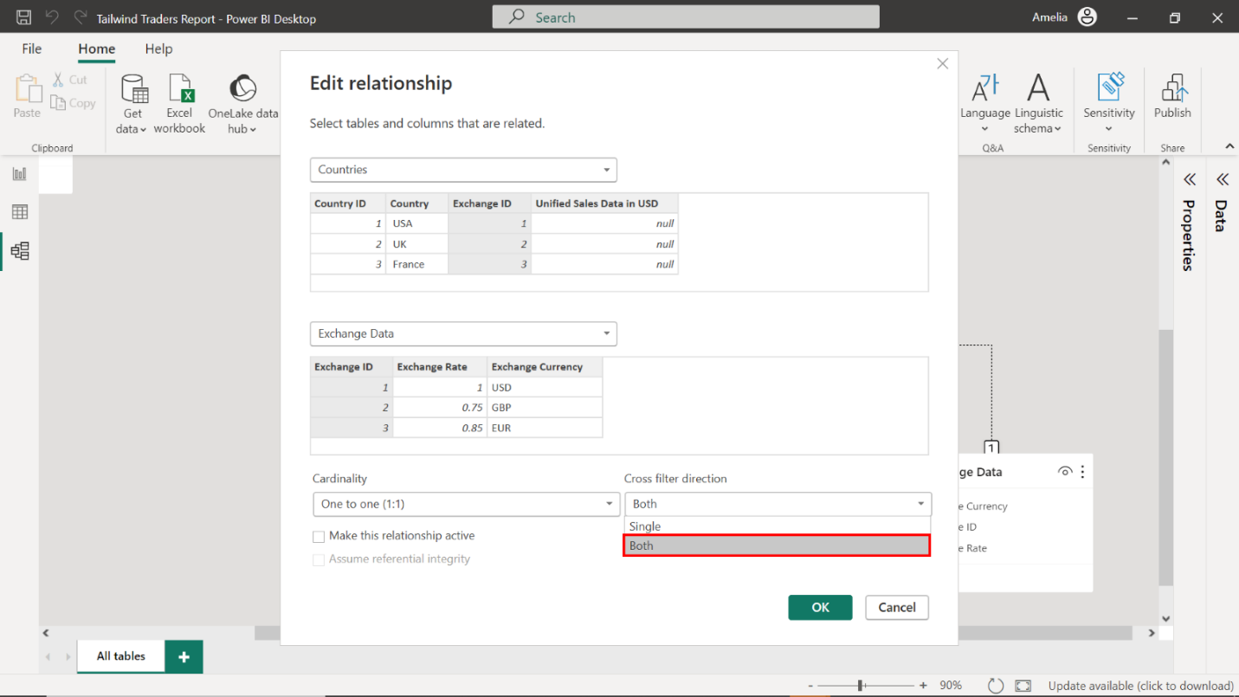

1. Ensure the **Make this relationship active** checkbox is selected.

Navigate to the **Make this relationship active** checkbox and confirm it’s checked. Select **OK** to apply your settings.

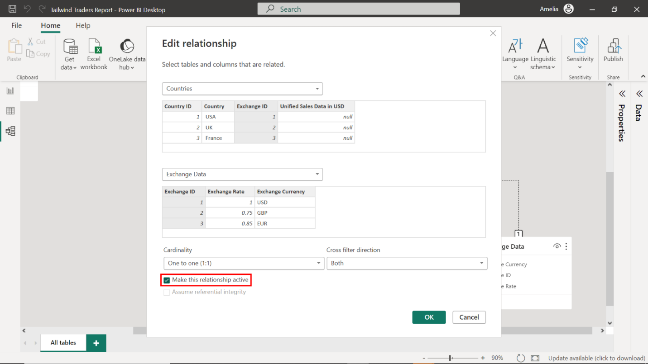

1. Inspect the relationship arrow in the Model View to ensure the arrows point in both directions and display a **1:1** symbol on either end of the connector.

Once you select **OK**, Power BI returns to the **Model View**. To ensure your settings have been enacted as required, check that your model resembles the screenshot below. The relationship arrow between the tables must point both ways, symbolizing a bi-directional link. There should also be a **1:1** symbol at both ends of the connector, signifying the one-to-one nature of this relationship.

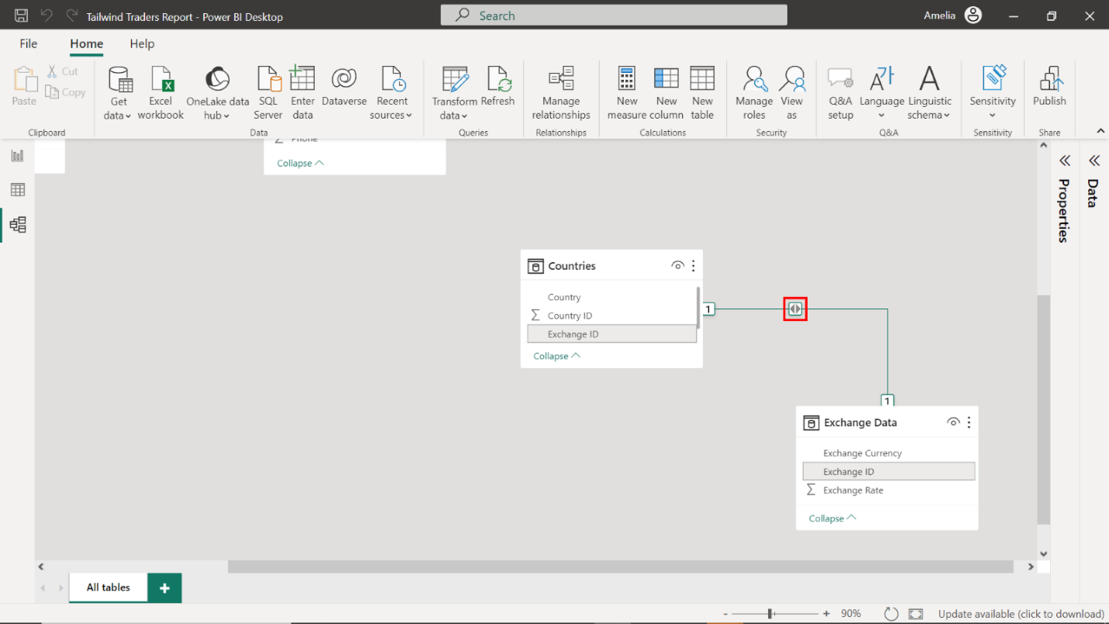

### Step 2: Create a relationship between Sales and Countries

1. Create a relationship on the **Country ID** field between the **Sales** and **Countries** tables.

Like the previous task, establish a connection on the **Country ID** field between the **Sales** and **Countries** tables to allow for geographical analysis of sales data.

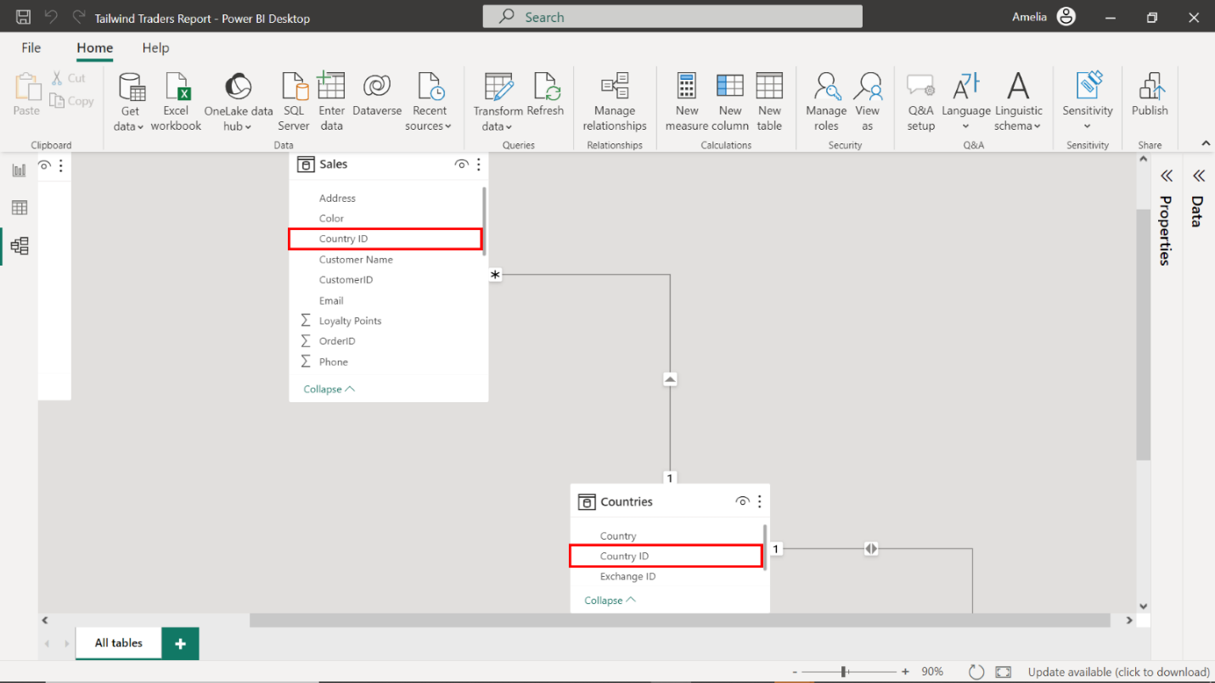

1. Set the **Cardinality** to **Many to One (1:1)**.
2. Set the **Cross-filter direction** to **Both** so that it’s bi-directional.
3. Ensure the **Make this relationship active** checkbox is selected.

Right-click the relationship, access the **Edit relationship** menu, and configure the above relationship settings as you did for the tables in the previous task. Your settings should resemble the following screenshot.

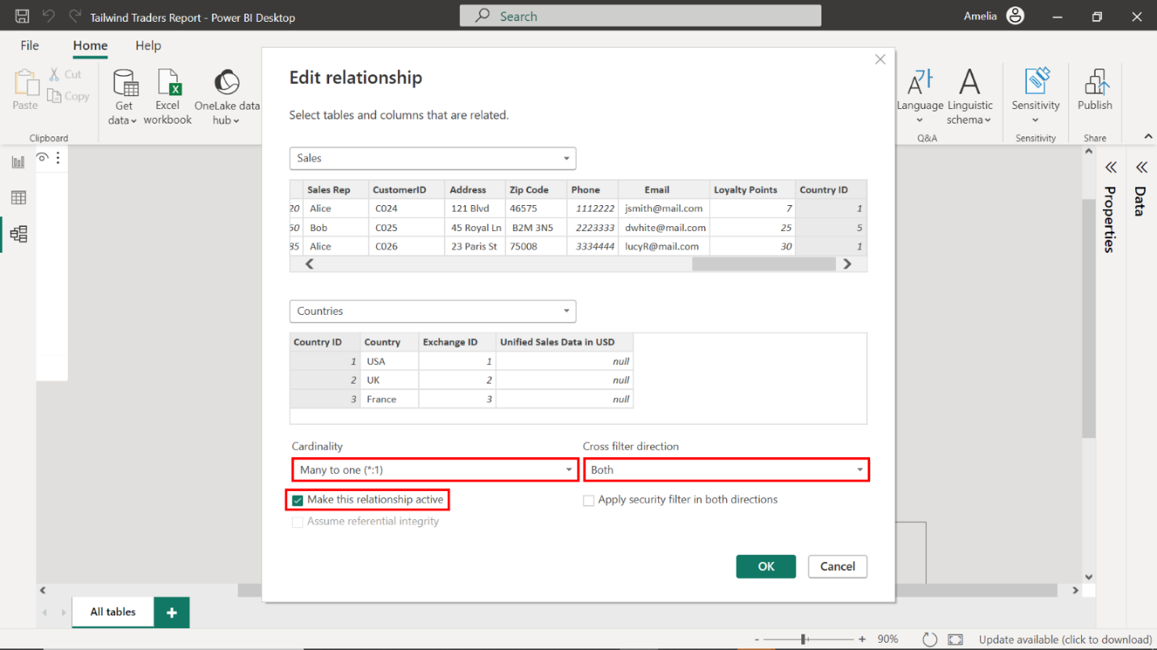

1. Inspect the relationship arrow in the Model View to ensure the arrows point in both directions and display a **\*:1** symbol on either end of the connector.

Select **OK** to apply your settings and return to **Model View**. Your model should resemble the screenshot below. Inspect the relationship arrow to ensure that it illustrates a bi-directional connection, complete with a **\*:1** symbol correctly representing the many-to-one relationship inherent in the sales data structure.

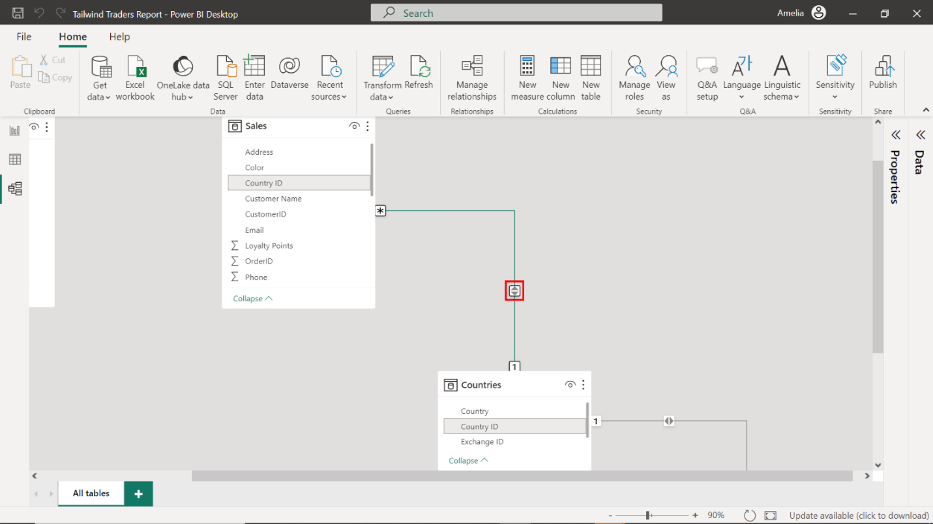

### Step 3: Create a relationship between the Purchases and Sales tables

1. Create a relationship on the **OrderID** field between the **Purchases** and **Sales** tables.

Create a relationship using the **OrderID** field as a bridge between the **Purchases** and **Sales** tables, linking procurement with sales.

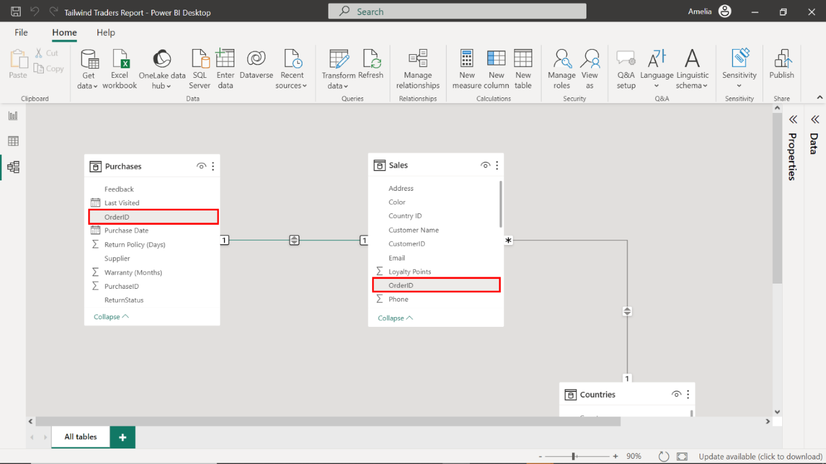

1. Set the **Cardinality** to **One to One (1:1)**.
2. Set the **Cross filter direction** to **Both** to be bi-directional.
3. Ensure the **Make this relationship active** checkbox is selected.

Right-click the relationship, access the **Edit relationship** menu, and configure the above relationship settings as you did for the tables in the previous task. Your settings should resemble the following screenshot.

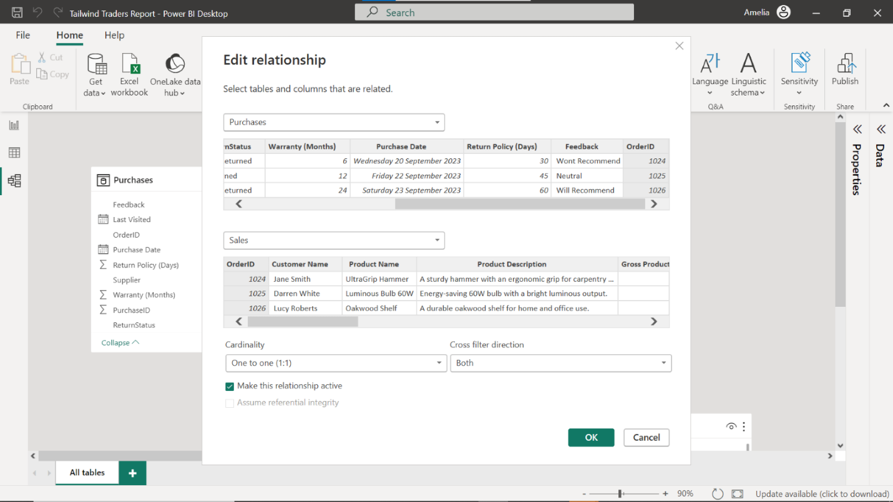

1. Inspect the relationship arrow in the Model View to ensure the arrows point in both directions and display a **1:1** symbol on either end of the connector.

Select **OK** to apply your settings and return to **Model View**. Your model should resemble the screenshot below. Validate the relationship arrow in the **Model View** to check that it indicates a bidirectional flow, complete with a **1:1** symbol at both ends, affirming a one-to-one correspondence between each order and its sales outcome.

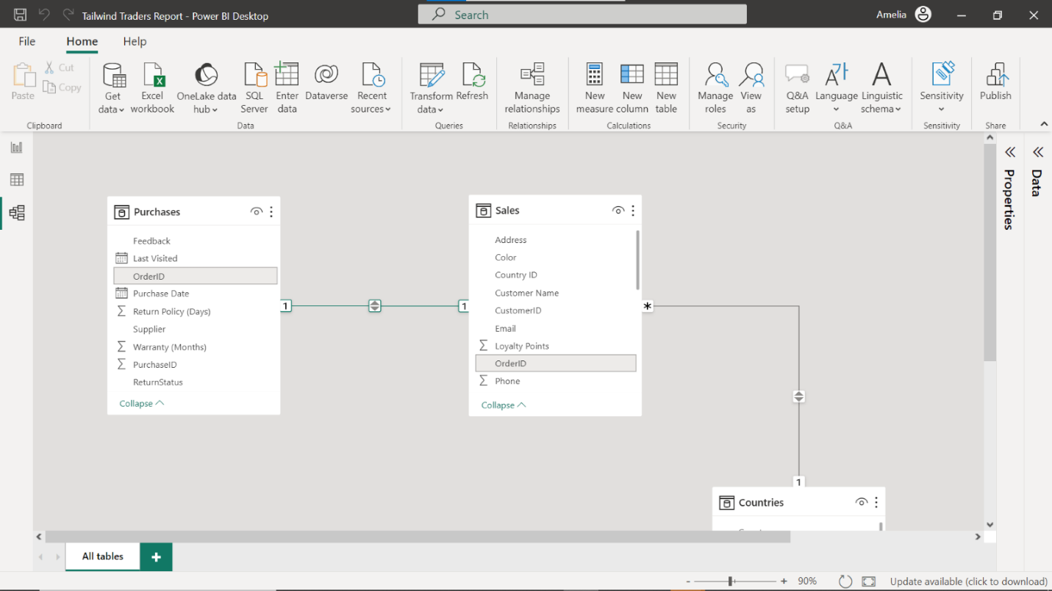

### Step 4: Configure the Calendar table

* Select **New Table** and add the following DAX code to create a new **Calendar** table:

CalendarTable =

ADDCOLUMNS(

CALENDAR(DATE(2020, 1, 1), DATE(2023, 12, 31)),

"Year", YEAR([Date]),

"Month Number", MONTH([Date]),

"Month", FORMAT([Date], "MMMM"),

"Quarter", QUARTER([Date]),

"Weekday", WEEKDAY([Date]),

"Day", DAY([Date])

)

Select **New Table** and input the provided DAX code to create a **Calendar table**, an indispensable tool for any time-based analysis.

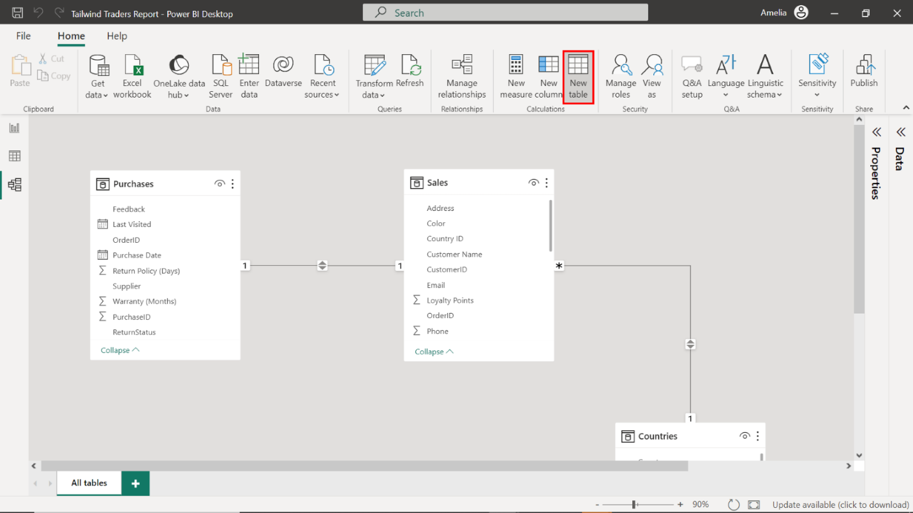

This table will become the backbone for time intelligence in the model, offering fields like **Year**, **Month Number**, **Month**, **Quarter**, **Weekday**, and **Day**, bringing a rich temporal dimension to the data landscape.

### Step 5: Create a relationship between the Calendar and Purchasestables

1. Create a relationship on the **Date** field between the **Calendar** and the **Purchase Date** in the **Purchases** table.

Create a relationship on the **Date** field that aligns the **Calendar** table and **Purchase Date** with **Purchases**.

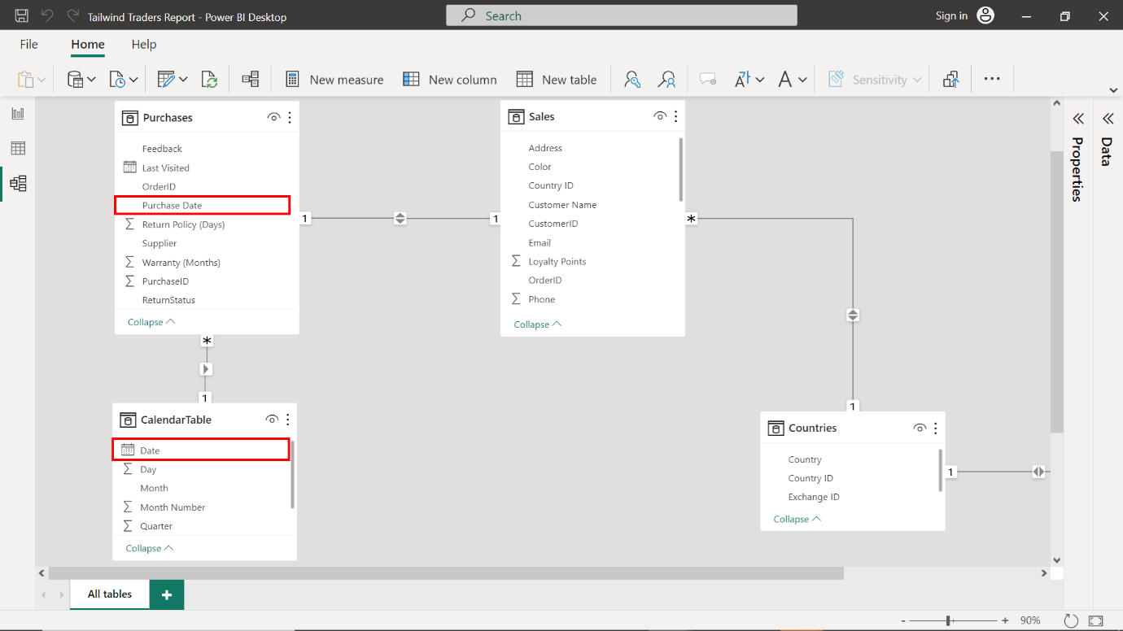

1. Set the **Cardinality** to **Many to One (1:1)**.
2. Ensure the **Make this relationship active** checkbox is selected.

Right-click the relationship, access the **Edit relationship** menu, and configure the above relationship settings as you did for the tables in the previous task. Your settings should resemble the following screenshot.

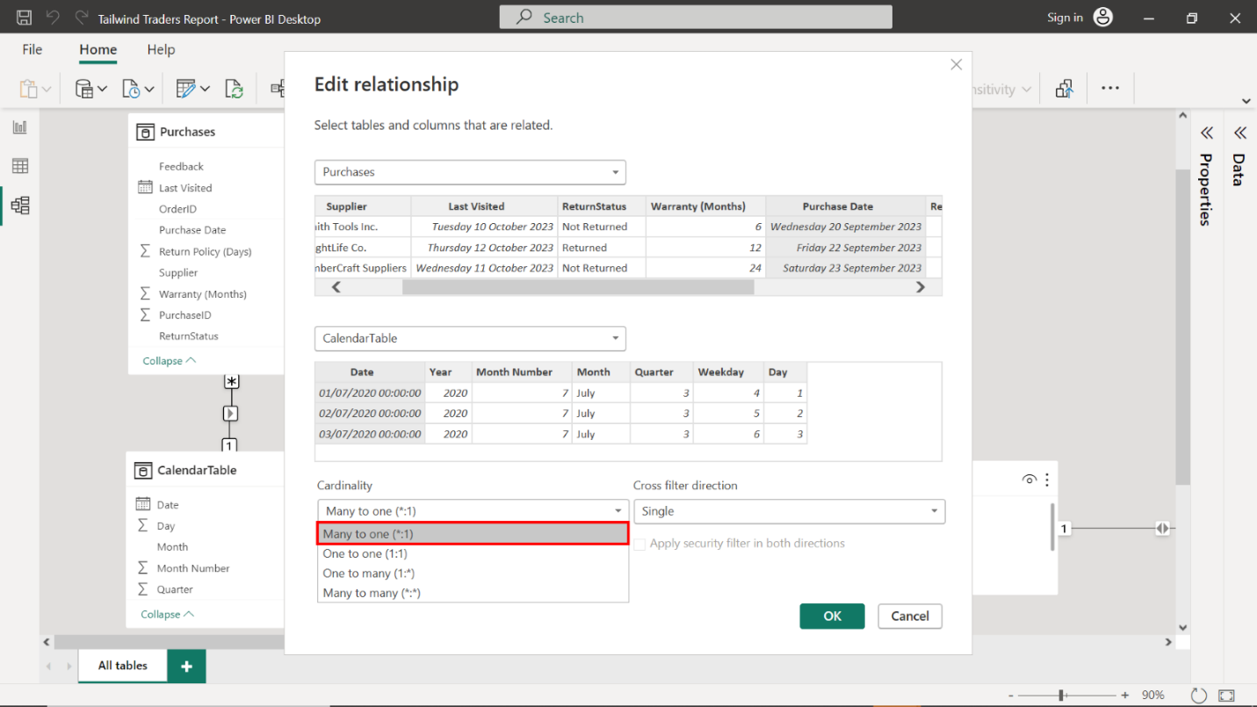

1. Inspect the relationship arrow in the **Model View** to ensure the arrows point in both directions and display a **\*:1** symbol on either end of the connector.

Select **OK** to apply your settings and return to **Model View**. Your model should resemble the screenshot below. Confirm that the relationship arrow correctly points in both directions and displays a **\*:1** symbol, validating the many-to-one relationship that connects **Purchases** to **Dates**.

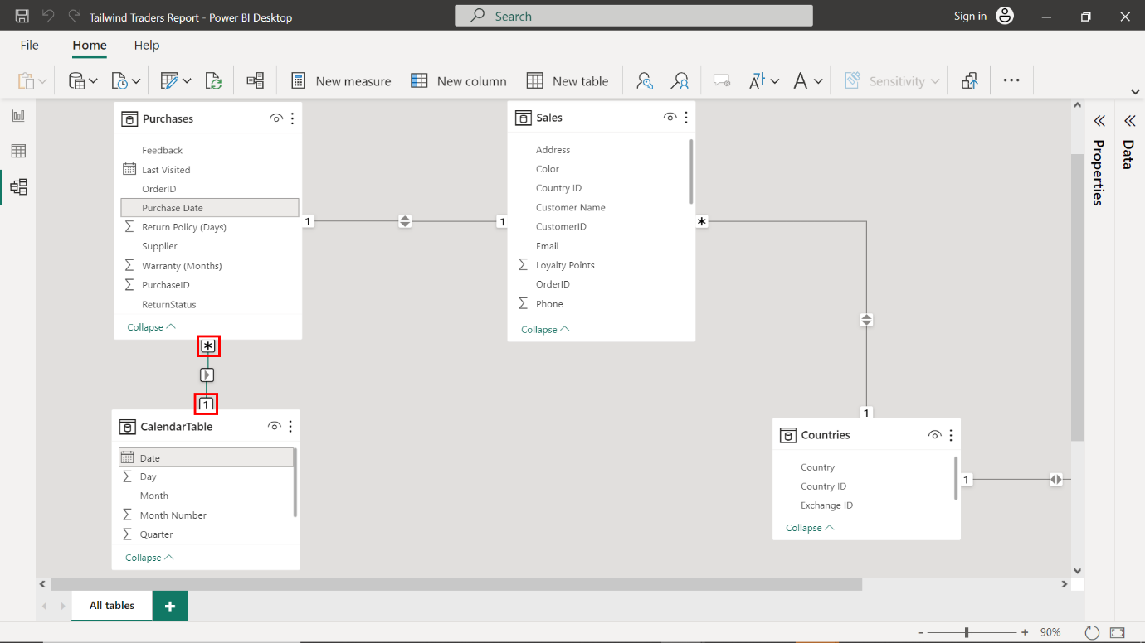

### Step 6: Create Sales in USD Calculated Table

1. Select **New Table** and add the following DAX code to create a new calculated table:

Sales in USD =

ADDCOLUMNS(

    Sales,

    "Country Name", RELATED(Countries[Country]),

    "Exchange Rate", RELATED('Exchange Data'[Exchange Rate]),

    "Exchange Currency", RELATED('Exchange Data'[Exchange Currency]),

    "Gross Revenue USD", [Gross Revenue] * RELATED('Exchange Data'[Exchange Rate]),

    "Net Revenue USD", [Net Revenue] * RELATED('Exchange Data'[Exchange Rate]),

    "Total Tax USD", [Total Tax] * RELATED('Exchange Data'[Exchange Rate])

)

Create a new calculated table named **Sales in USD** by selecting **New Table** and entering the DAX code provided. This adjusts the **Sales** values into a unified currency format.

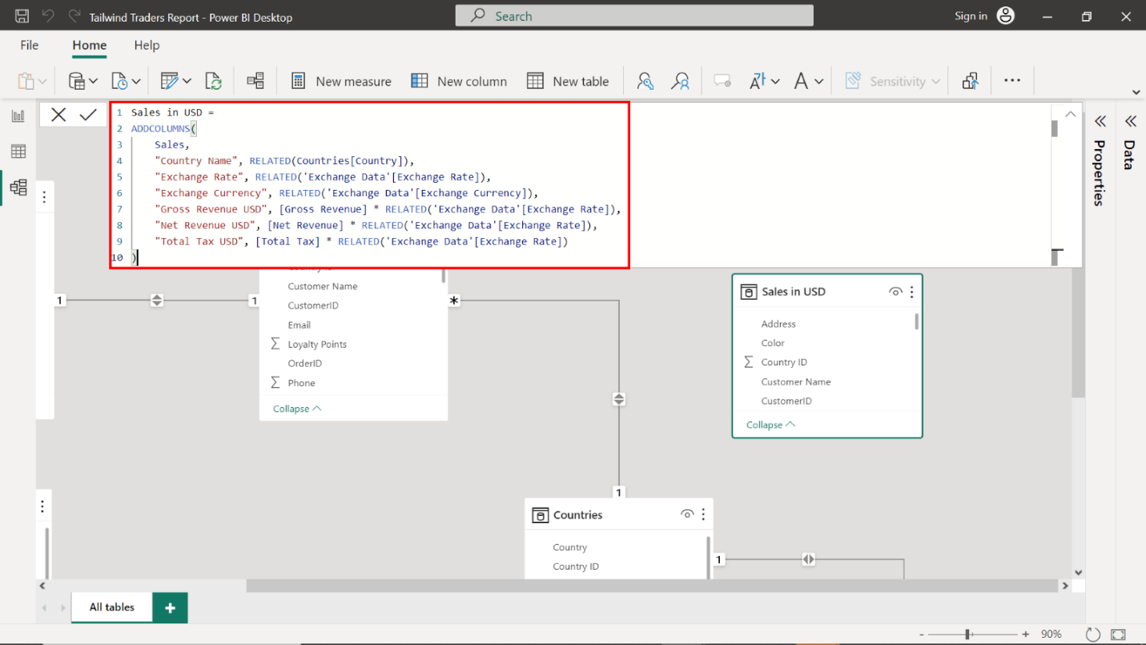

1. Note the **Gross Revenue USD**, **Net Revenue USD**, and **Total Tax USD** for the **Order ID= 1035** on the **Sales in USD** table.

The **Net Revenue** for **Order ID 1035** placed by **Amelia Carter** is precisely **682.62 USD.** The **Gross Revenue USD** measures **734 USD**, and the **Total Tax USD** is **51.38 USD**.

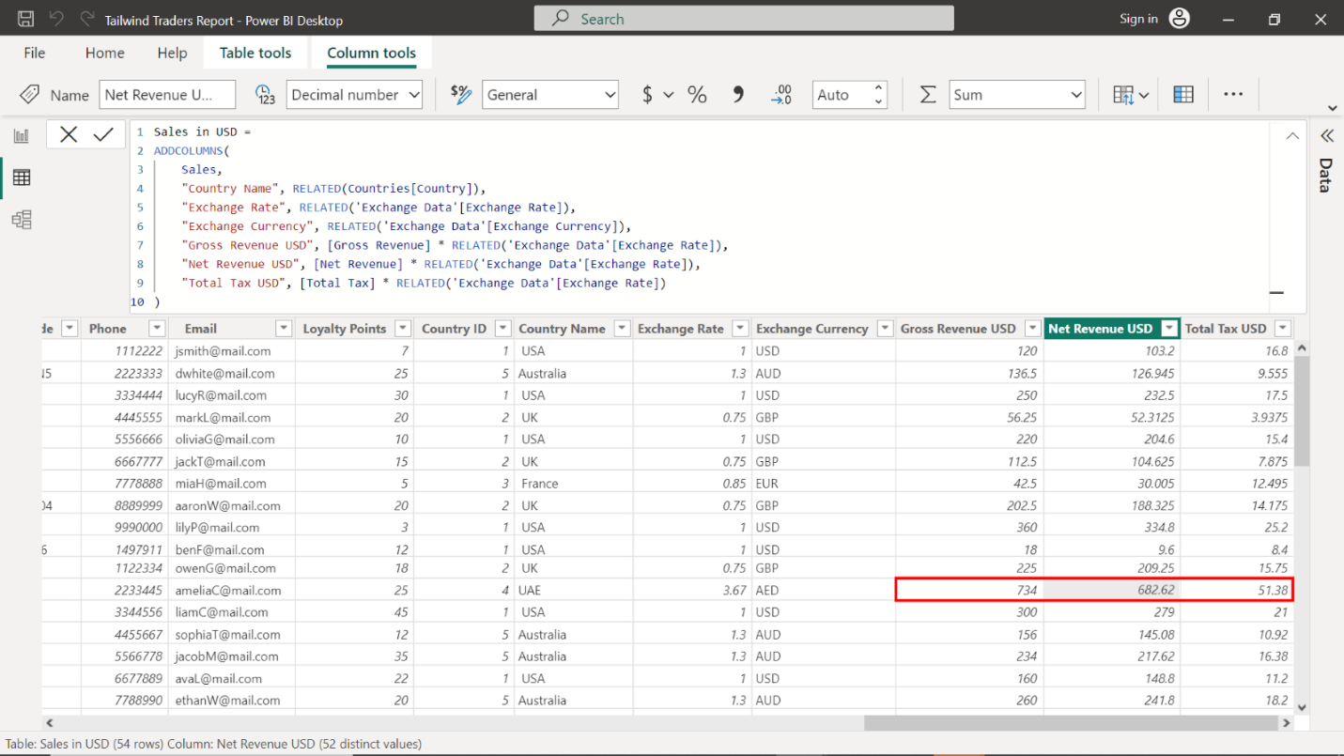

### Step 7: Create a relationship between the Sales in USD and Sales tables

1. Create a relationship between the **Sales in USD** and **Sales** tables on the **Order ID** field.

Link the **Sales in USD** table with the **Sales** table by creating a relationship based on the **Order ID** field, enabling Tailwind Traders to contrast the original sales data with its USD equivalent.

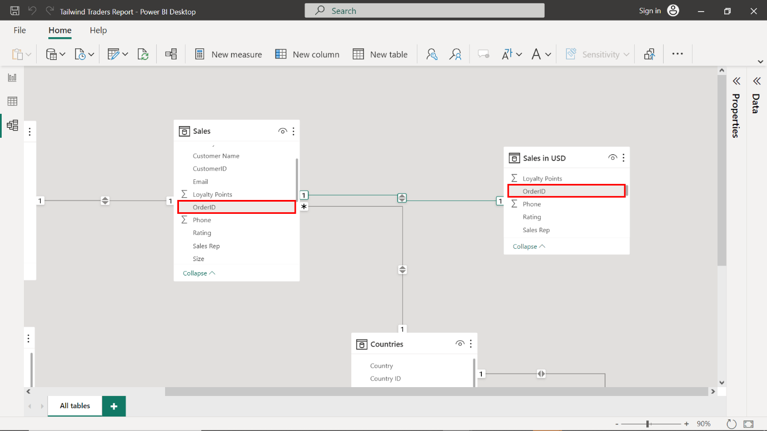

1. Set the **Cardinality** to **Many to One (1:1)**.
2. Ensuring the **Make this relationship active** checkbox is selected.

Right-click the relationship, access the **Edit relationship** menu, and configure the above relationship settings as you did for the tables in the previous task. Your settings should resemble the following screenshot. Ensure the **Make this relationship active** checkbox is selected to prioritize this relationship as the default linkage for navigating between sales records and their USD counterparts.

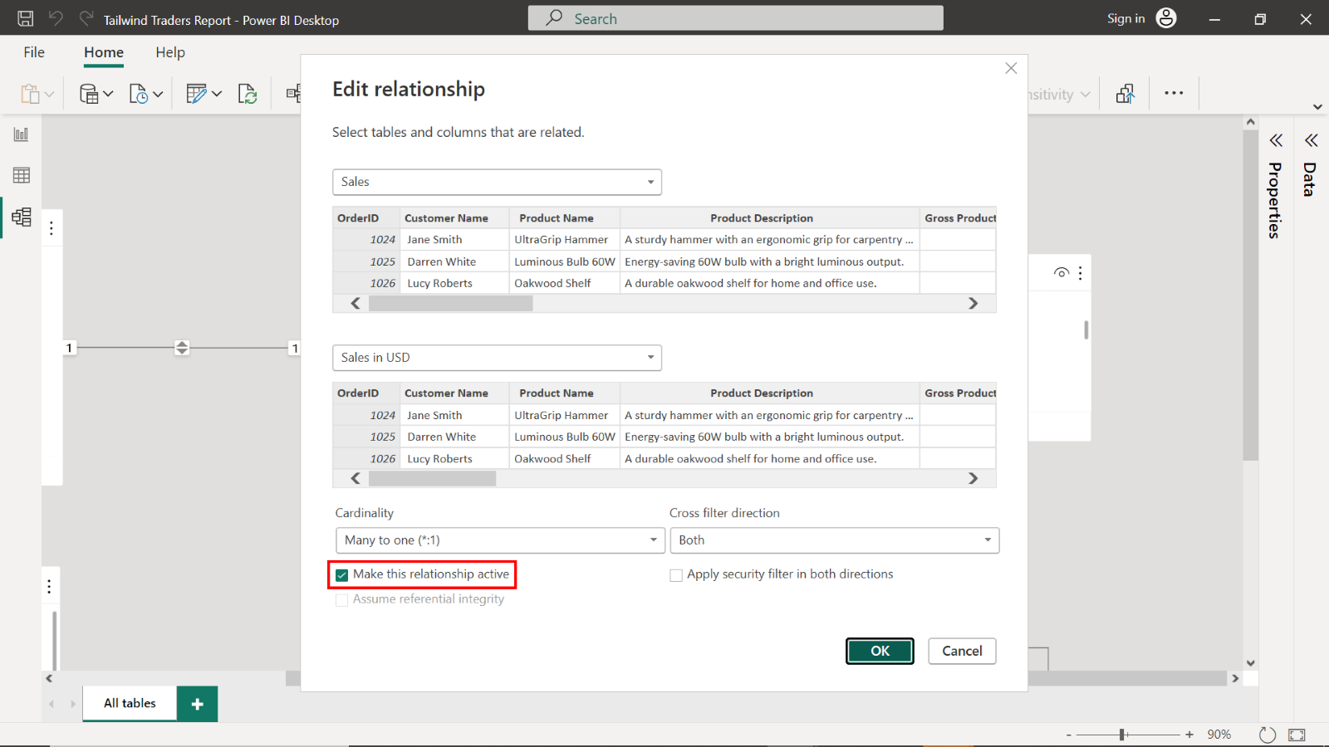

1. Inspect the relationship arrow in the Model View to ensure the arrows point in both directions and display a **1:1** symbol on either end of the connector.

Select **OK** to apply your settings and return to **Model View**. Examine the relationship arrow to verify that it correctly illustrates a bi-directional relationship, with a **\*:1** symbol on either end, confirming the proper relationship structure for USD sales analysis.

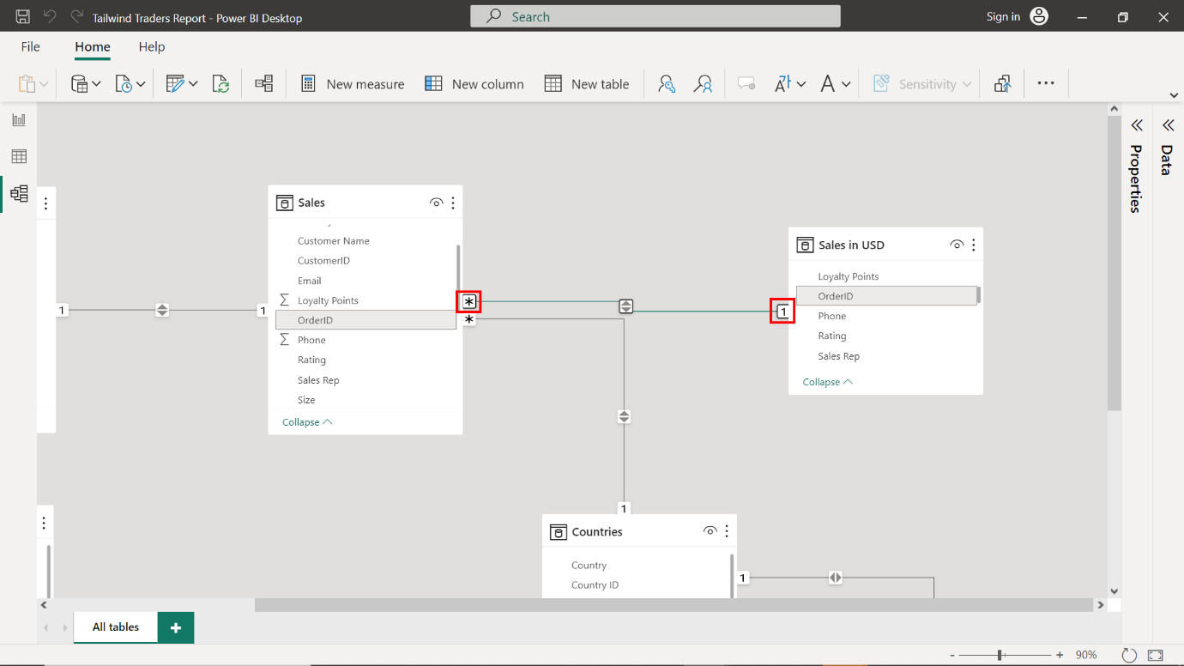

# Exemplar: Capstone project - Part 2

## Overview

In the second set of Capstone project exercises, you had to assist Tailwind Traders with configuring its aggregations and generating insights in the form of reports from its data.

The two exercises you undertook in this second phase were:

* Configure aggregations using DAX.
* And create sales and profit reports.

This reading provides you with a step-by-step guide for completing these tasks. It also includes screenshots that you can compare against your work.

You can also review the learning materials provided in this course for more guidance.

## Exercise 1: Configure aggregations using DAX

### Step 1: Calculate Yearly Profit margin

1. Create a new measure for the **Sales in USD** table.

Right-click on the **Sales in USD** table in the **Fields** pane and select **New Column**.

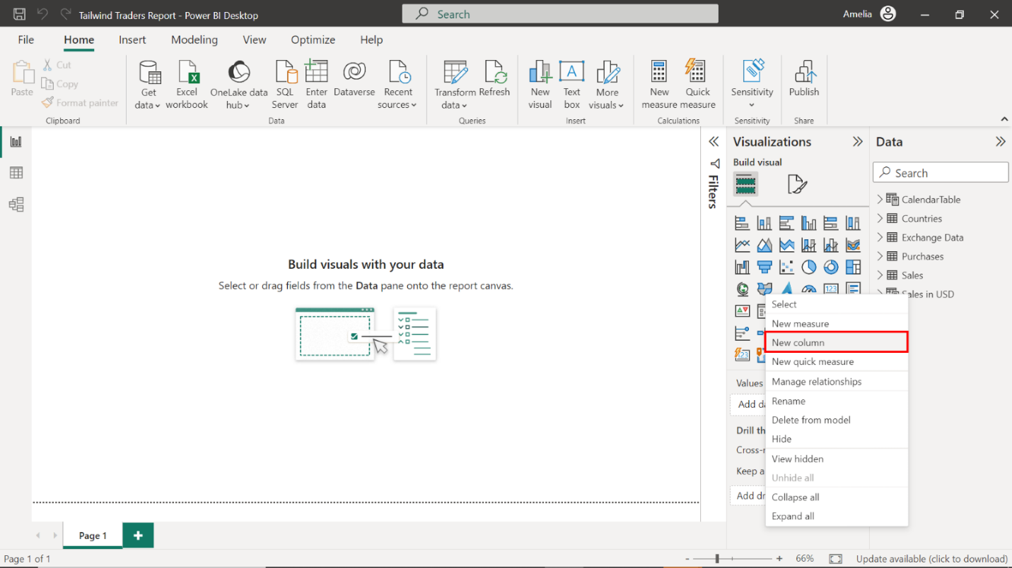

1. In the formula bar, create a new column that represents the yearly profit margin. This margin should be derived by dividing the gross revenue by the total net revenue within the **Sales in USD** table.

Right-click on the **Sales in USD** table in the **Fields** pane and select **New Column** to set the stage for this calculation. Then, input the provided DAX formula into the formula bar.

1

Yearly Profit Margin = 'Sales in USD'[Gross Revenue USD] / 'Sales in USD'[Net Revenue USD]



This calculation divides the **Gross Revenue** by the **Net Revenue**, and shows how much money is kept as profit from sales after costs. This measure provides an overarching view of Tailwind Traders’ financial efficiency throughout the year and is a key indicator of the company's financial health.

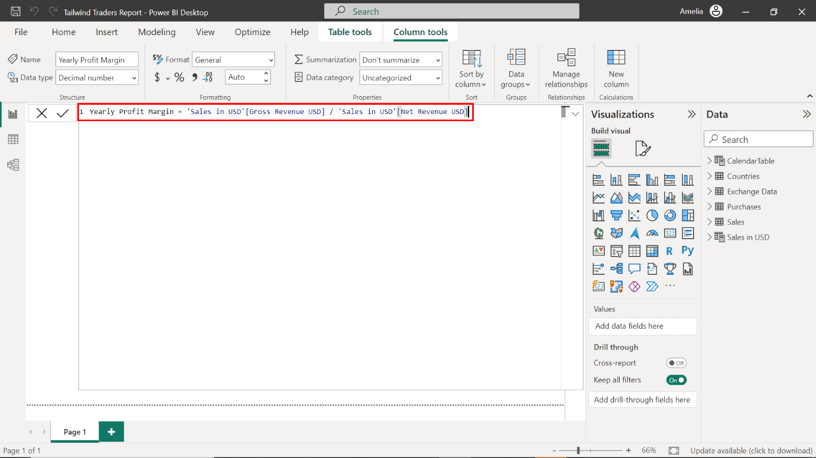

### Step 2: Calculate Quarterly Profit

1. Create a new measure for quarterly profit. Consider using a function that aggregates data until the end of the current quarter. To achieve this, you must reference the calculated yearly profit and a calendar table.

As you did in the previous task, right-click the **Sales in USD** table in the **Fields** pane and select **New Column**. Then, input the provided DAX formula into the formula bar:

1

Quarterly Profit = CALCULATE([Yearly Profit Margin], DATESQTD('CalendarTable'[Date]))



This calculation isolates the profit made in each quarter by using a time intelligence function, which filters the profit to each respective quarter. This data provides actionable insights for short-term planning and strategy.

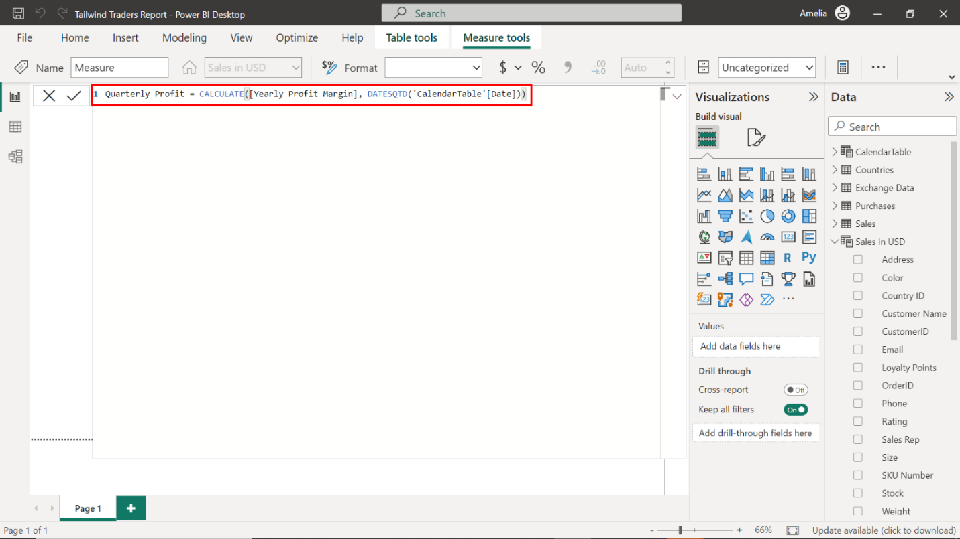

### Step 3: Calculate Year-to-Date Profit

1. Right-click on the **Sales in USD** table in the **Fields** pane and select **New Measure**.
2. Create a new measure for the year-to-date profit. You'll need a function aggregating data from the start of the year to the current date.

As you did in the previous task, right-click the **Sales in USD** table in the **Fields** pane and select **New Column**. Then, input the provided DAX formula into the formula bar:

1

YTD Profit = TOTALYTD([Yearly Profit Margin], 'CalendarTable'[Date])



This measure accumulates the profit from the first day of the fiscal year to the current date, providing a running total of Tailwind Traders' profitability. This step provides a real-time snapshot of the company’s financial trajectory, allowing for comparison against the same period in previous years or projected targets.

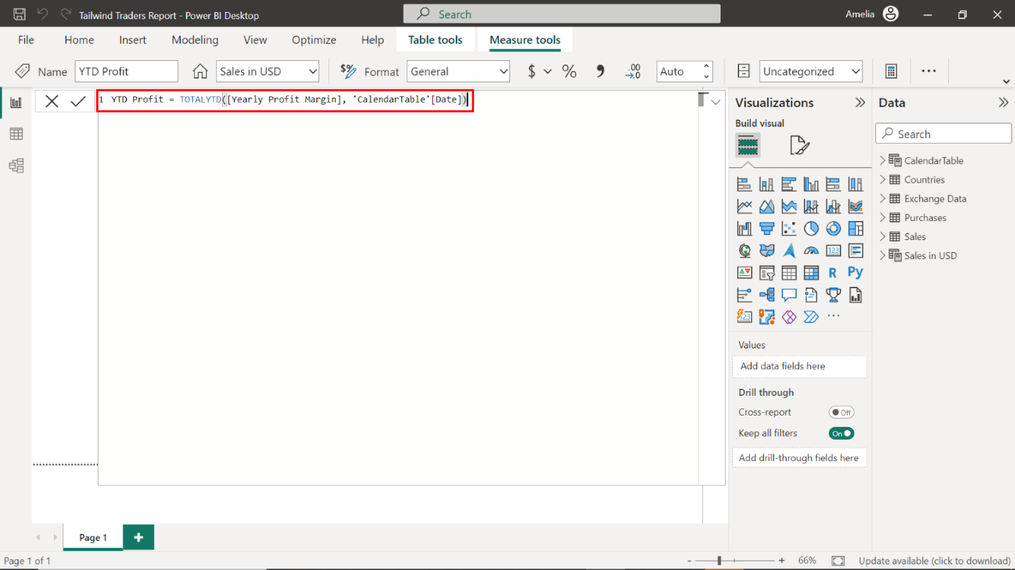

### Step 4: Calculate Median Sales

1. Right-click on the **Sales in USD** table in the **Fields** pane and choose **New Measure**.
2. In the formula bar, create a new measure to represent the median sales. Consider the statistical functions in **DAX** that can help you find the middle value of gross revenue.

Right-click on the **Sales in USD** table and choose **New Measure**. Input the provided DAX formula into the formula bar.

1

Median Sales = MEDIAN('Sales in USD'[Gross Revenue USD])



The median is a statistical measure that indicates the middle value in a set of numbers, which, in this case, represents sales volumes. Using the **MEDIAN** function on **Gross Revenue** identifies the sales value at the center of the dataset.

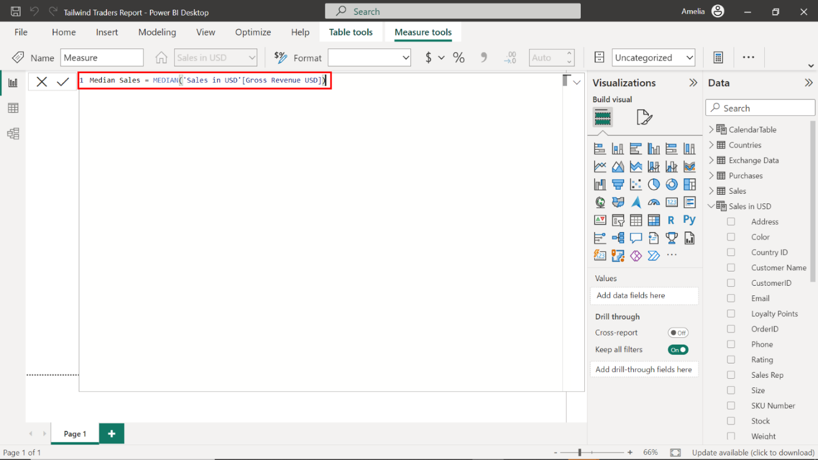

### Step 5: Access the Performance Analyzer

1. Find and select the **Performance Analyzer** option within the **View** tab.

Upon selecting the **Report** view icon, you must open the **Performance Analyzer**. Locate and select the **View** tab on the ribbon interface at the top of your Power BI report. Within the **View** tab, find and select the **Performance Analyzer** option.

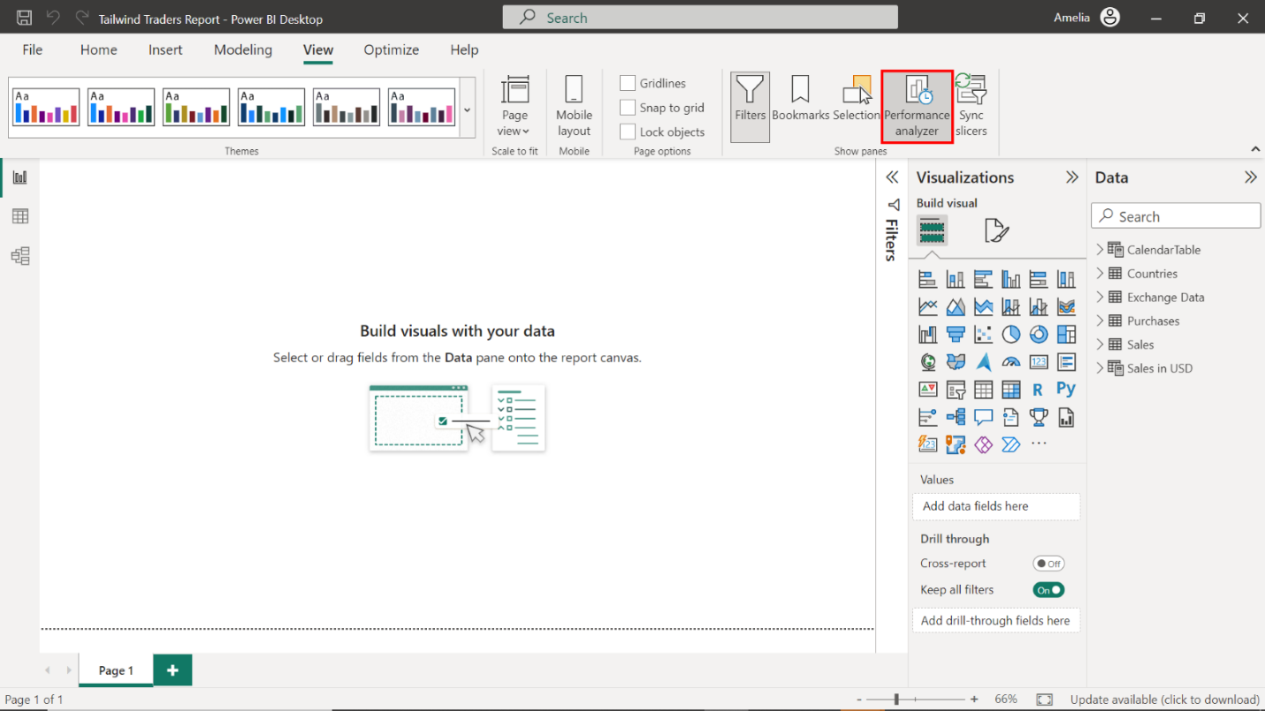

1. Create an empty Card visual and drag the **Yearly Profit Margin** field to the **Fields** well. Repeat this process for the **Median Sales**, **Quarterly Profit,** and **YTD Profit**.

Select the **Card** icon in the **Visualizations** pane. An empty Card visual appears on the canvas. Locate the **Sales in USD** table and drag the **Yearly Profit Margin** field to the **Fields** well in the **Visualizations** pane. Repeat this process for the **Median Sales**, **Quarterly Profit** and **YTD Profit**.

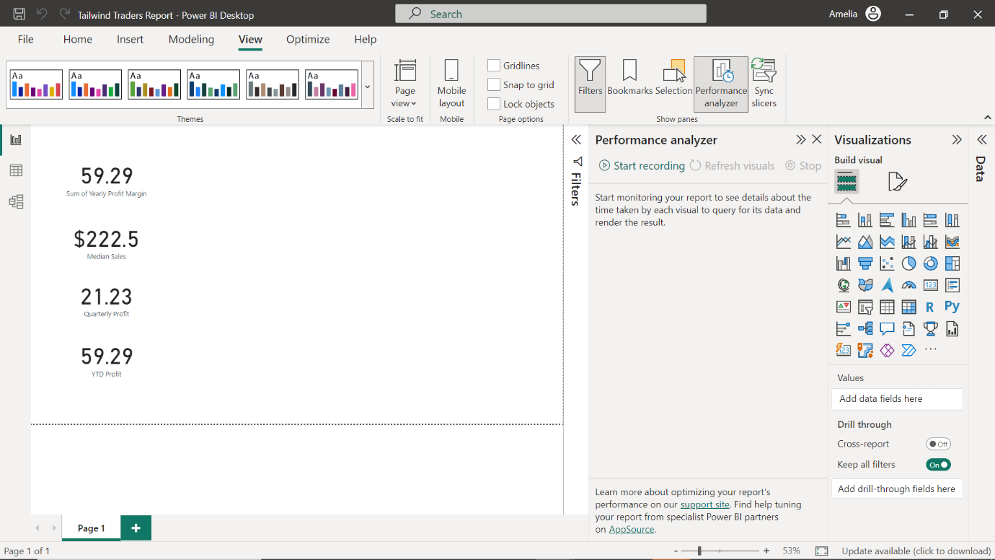

1. Begin recording the performance of the card visuals using the Performance Analyzer’s recording feature.

Locate and select the **Start Recording** button in the **Performance Analyzer** pane.

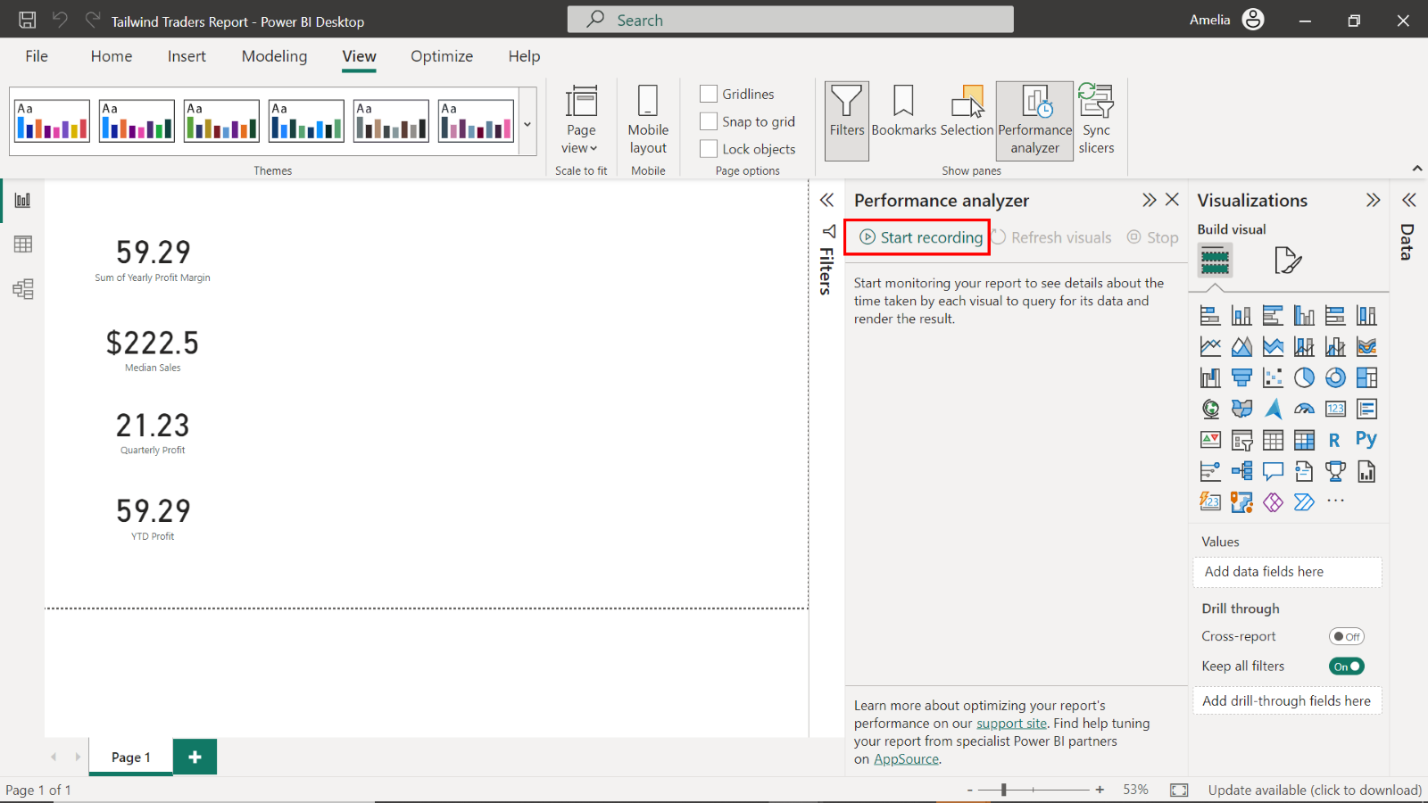

1. Refresh your reports to test their performance.

You can refresh a report using two methods:

* Select the Refresh button in the **Home** tab of the ribbon interface
* or interact directly with the report.

As you interact with the report while the **Performance Analyzer** is recording, it tracks and documents the time taken to load each visual item.

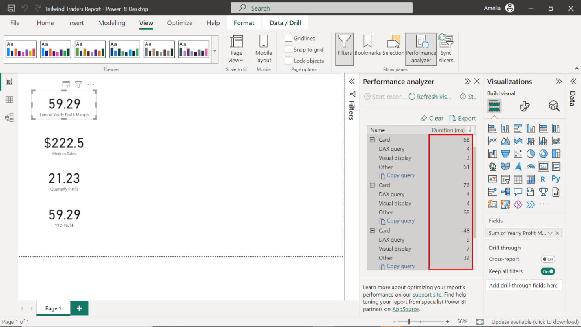

1. Observe the list of all visual items in your report and their respective load times. Ensure the **DAX** query time of visual items is **< 200ms** and note any slow-loading visuals.

Observe the list of all visual items in your report and their respective load times. Ensure the DAX query time of visual items is **< 200ms** and note down any slow-loading visuals. This step is important not only for data analysis accuracy but also for reports' performance optimization.



1. Select **Stop** and remove all Card visuals, resulting in a blank Canvas.

Select Stop and remove all Card visuals upon completion, resulting in a blank Canvas.

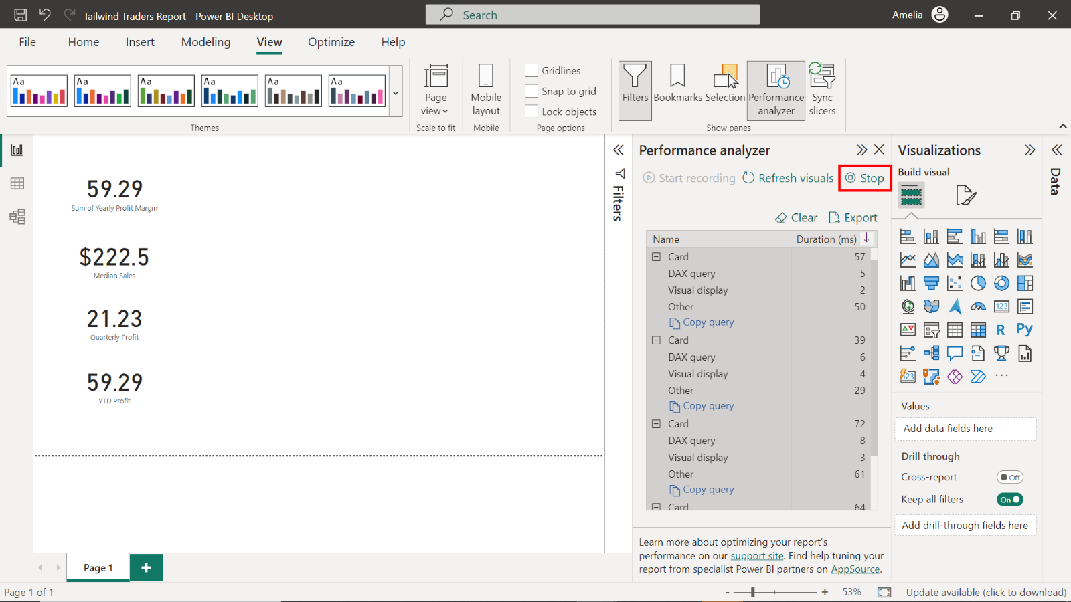

## Exercise 2: Create a Sales report

### Step 1: Create a Sales Overview report

1. Open the **Tailwind Traders Report.pbix** Power BI file.

OpenPower BI Desktop and select the **File** menu in the top left corner.

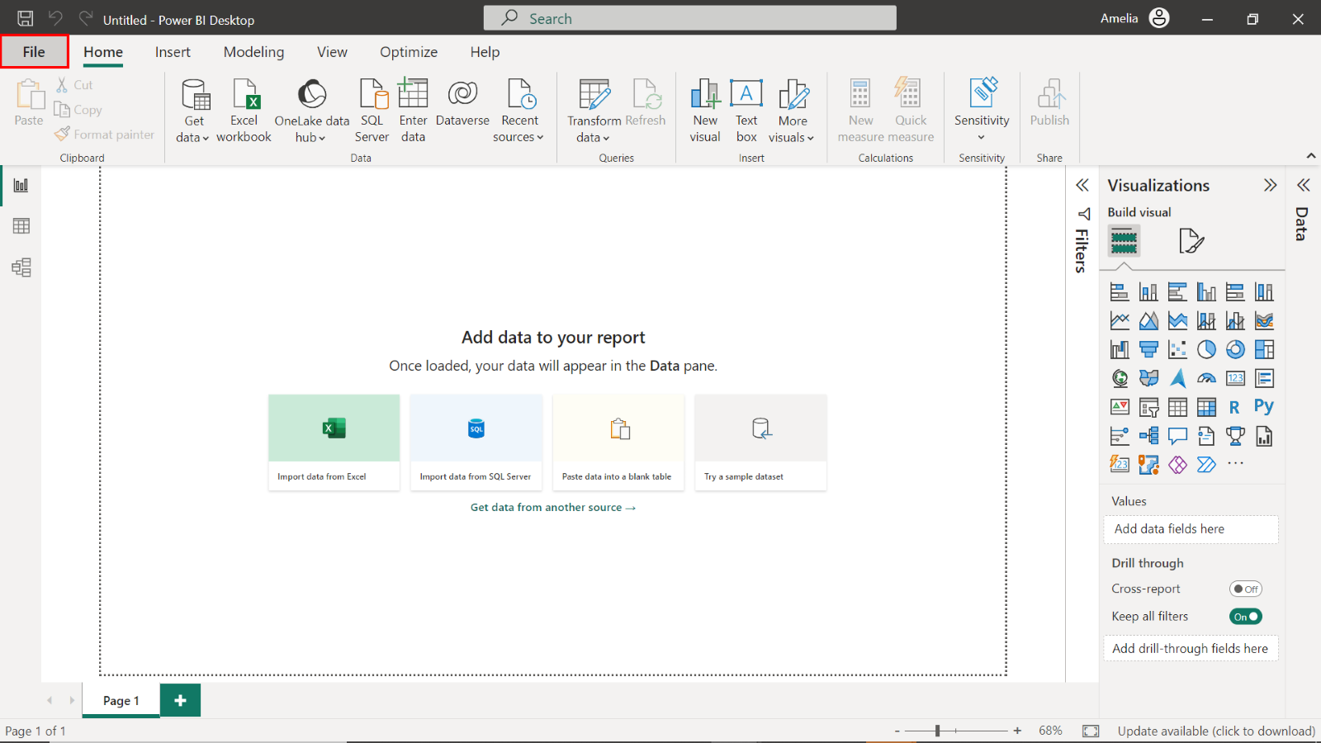

Navigate to the location where your **Tailwind Traders Report.pbix** file is saved.

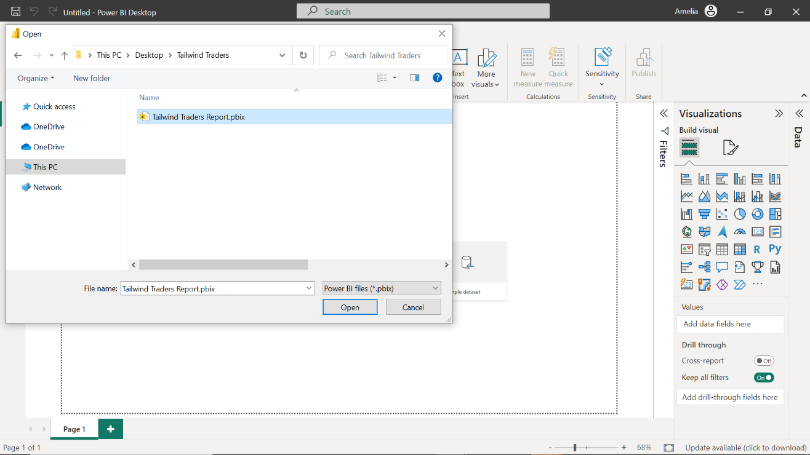

Select the **Tailwind Traders Report.pbix** file and select **Open** in the file explorer window. This action opens the saved project in the Power BI Desktop application.

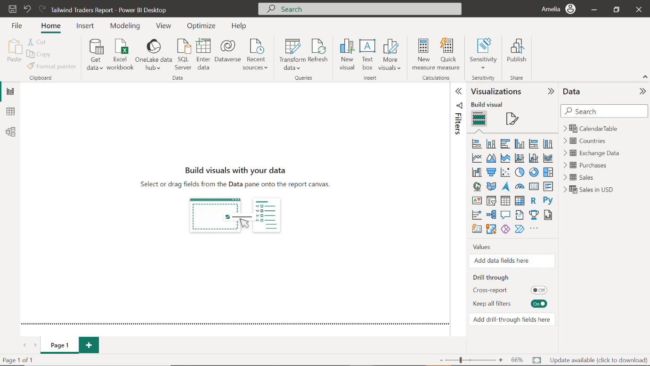

1. Rename the report **Sales Overview**.

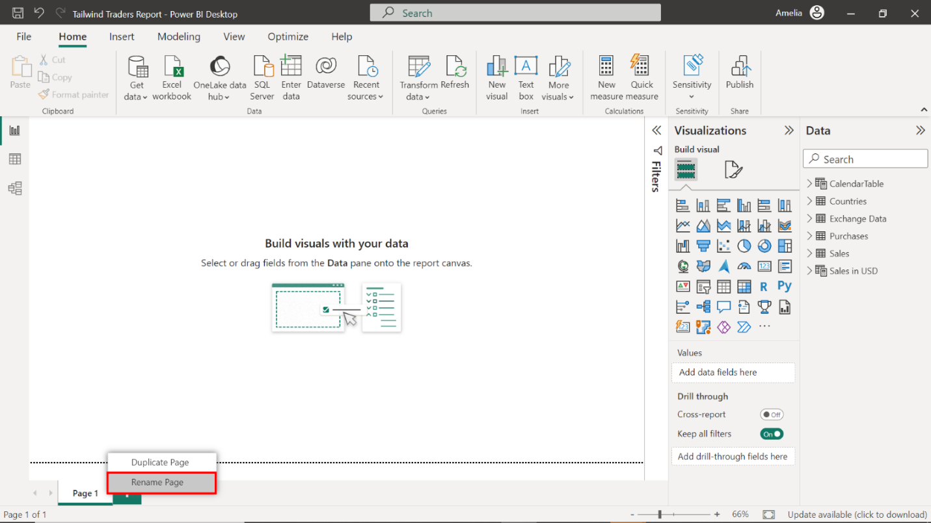

Right-click the page name and select **Rename Page** from the list of options. Rename the page to **Sales Overview**.

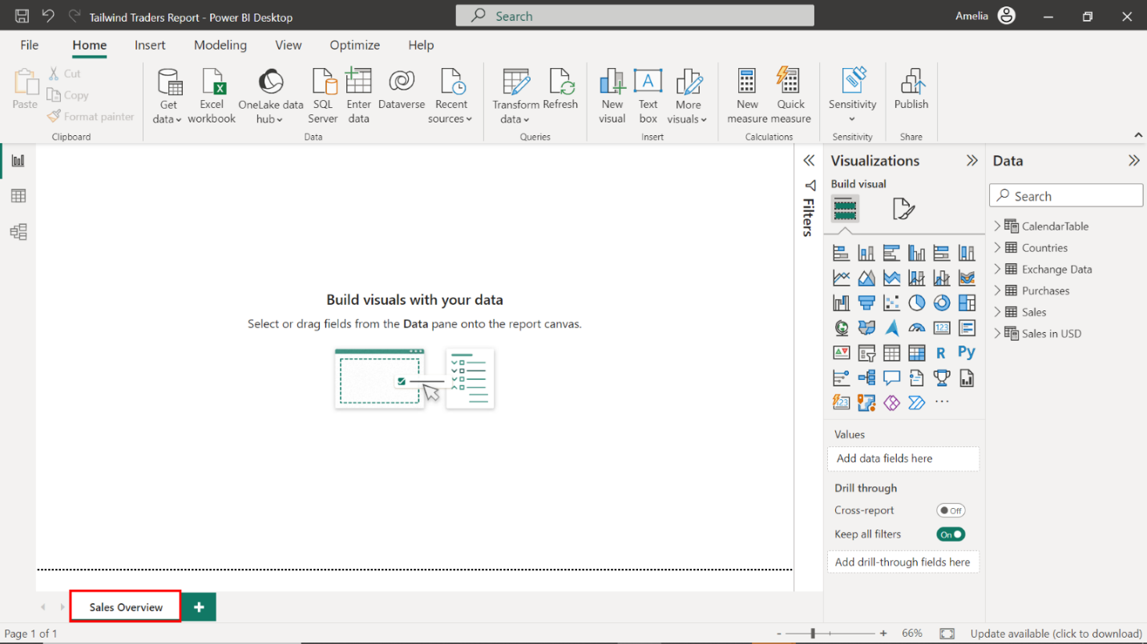

### Step 2: Create a bar chart for loyalty points by country

1. Create a clustered bar chart that visualizes loyalty points by country using data from the **Sales in USD** table.

Locate the **Visualizations** pane on the right-hand side of your screen. Select the **Clustered bar chart** icon to create an empty bar chart visualization on the canvas.

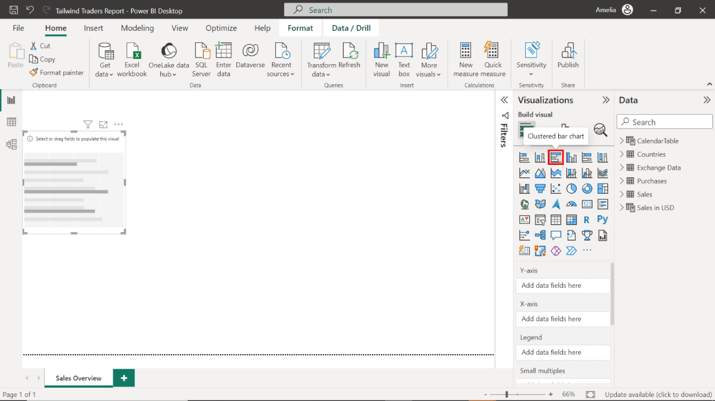

1. Configure the chart as follows:

* Display the country names on the Y-Axis.
* Display the loyalty points on the X-Axis.
* Resize and position the chart to the left side of the canvas.
* Title the chart **Loyalty Points by Country**.
* Toggle on the data labels.

Locate the **Fields** pane on the right-hand side of the screen. This area contains the**Sales in USD** table. Select the table to expand it and view its fields.

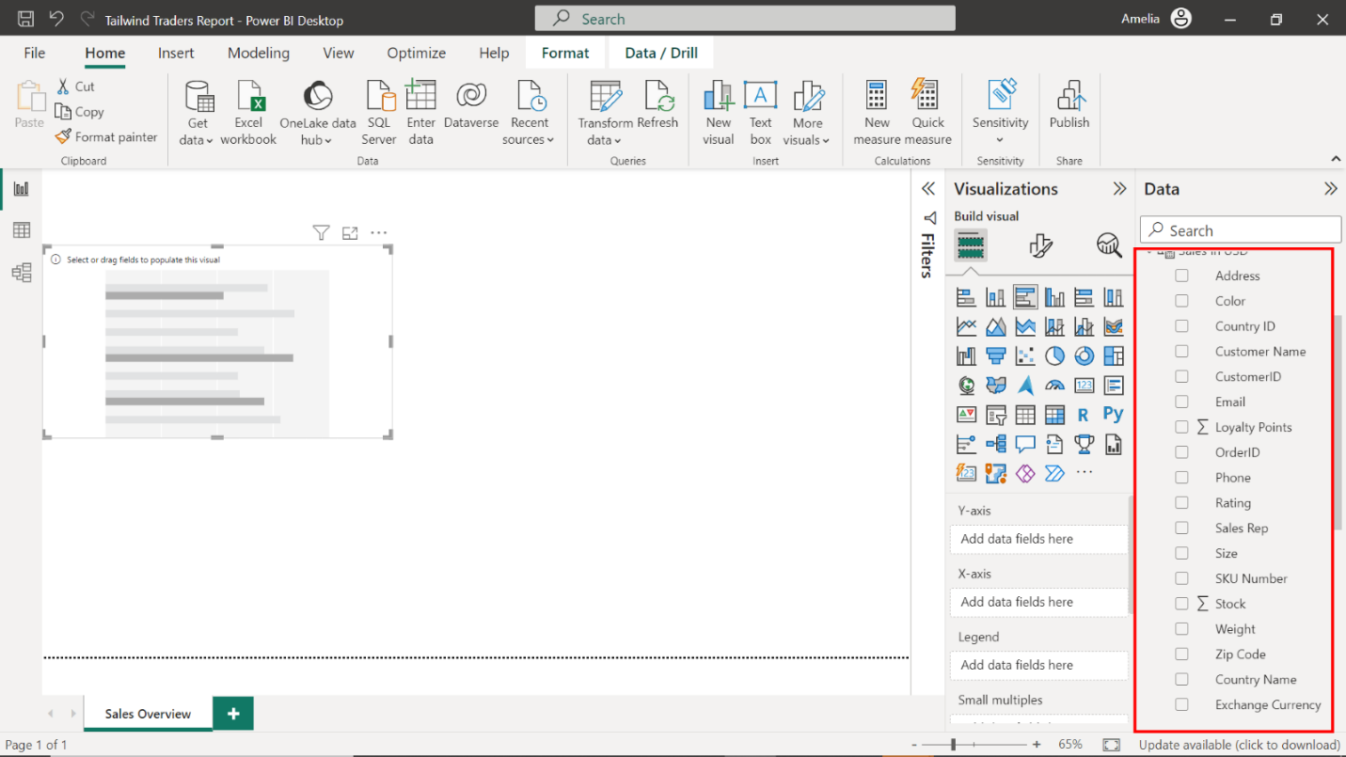

Drag the **Country Name** field from the **Fields** pane to the **Y-Axis** well in the **Visualizations** pane.

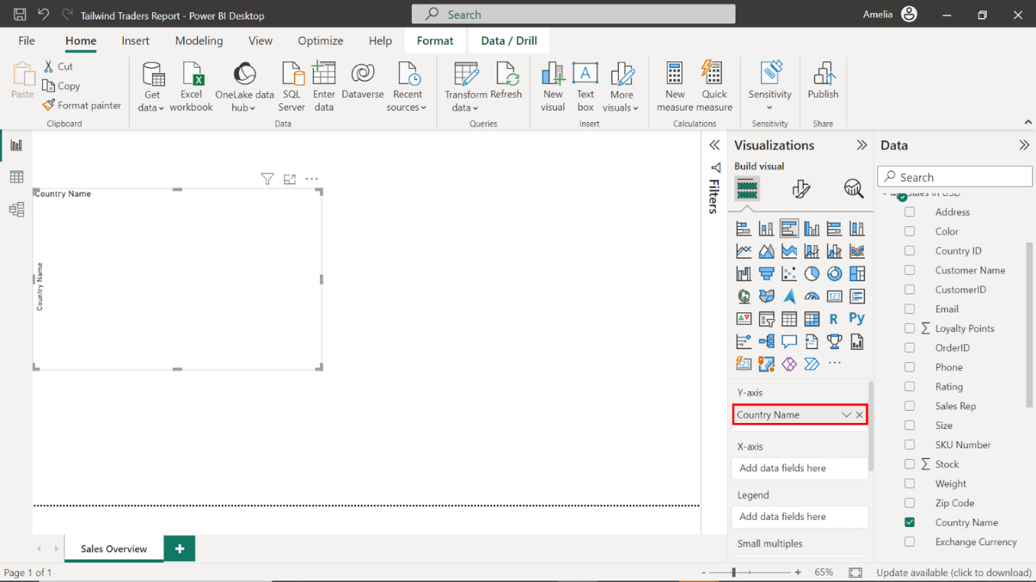

Next, drag the **Loyalty Points** field from the **Fields** pane to the **X-Axis** well in the **Visualizations** pane.

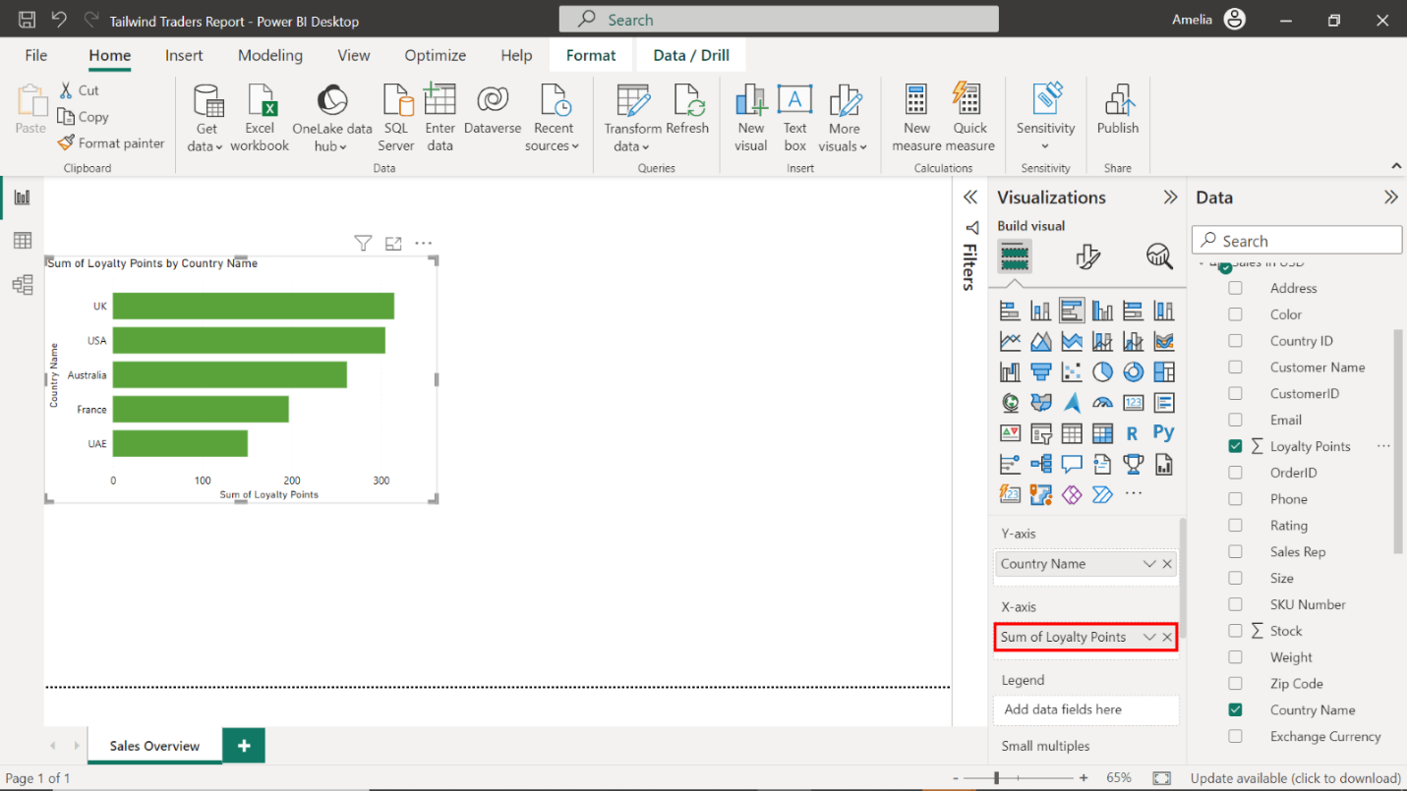

Select the edges of the bar chart on your canvas to resize it and place it on the left side of the canvas.

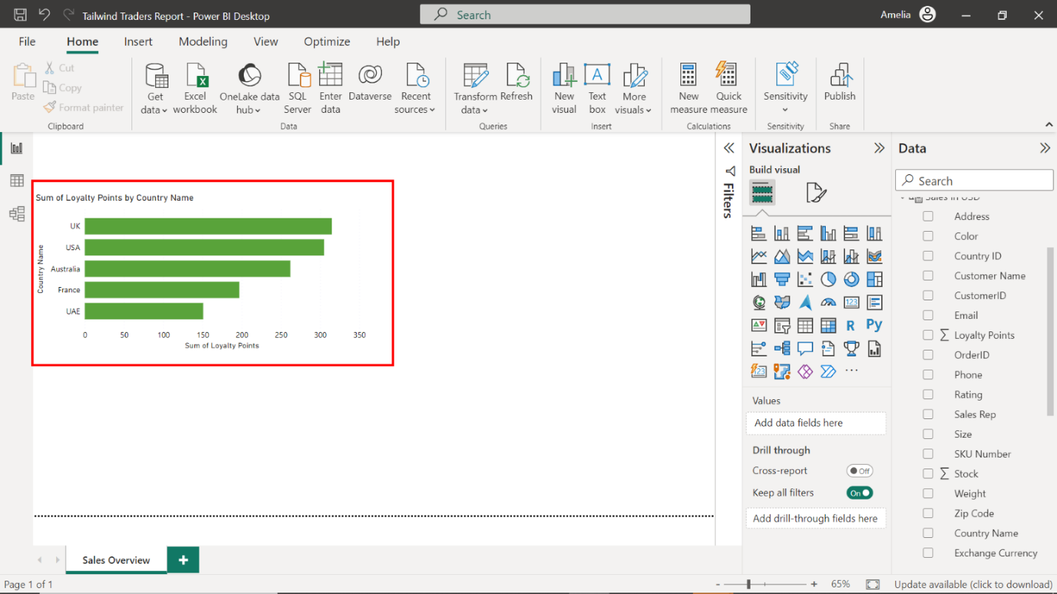

To format this visual, select the **Format** tab and title the chart **Loyalty Points by Country**.

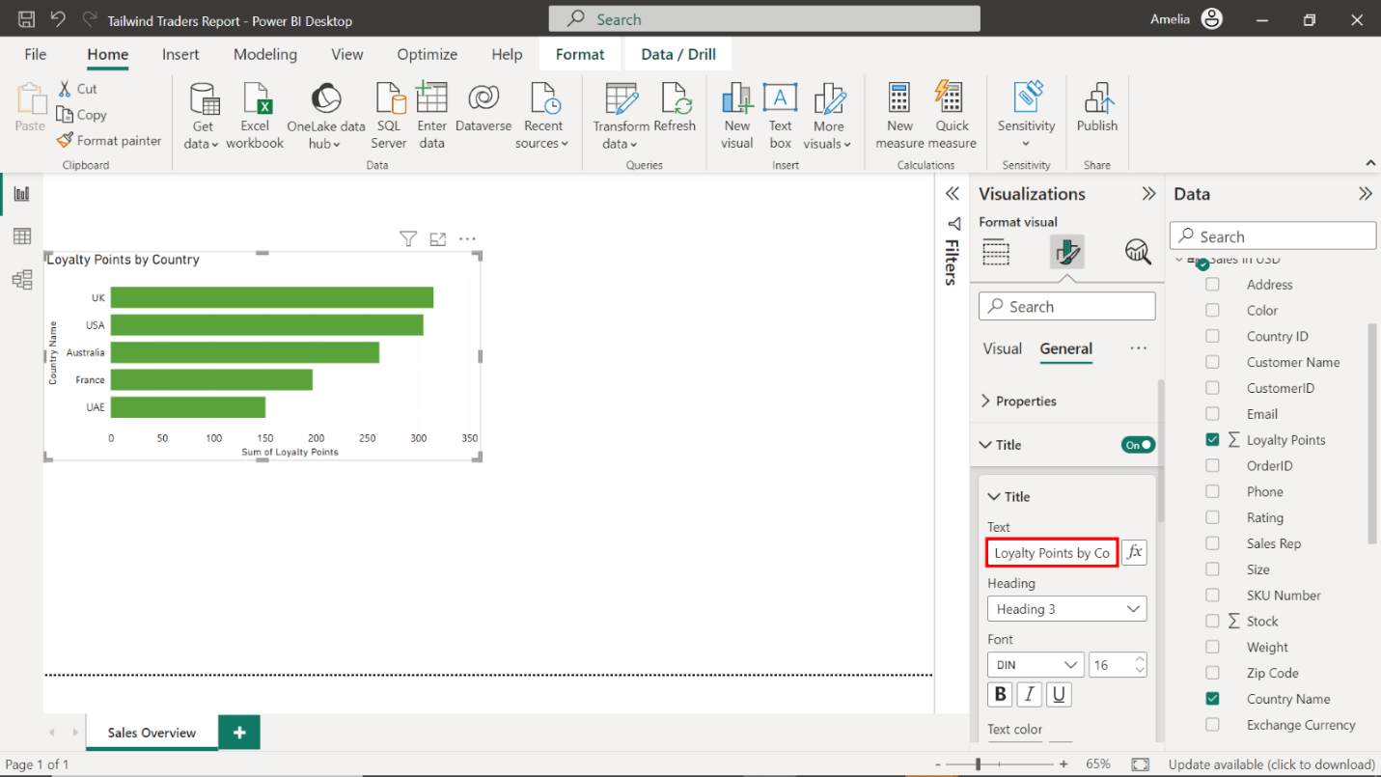

Next, select **Data labels** and toggle the switch **ON**to display the loyalty points on each bar.

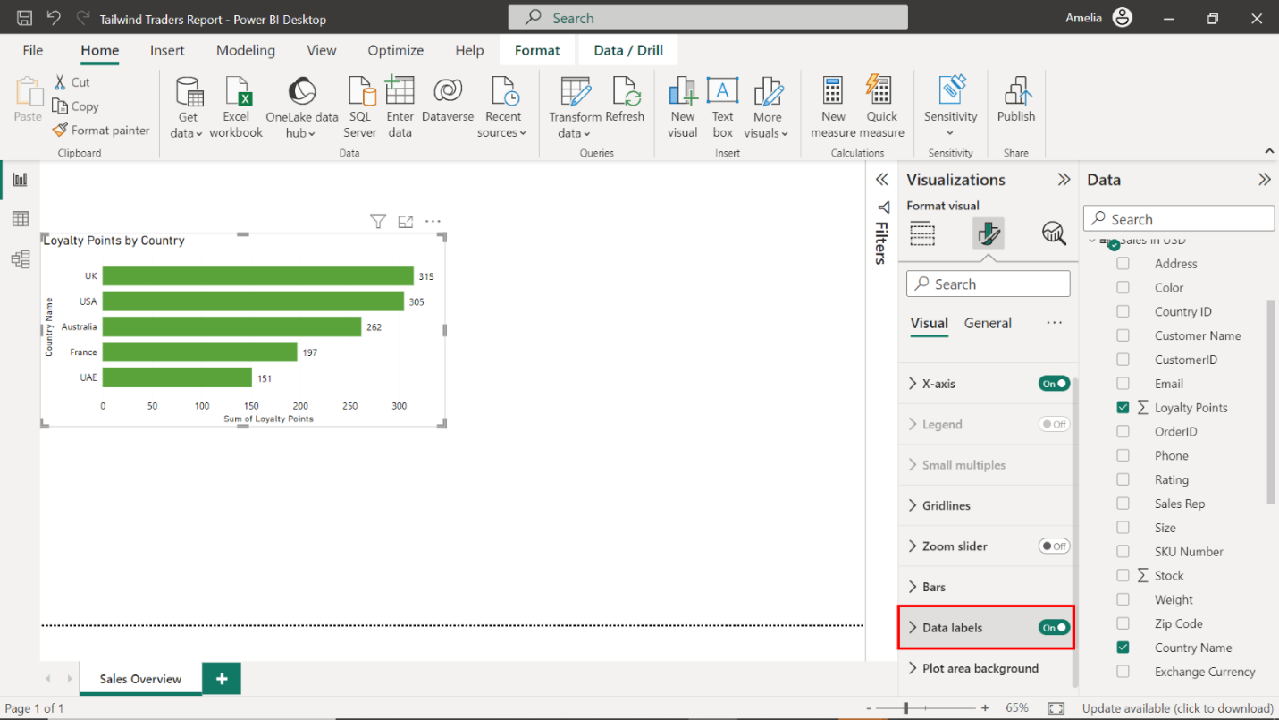

Note down the country with the highest **Loyalty Points** value. The **UK** leads the chart with **315** loyalty points.

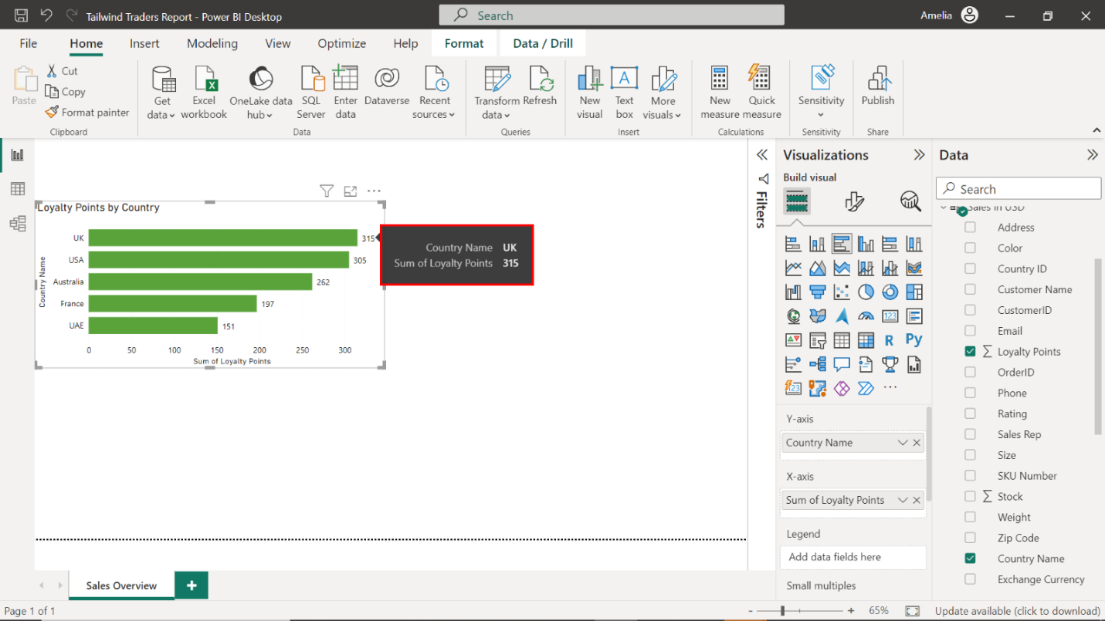

### Step 3: Create a column chart for Quantity Sold by Product

1. Create a clustered column chart that visualizes the quantity sold by product using data from the **Sales in USD** table.

Select the **Clustered column chart** icon from the **Visualizations** pane to create an empty column chart visualization on the canvas.

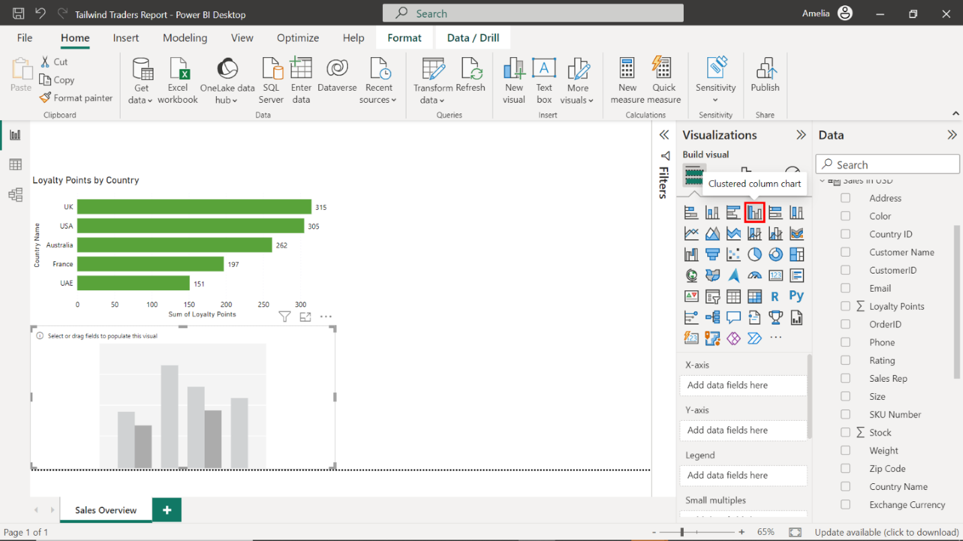

1. Configure the chart as follows:

* Display the product names on the Y-Axis.
* Display the quantity purchased on the X-Axis.
* Resize and position the chart to the right of the **Loyalty Points by Country** bar chart.
* Title the chart **Quantity Sold by Product**.
* Toggle on the data labels.

Locate the **Sales in USD** table on the right-hand side of the screen. Drag the **Product Name** field from the **Fields** pane to the **X-Axis** well in the **Visualizations** pane. Next, drag the **Quantity Purchased** field from the **Fields** pane to the **Y-Axis** well in the **Visualizations** pane.

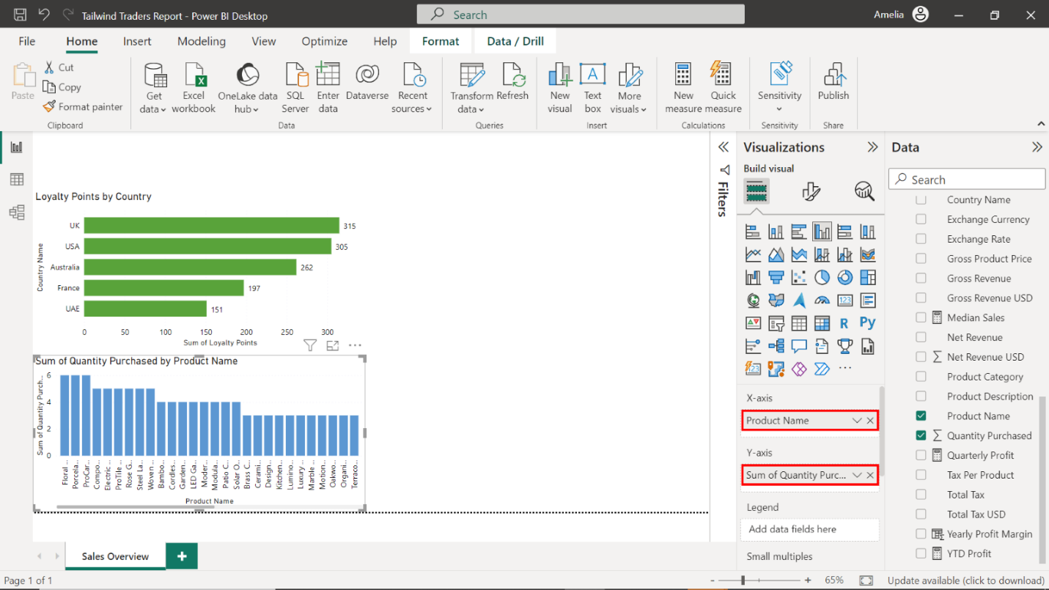

Select the edges of the visualization on your canvas to resize it, and place it on the right, next to the **Loyalty Points by Country** bar chart.

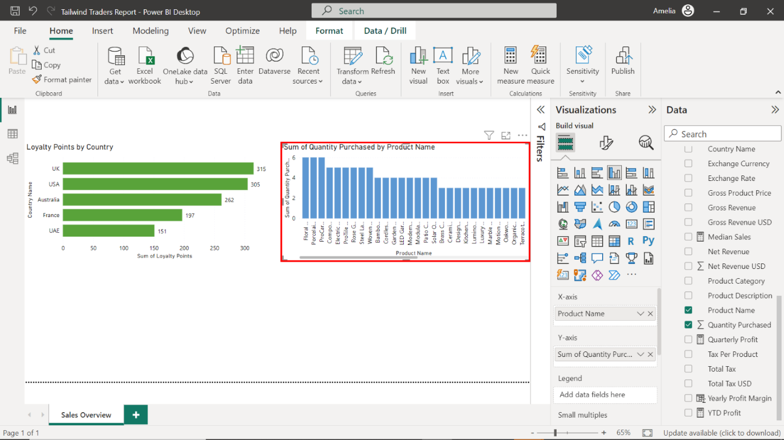

Navigate to the **Format** options and title the chart **Quantity Sold by Product**.

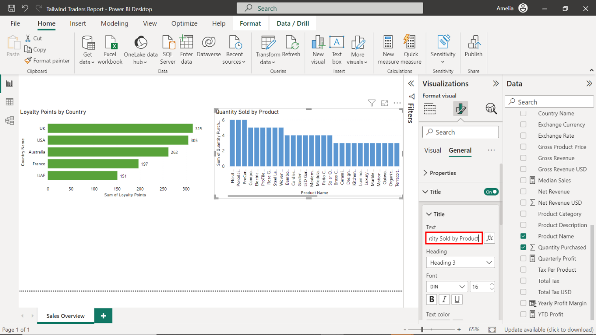

Select **Data labels** and toggle the switch **ON** to display the quantity sold on each column.

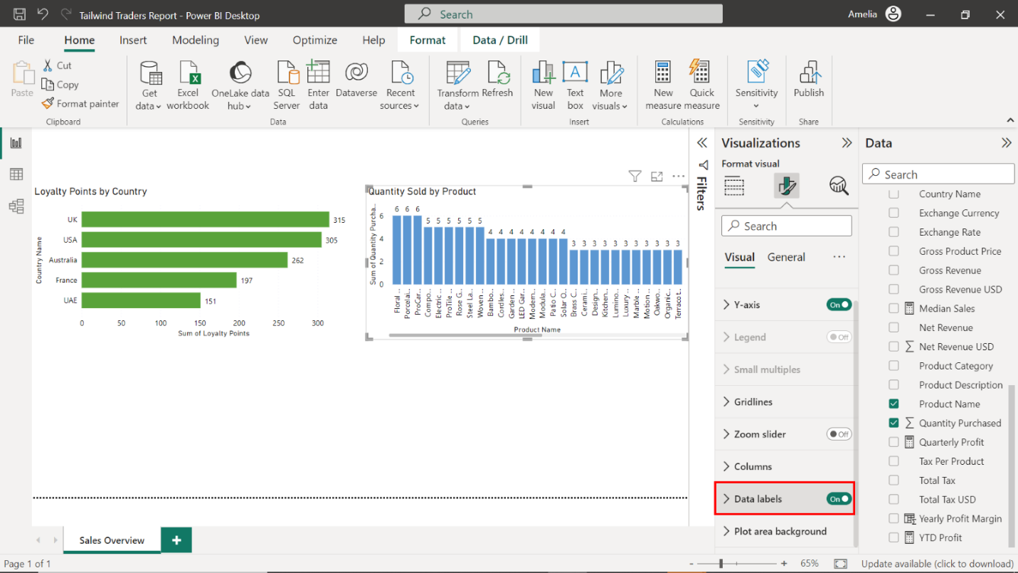

### Step 4: Create a pie chart for median sales distribution by country

1. Create a pie chart that visualizes median sales distribution by country using data from the **Sales in USD** table.

Select the **Pie chart** icon from the **Visualizations** pane to create an empty pie chart visualization on the canvas.

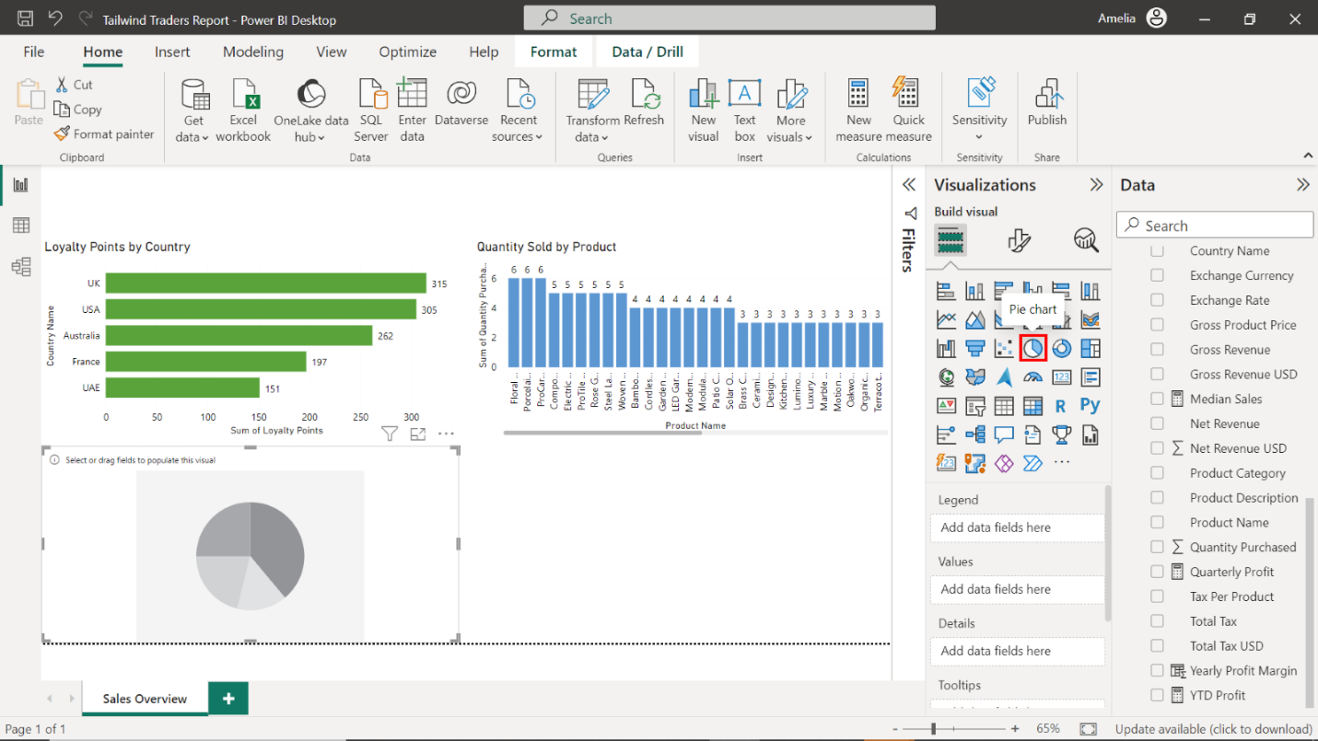

1. Configure the chart as follows:

* Display the country names in the **Legend** area.
* Display the median sales in the **Values** area.
* Adjust the chart size and position it below the **Loyalty Points by Country** bar chart.
* Title the chart **Median Sales Distribution by Country**.
* Display detailed labels.

Locate the **Sales in USD** table on the right-hand side of the screen and drag the **Country Name** field from the **Fields** pane to the **Legend** well in the **Visualizations** pane. Then, drag the **Median Sales** field from the **Fields** pane to the **Values** well in the **Visualizations** pane.

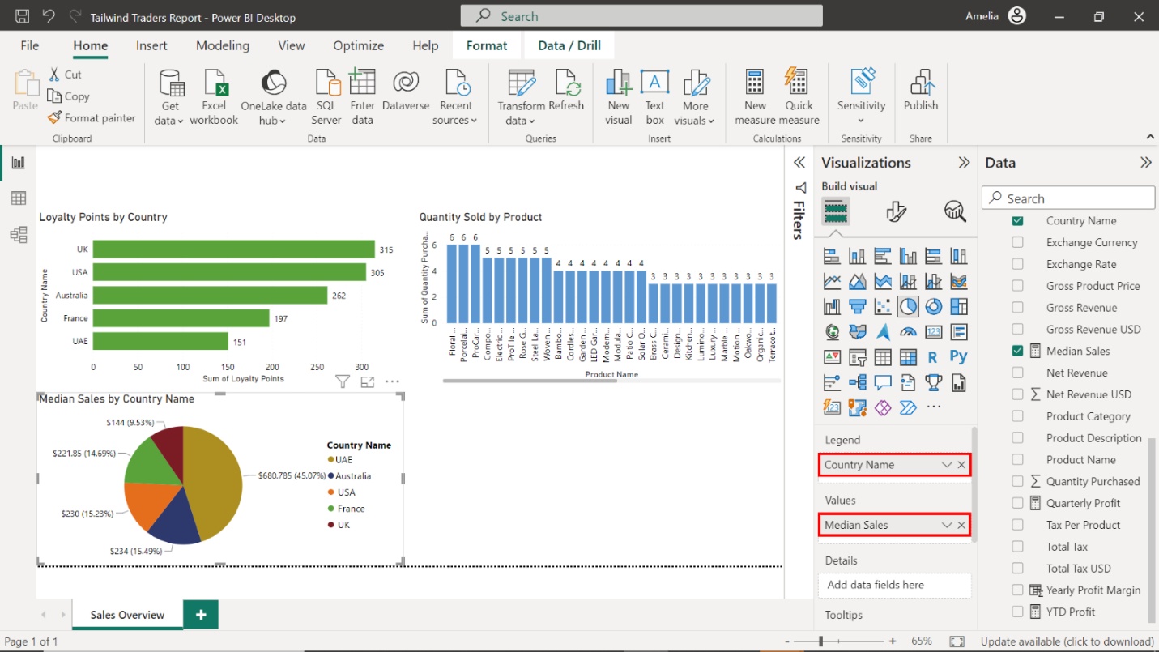

Select the edges of the visualization on your canvas to resize it, and place it below the **Loyalty Points by Country** bar chart.

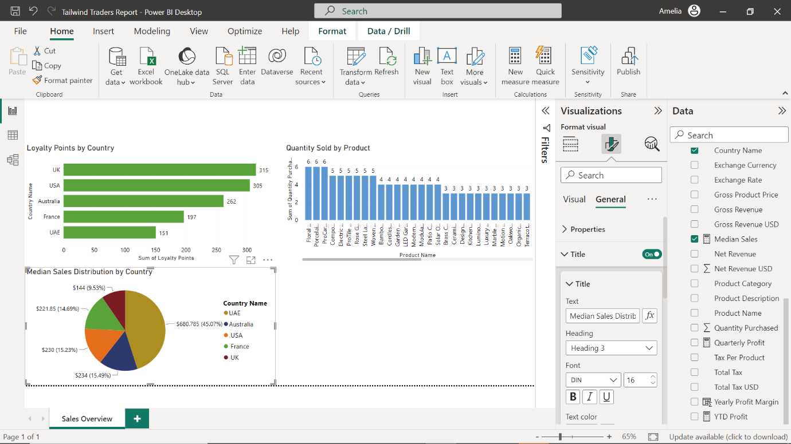

Title the chart **Median Sales Distribution by Country**.

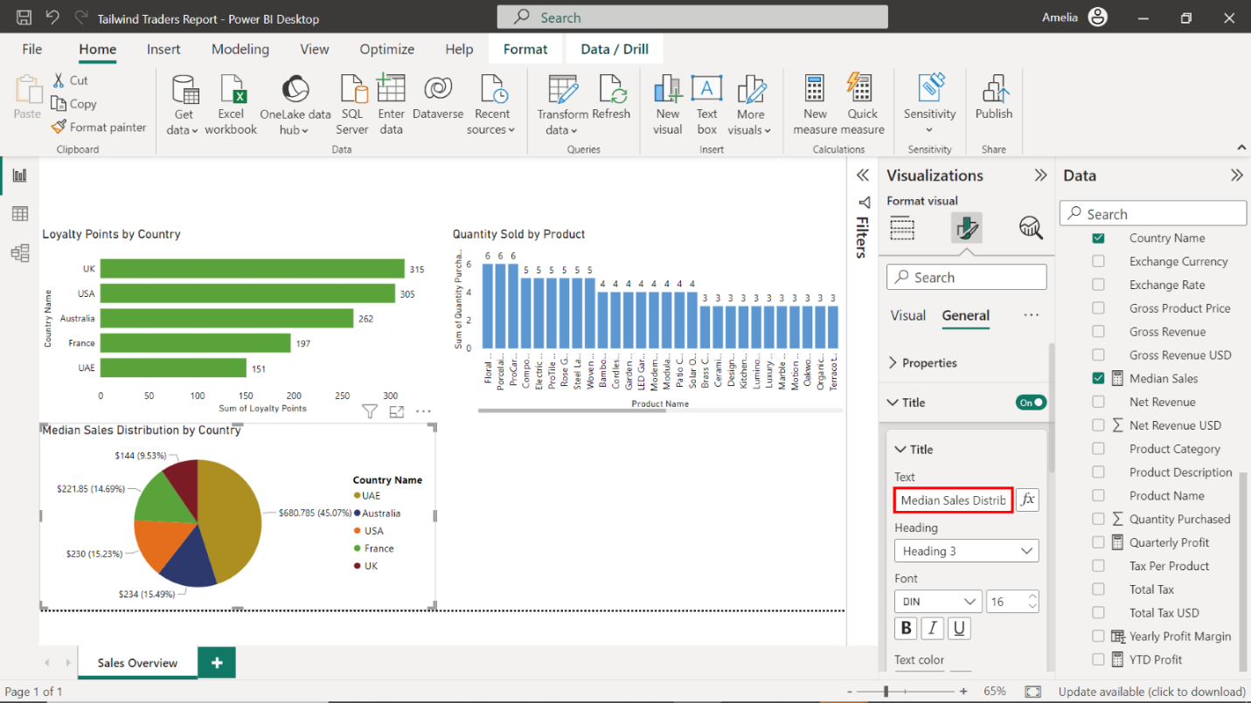

Select **Detailed labels**,and from the dropdown, select **All detail labels**.

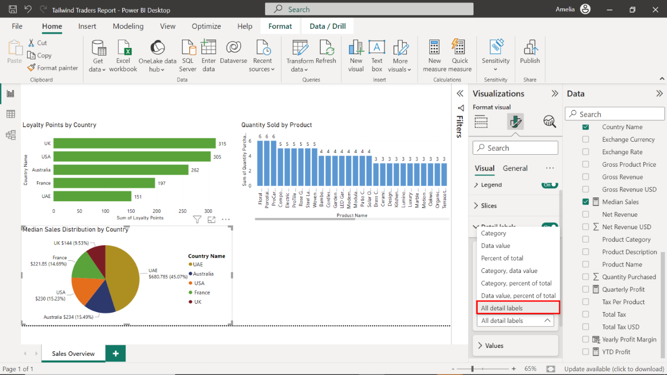

1. Sort the data in ascending order.

Select the ellipses located at the top right corner of the visualization. Select the **SortAxis** dropdown, then select **Sort ascending**.

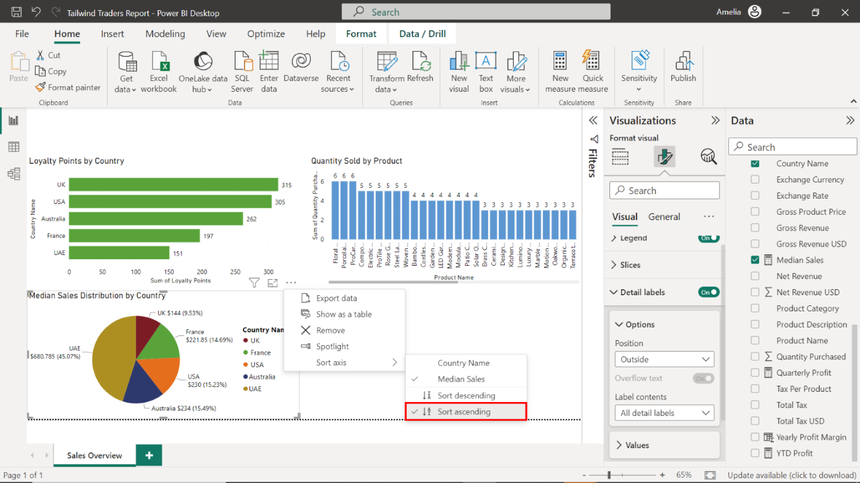

### Step 5: Create a line chart for median sales over time

1. Create a line chart that visualizes median sales over time using data from the **Sales in USD** table.

Select the **Line chart** icon from the **Visualizations** pane to create an empty line chart visualization on the canvas.

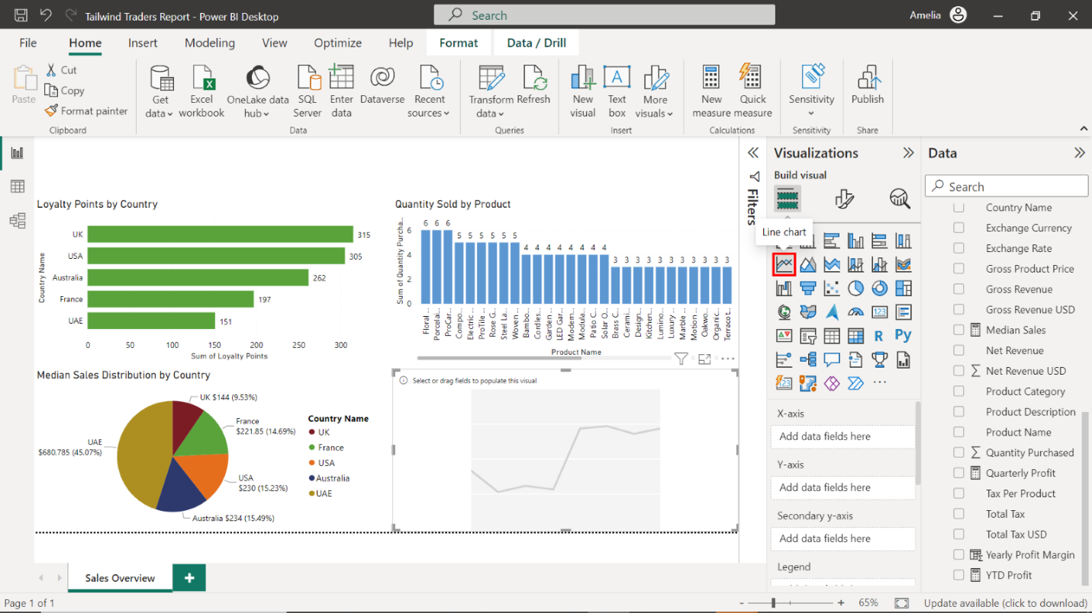

1. Configure the chart as follows:

* Display date data on the X-axis.
* Display median sales data on the Y-axis.
* Adjust and position the chart below the **Quantity Sold by Product** column chart.
* Title the chart **Median Sales Over Time**.
* Toggle on the data labels.

Locate the **CalendarTable** on the right-hand side of the screen. Drag the **Date** field from the **Fields** pane to the **X-Axis** well in the **Visualizations** pane.

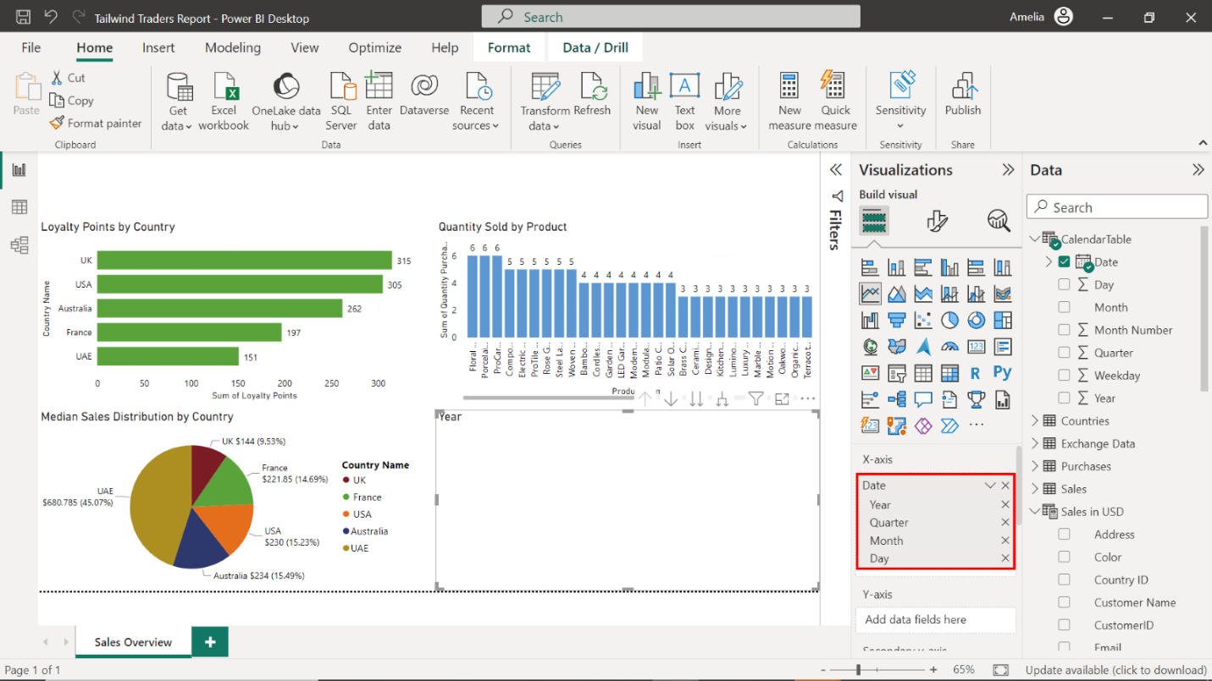

Locate the **Sales in USD** table and drag the **Median Sales** field from the **Fields** pane to the **Y-Axis** well in the **Visualizations** pane.

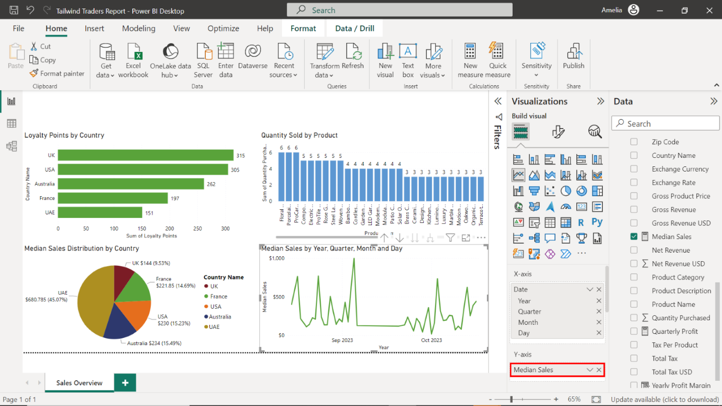

Select the edges of the visualization on your canvas to resize it, and place it below the **Quantity Sold by Product** column chart.

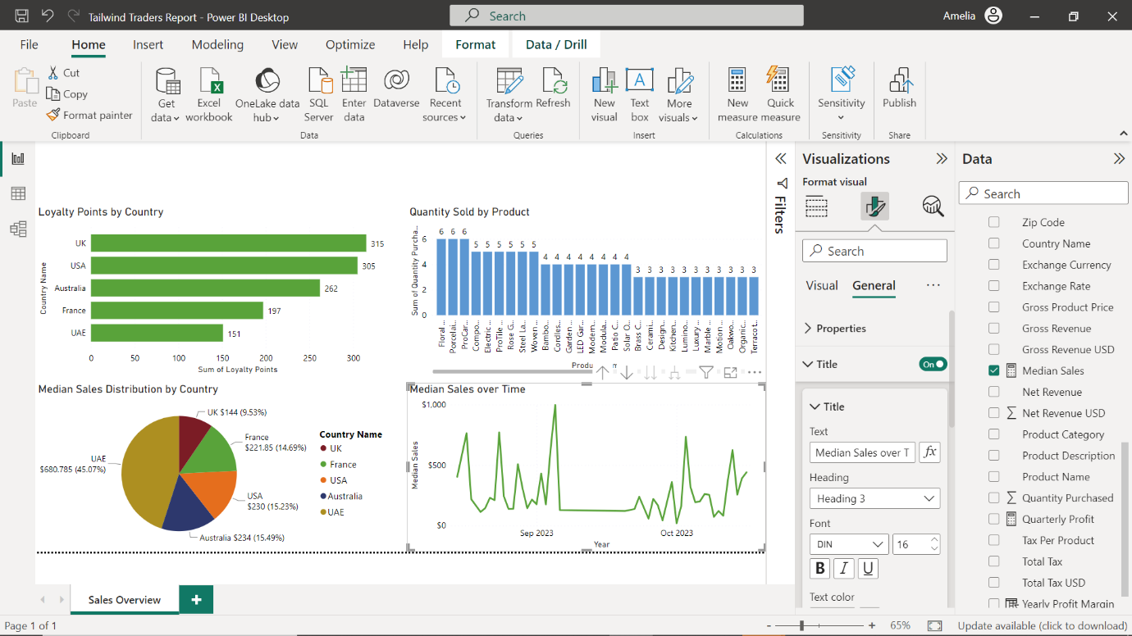

Title the chart **Median Sales over Time**.

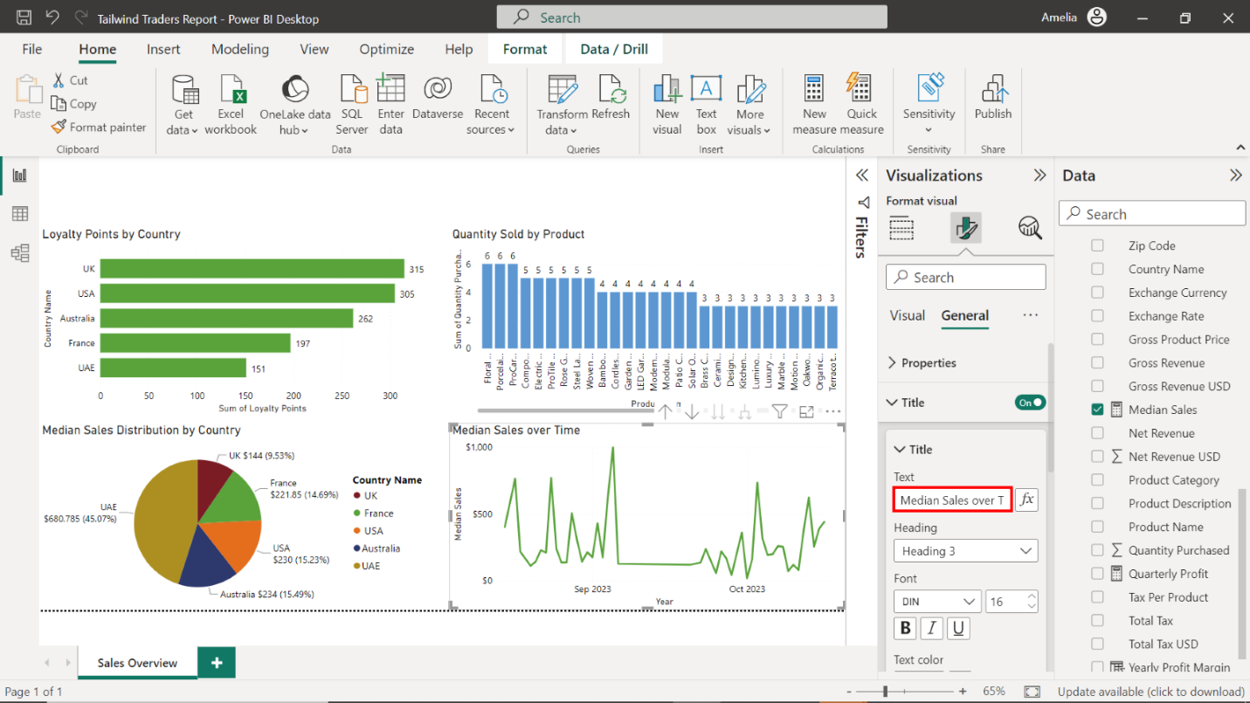

1. Configure an analytics forecast as follows:

* Set **Units** to **Days**.
* Set **Forecast Length** to **2**.
* Set **Confidence interval** to **99%**.

Select the **Analytics** tab, represented by a magnifying glass icon. Locate the **Forecast** option and toggle the switch beside it to add a forecast line to your chart.

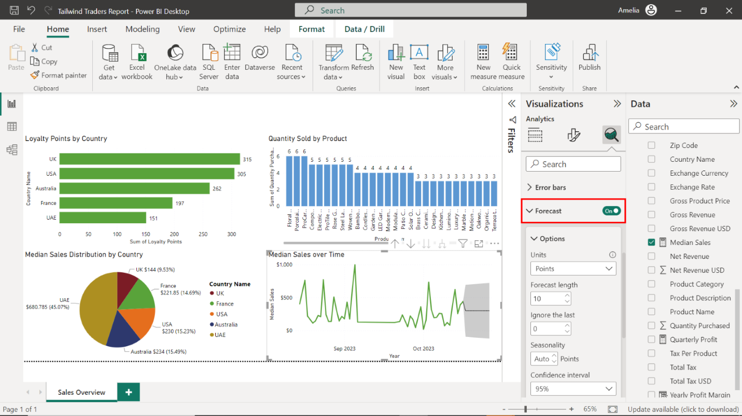

Set the **Units** to **Days**, **Forecast Length** to **2**, and the **Confidence interval** to **99%**. Select **Apply** to apply the changes. The forecasted line appears on your line chart in a different color with shading to indicate the confidence intervals.

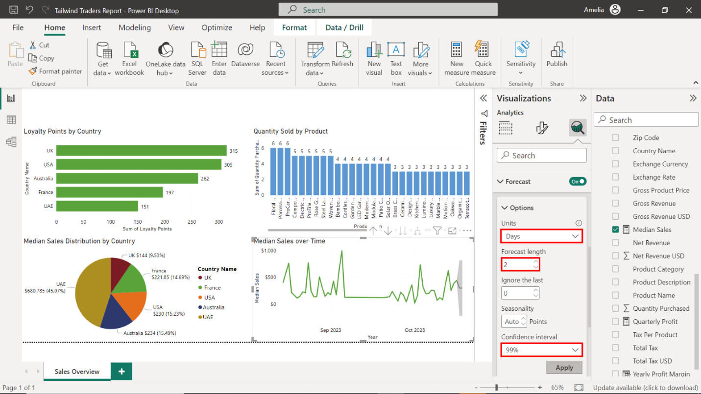

### Step 6: Create cards to visualize your measures

1. Create cards that visualize the following measures:

* **Stock**.
* **Quantity Purchased**.
* **Median Sales**.

Select the **Card** icon in the **Visualizations** pane while ensuring nothing is selected on the canvas. An empty Card visual appears on the canvas.

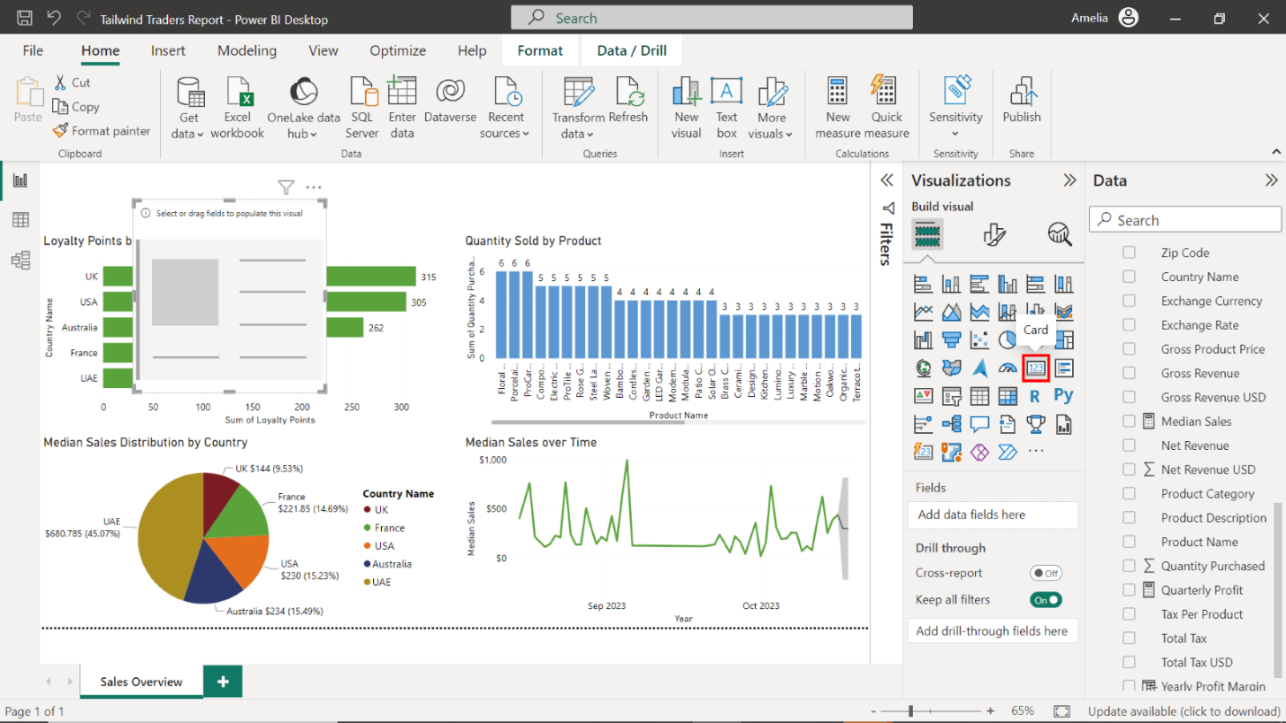

Locate the **Sales in USD** table and drag the **Sum of Stock** field to the **Fields** well in the **Visualizations** pane.

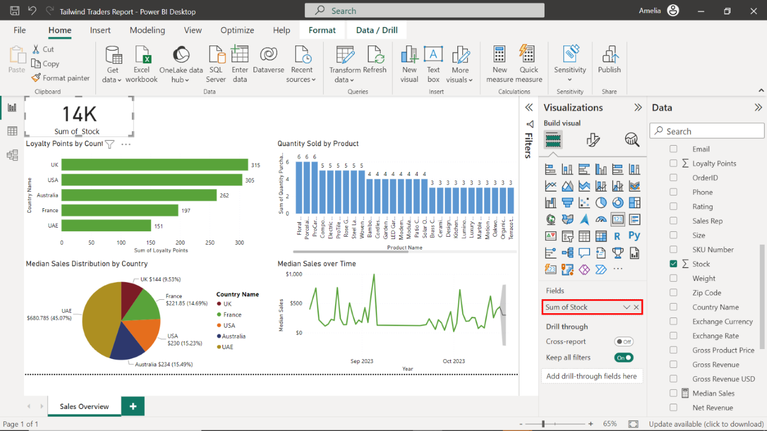

Repeat this process for the **Sum of Quantity Purchased** and **Median Sales** measures.

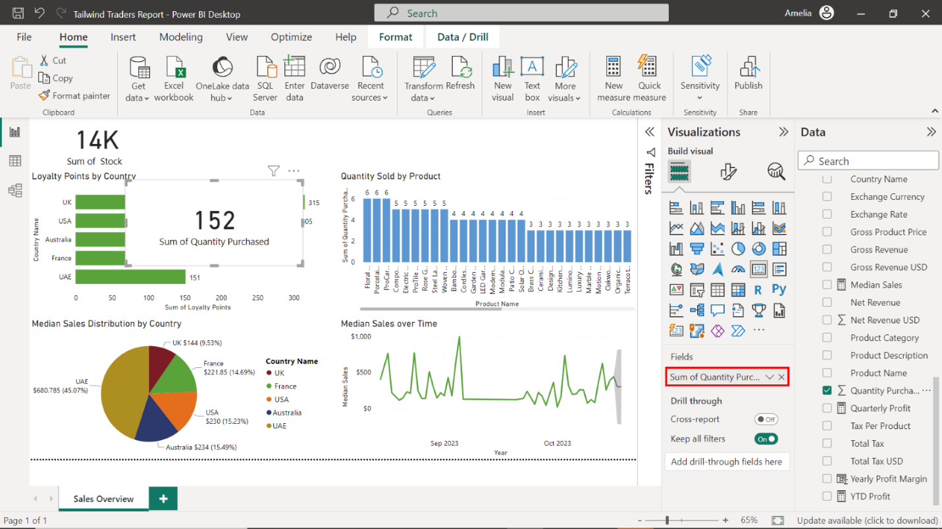

1. Position the cards as follows:

* Place the **Stock** and **Quantity Purchased** cards above the **Loyalty Points by Country** bar chart.
* Place the **Median Sales** card above the **Quantity Sold by Product** column chart.

Select the edges of the Stock and Quantity Purchased cards on your canvas to resize them. Place both cards above the **Loyalty Points by Country** bar chart.

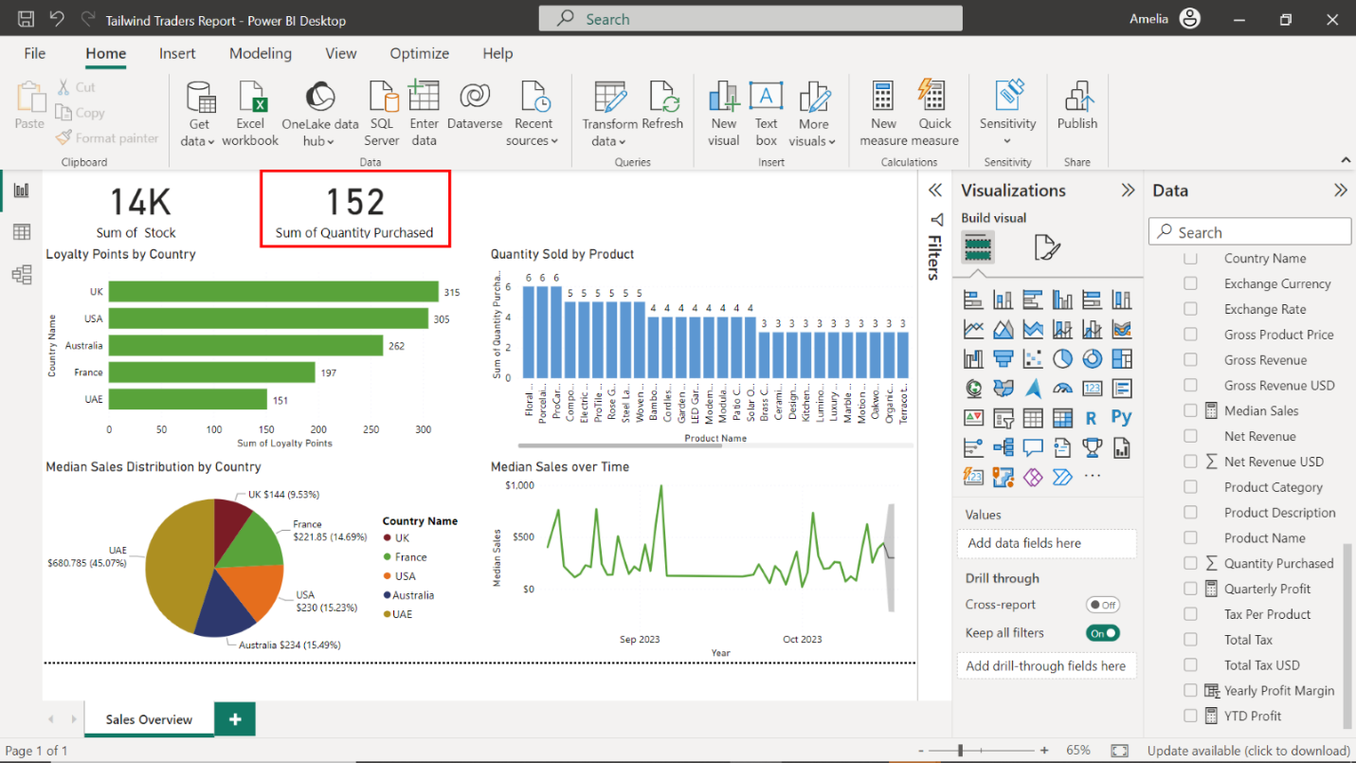

Repeat this process for the **Median Sales** card, placing it above the **Quantity Sold by Product** column chart.

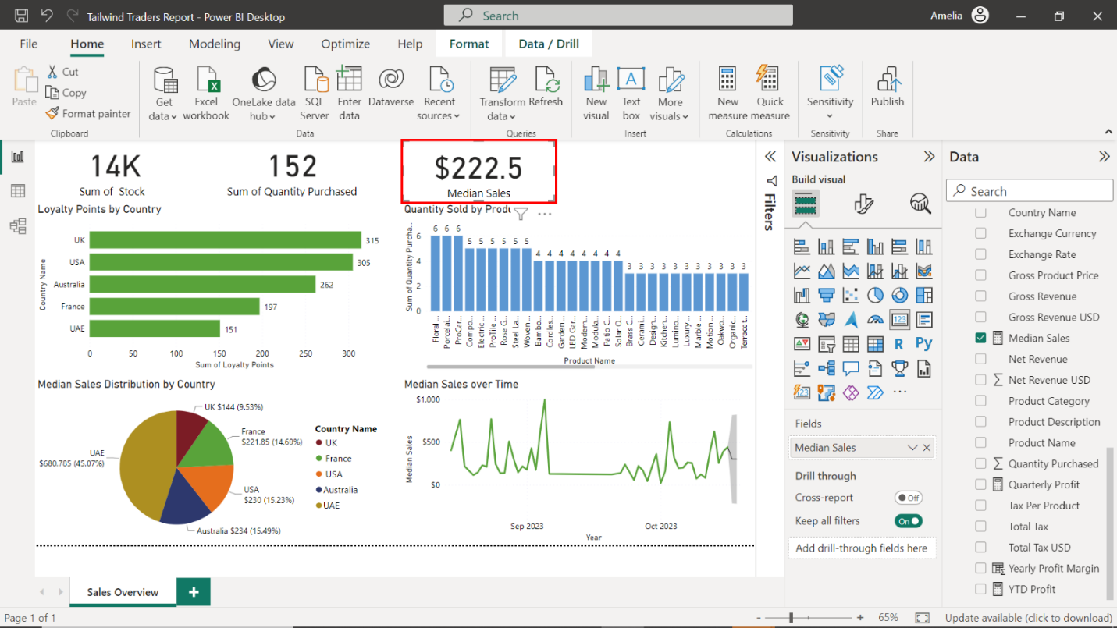

### Step 7: Add a slicer to the report

1. Create a slicer that displays the **Country Name** data from the **Sales in USD** table.

In the **Visualizations** pane, select the **Slicer** icon and drag the **Country Name** field from the **Sales in USD** table to the **Field** area.

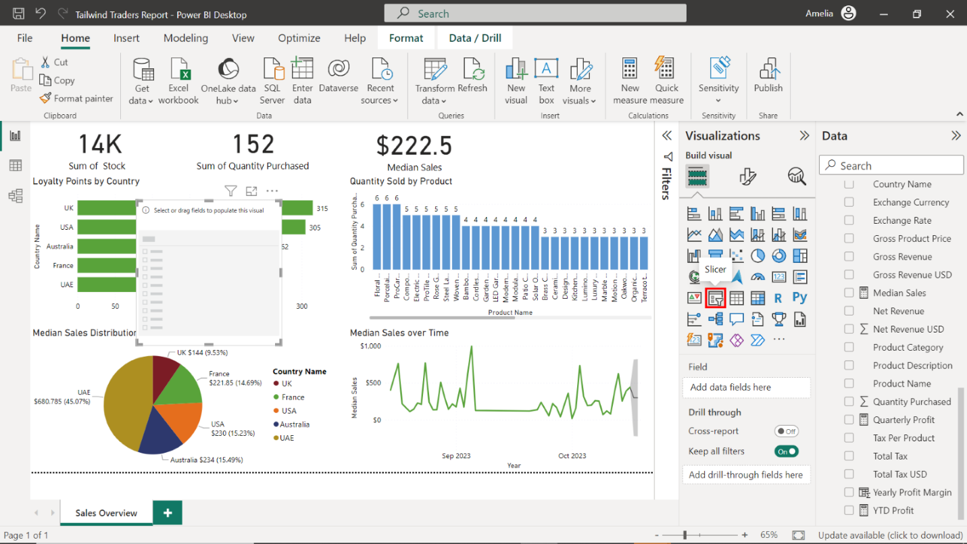

1. Position the slicer above the **Quantity Sold by Product** column chart.

Select the edges of the slicer to resize it. Place it above the **Quantity Sold by Product** column chart.

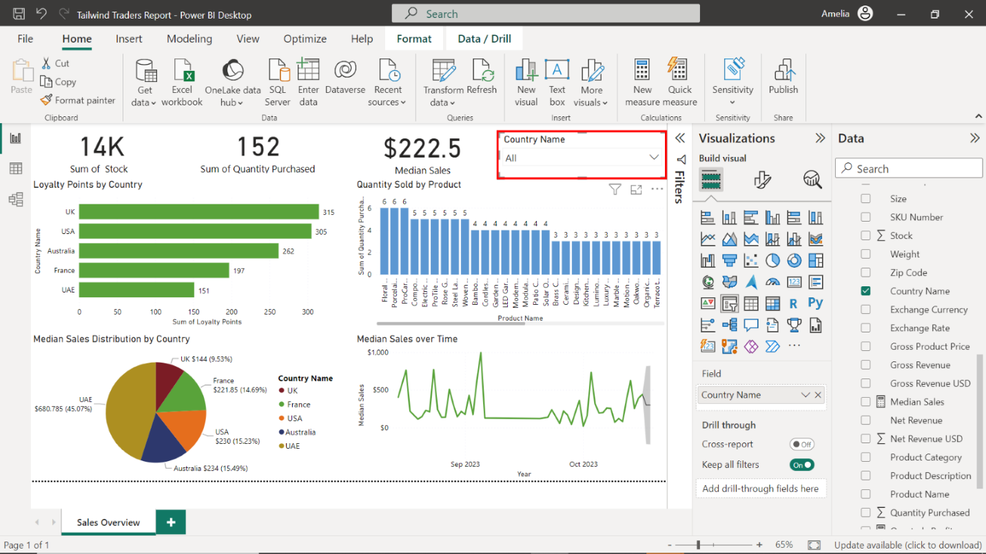

1. Save your report.

Select the **disk icon** on the top left of the window to save the report.

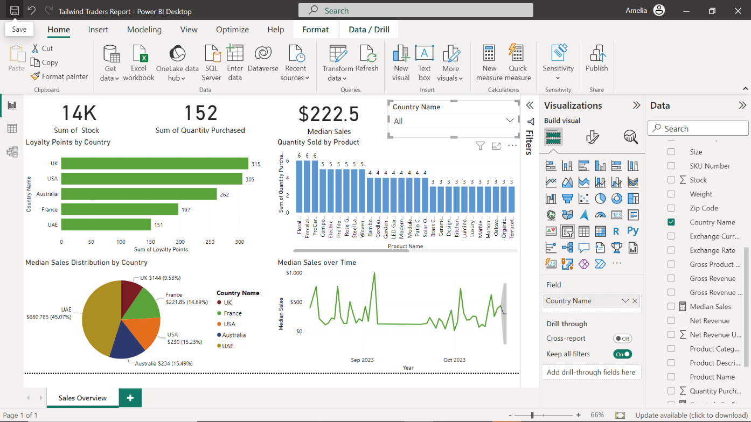

## Exercise 3: Create a Profit report

### Step 1: Create Profit Overview report

1. Open your **Sales Overview** report.

Open the **Sales Overview** report within Power BI.

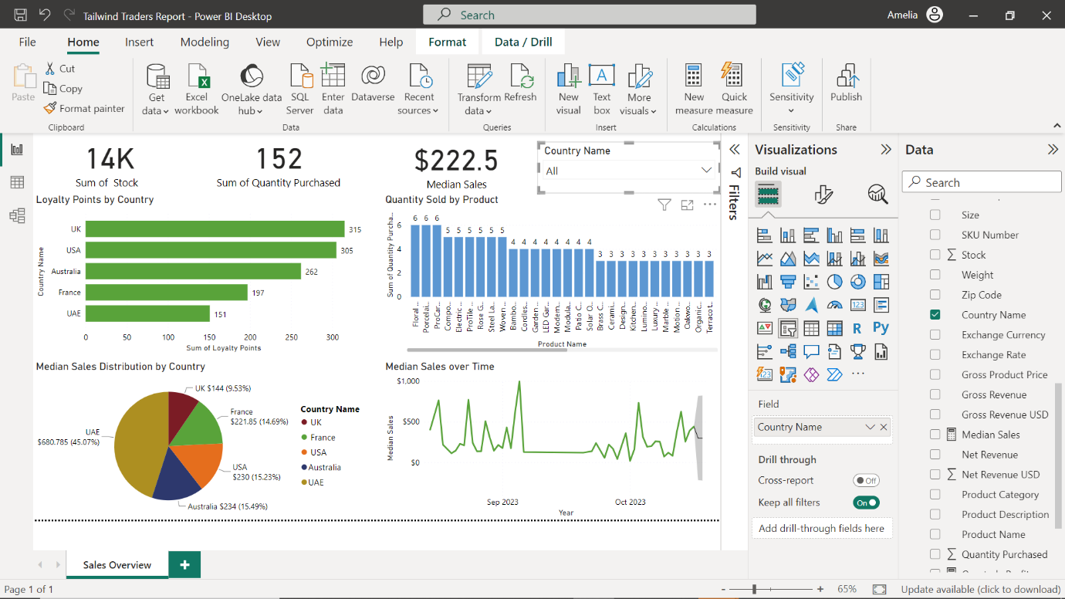

1. Create a new page in your existing **Sales Overview** report and name it**Profit Overview**.

To add a new page, select the **New Page** option.

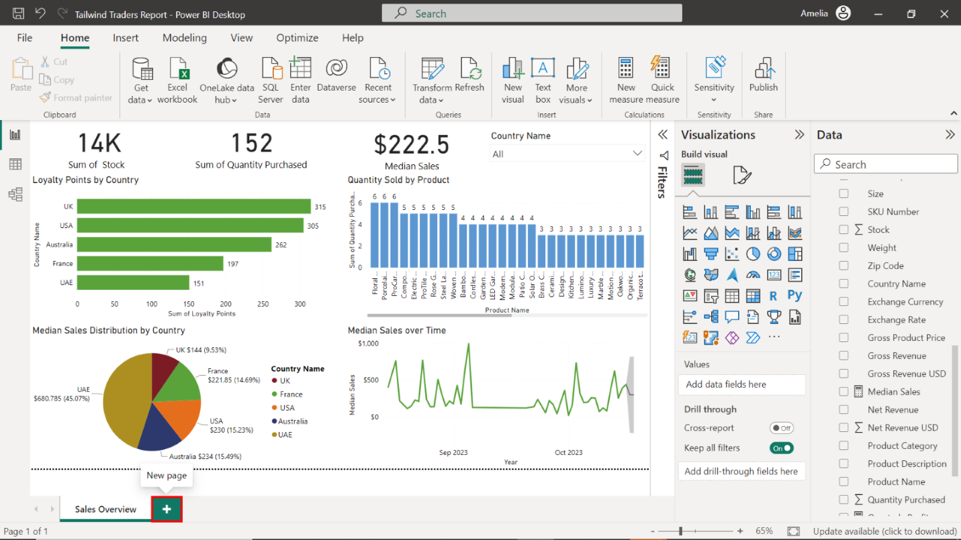

Right-click the new page, select the **Rename** option, and title the report **Profit Overview**.

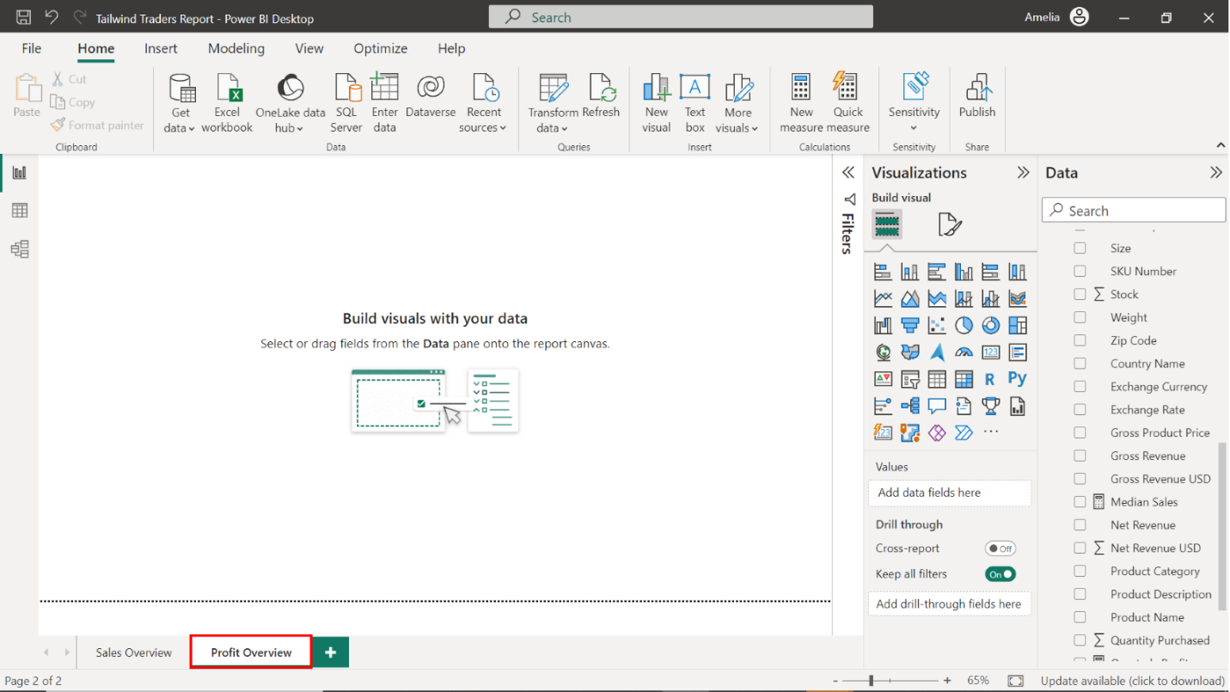

### Step 2: Create a bar chart for Net Revenue by Product

1. Create a clustered bar chart that visualizes **Net Revenue** using data from the **Product Sales in USD** table.

Locate the **Visualizations** pane on the right-hand side of your screen. Select the **Clustered bar chart** icon to create an empty bar chart visualization on the canvas.

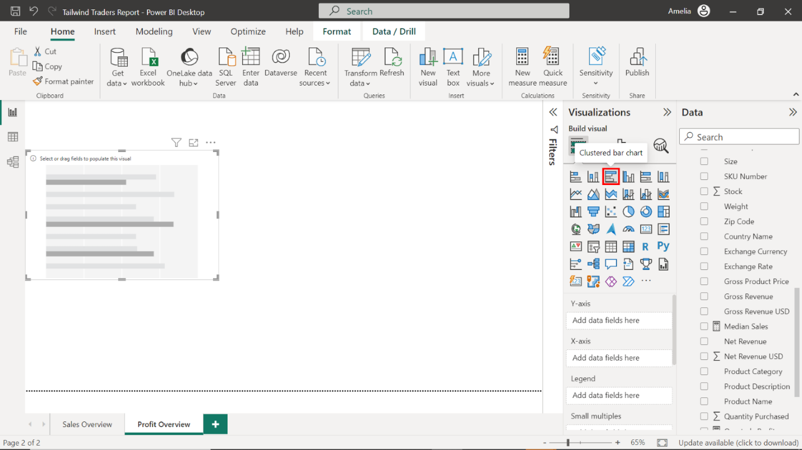

1. Configure the chart as follows:

* Display the **Product Name** on the Y-Axis.
* Display the **Net Revenue USD** on the X-Axis.
* Resize and position the chart to the left side of the canvas.
* Title the chart **Net Revenue by Product**.
* Toggle on the data labels.

Locate the **Product Name** table on the right-hand side of the screen. Drag the **Product Name** field from the **Fields** pane to the **Y-Axis** well in the **Visualizations** pane. Next, drag the **Net Revenue USD** field from the **Fields** pane to the **X-Axis** well in the **Visualizations** pane.

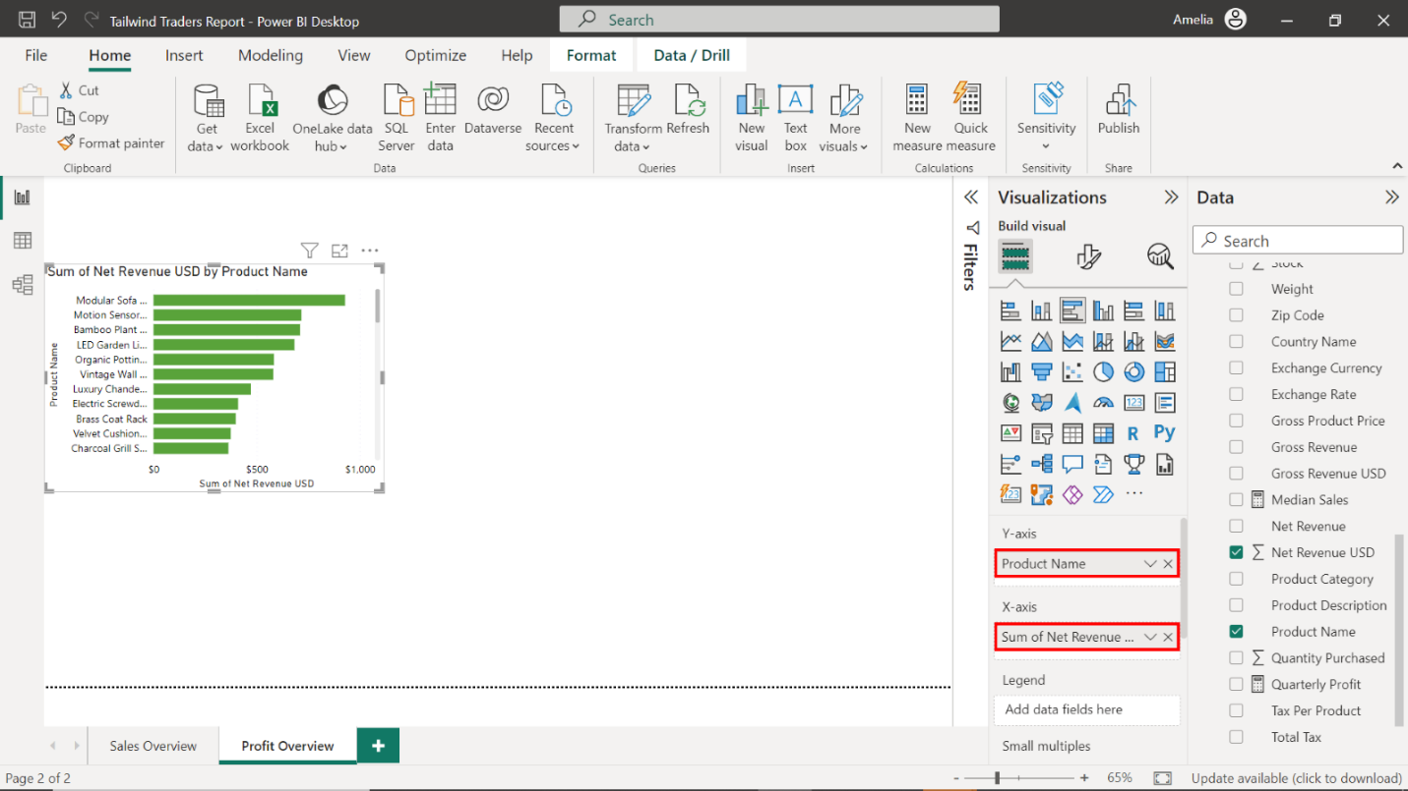

Select the edges of the visualization to resize it and place it on the left side of the canvas.

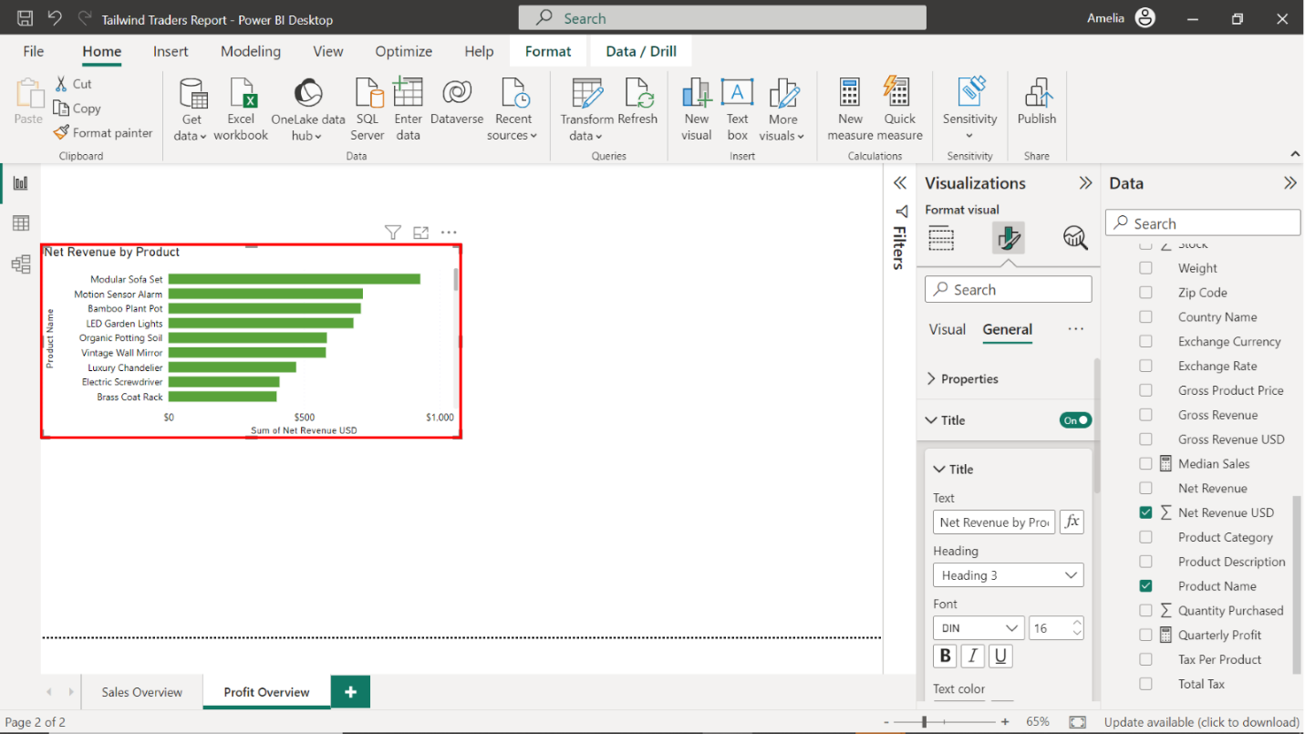

To format this visual, select the **Format** tab and title the chart **Net Revenue by Product**.

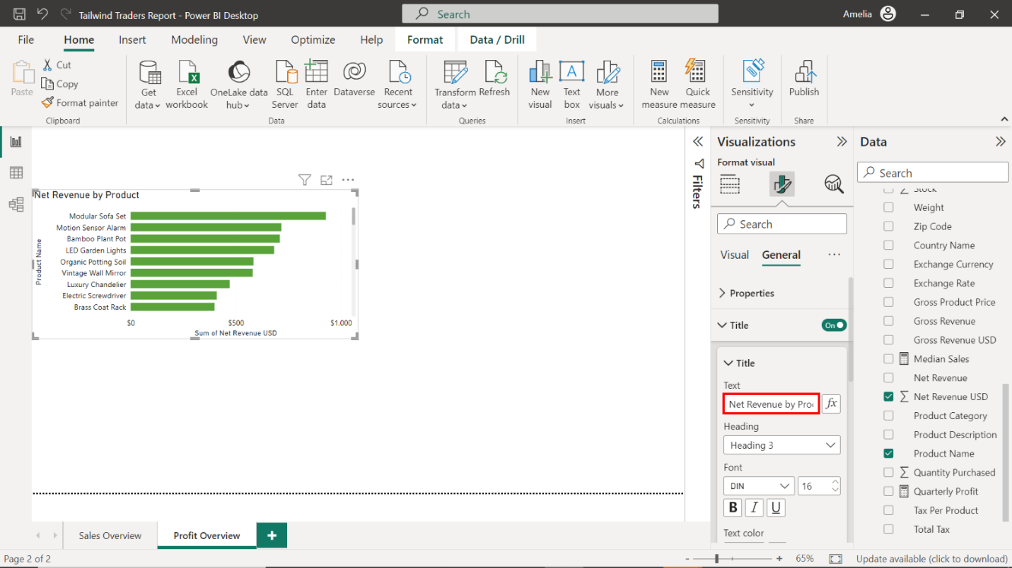

Select **Data labels** and toggle the switch **ON** to display the revenue on each bar.

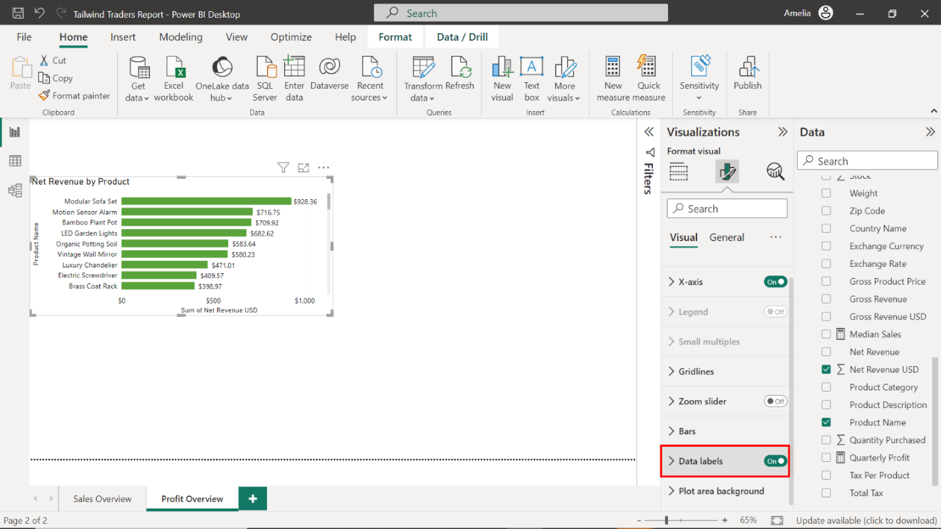

1. Note the product with the highest **Net Revenue** value.

Note the product with the highest **Net Revenue** value: the **Modular Sofa Set** at **928.36 USD**.

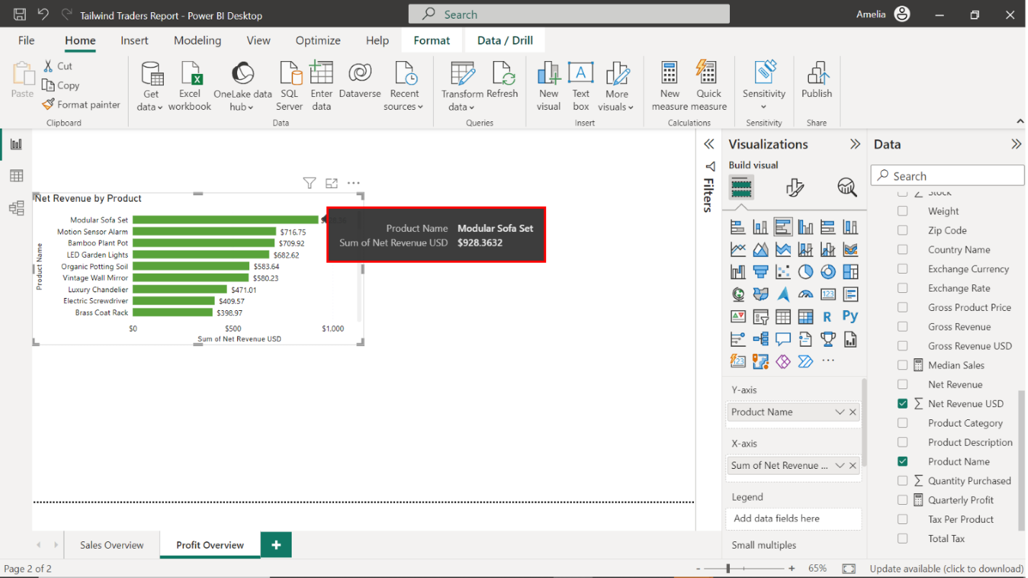

1. Sort the data in descending order.

Select the ellipsis from the top right corner of the chart. Select the **Sort Axis** dropdown, then select **Sort descending**.

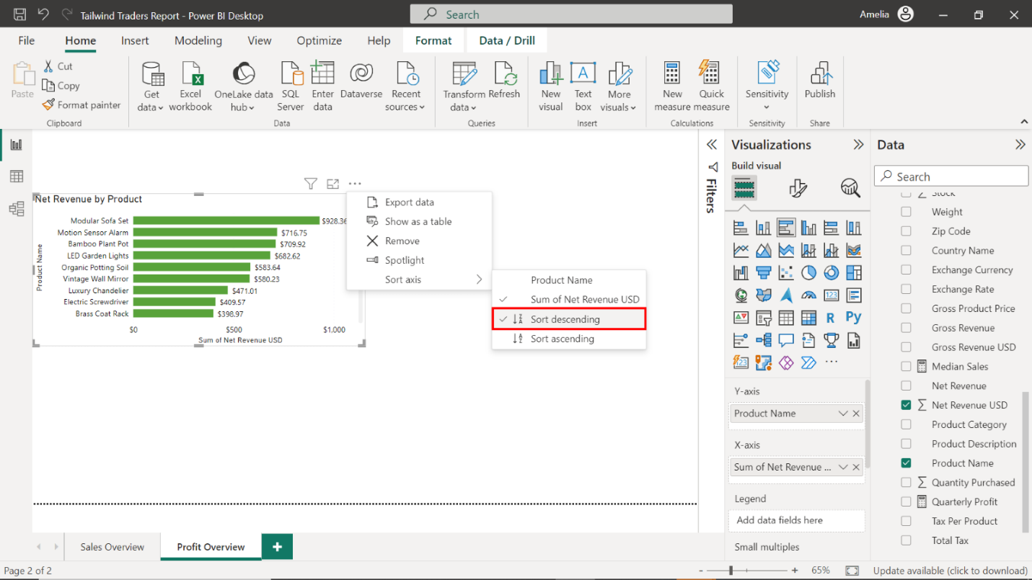

### Step 3: Create a donut chart for Yearly Profit Margin by Country

1. Create a donut chart that visualizes **Yearly Profit Margin by Country** using data from the **Product Sales in USD** table.

Select the **Donut chart** icon from the **Visualizations** pane to create an empty donut chart visualization on the canvas.

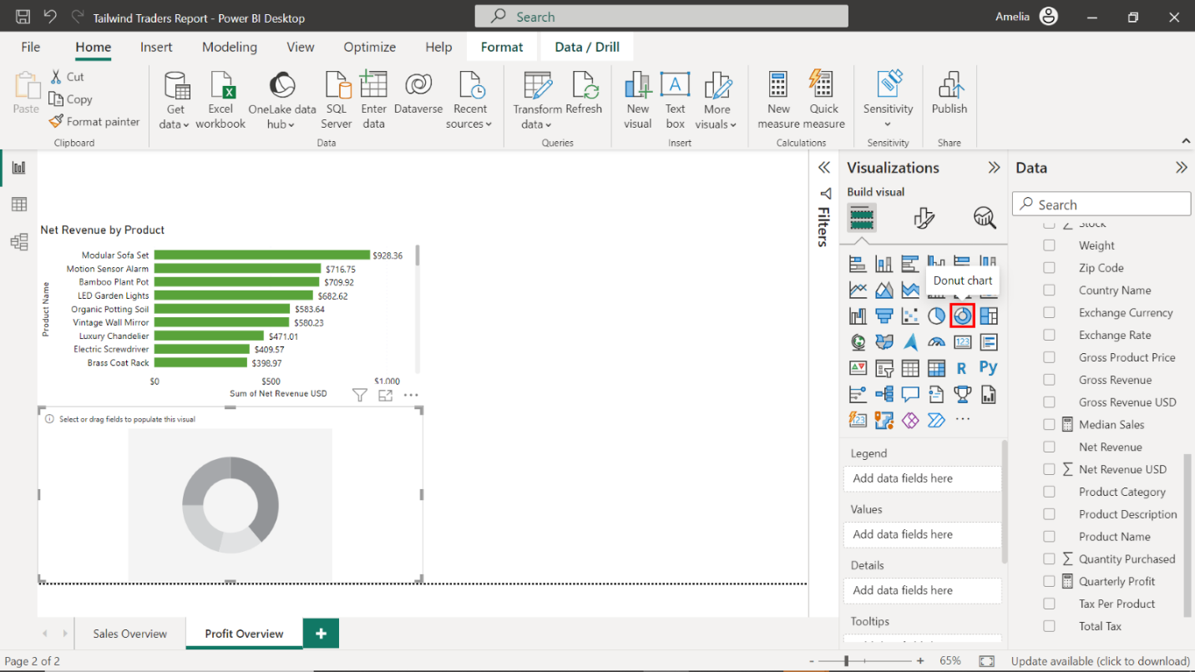

1. Configure the chart as follows:

* Display the **Country Name** in the **Legend** area.
* Display the **Yearly Profit Margin** in the **Values** area.
* Resize and position the chart to the right side of the canvas, next to the **Net Revenue by Product chart**.
* Title the chart **Yearly Profit Margin by Country**.
* Enable detailed labels for the **Percent of total** category.

Locate the **Sales in USD** table on the right-hand side of the screen and drag the **Country Name** field from the **Fields** pane to the **Legend** well in the **Visualizations** pane. Next, drag the **Yearly Profit Margin** field from the **Fields** pane to the **Values** well in the **Visualizations** pane.

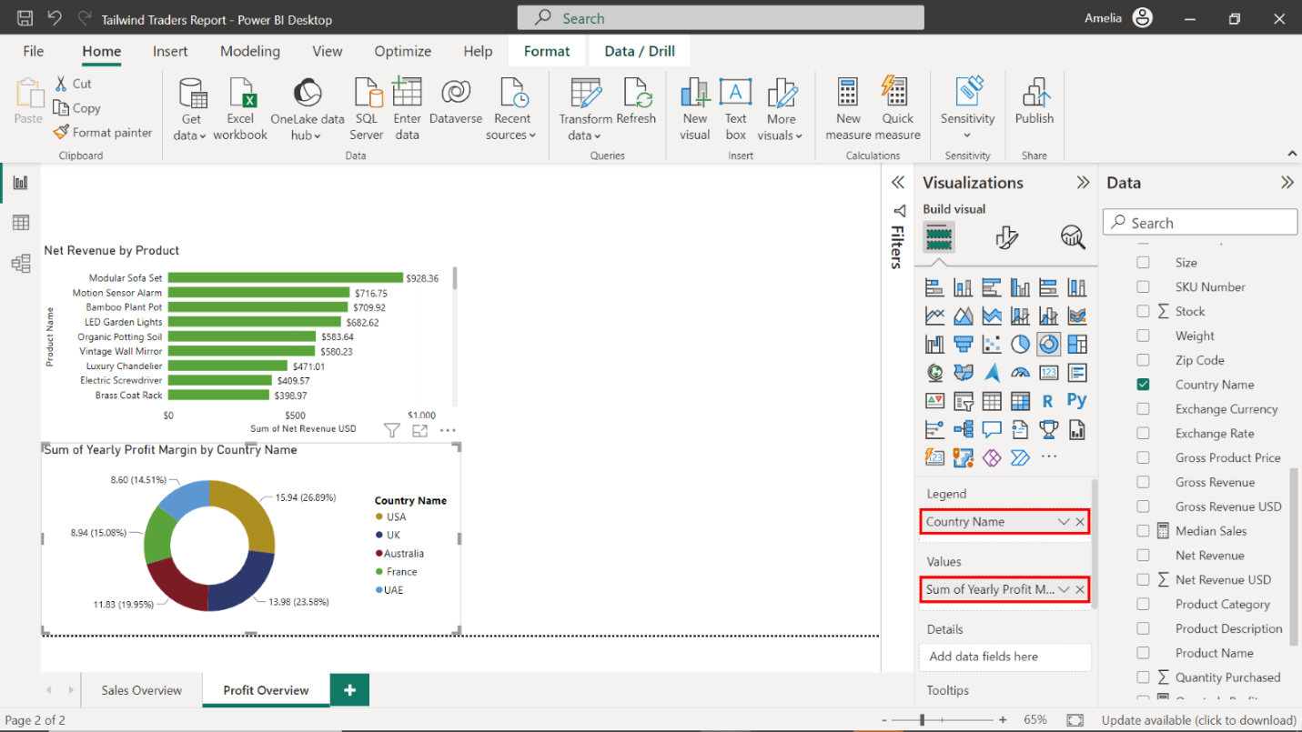

Select the edges of the visualization to resize it. Place it to the right of the **Net Revenue by Product** chart.

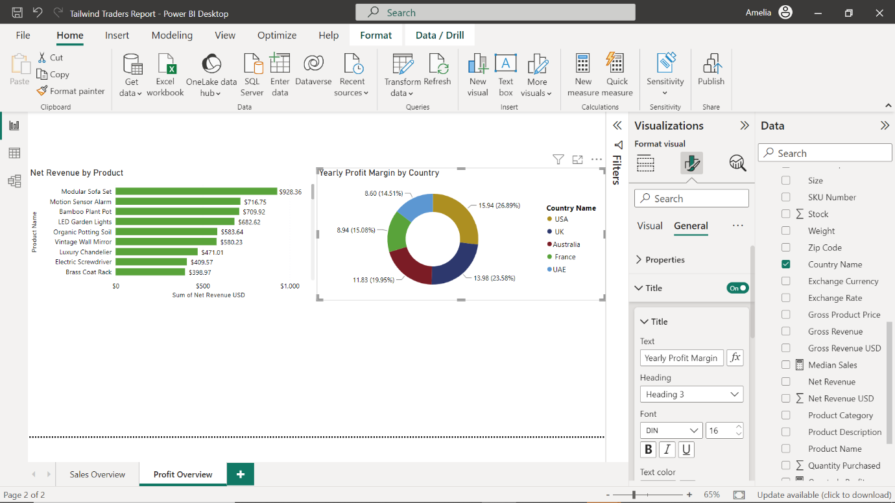

In the **Format** tab, title the chart **Yearly Profit Margin by Country**.

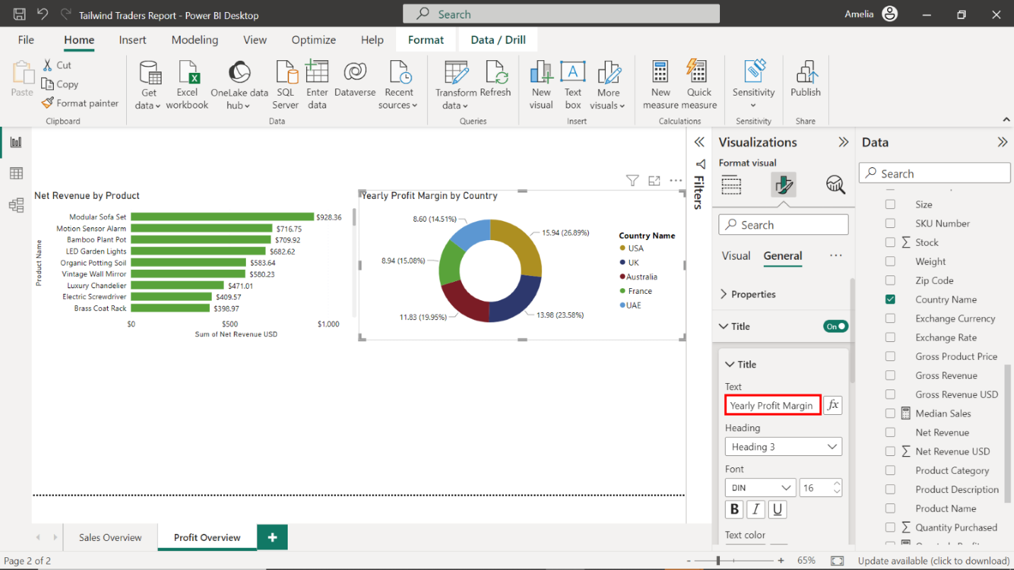

Select **Detailed labels**. Select **Category, percent of total** from the dropdown.

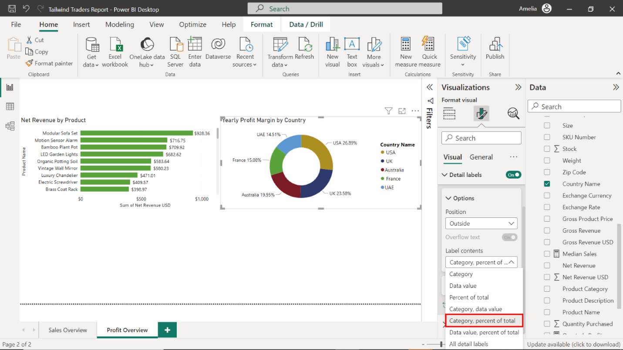

### Step 4: Create an area chart for Yearly Profit Margin over Time

1. Create an area chart that visualizes **Yearly Profit Margin over Time**.

Select the **Area Chart** icon from the **Visualizations** pane to create an empty area chart visualization on the canvas.

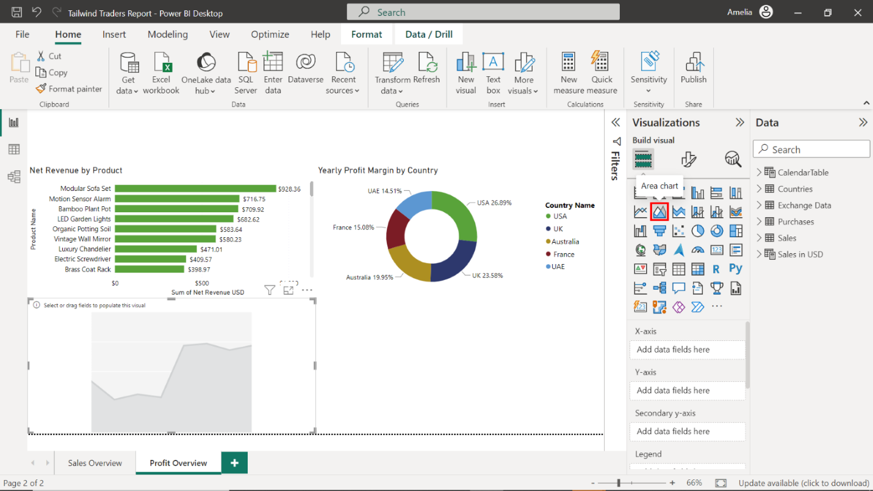

1. Configure the chart as follows:

* Display the **Date** on the Y-axis.
* Display the **Yearly Profit Margin** on the X-axis.
* Resize and position the chart below the **Net Revenue by Product**bar chart and **Yearly Profit Margin by Country** donut chart.
* Title the chart **Yearly Profit Margin over Time**.
* Toggle on the **data labels**.

Locate the **CalendarTable** on the right-hand side of the screen. Drag the **Date** field from the **Fields** pane to the **X-axis** well in the **Visualizations** pane.

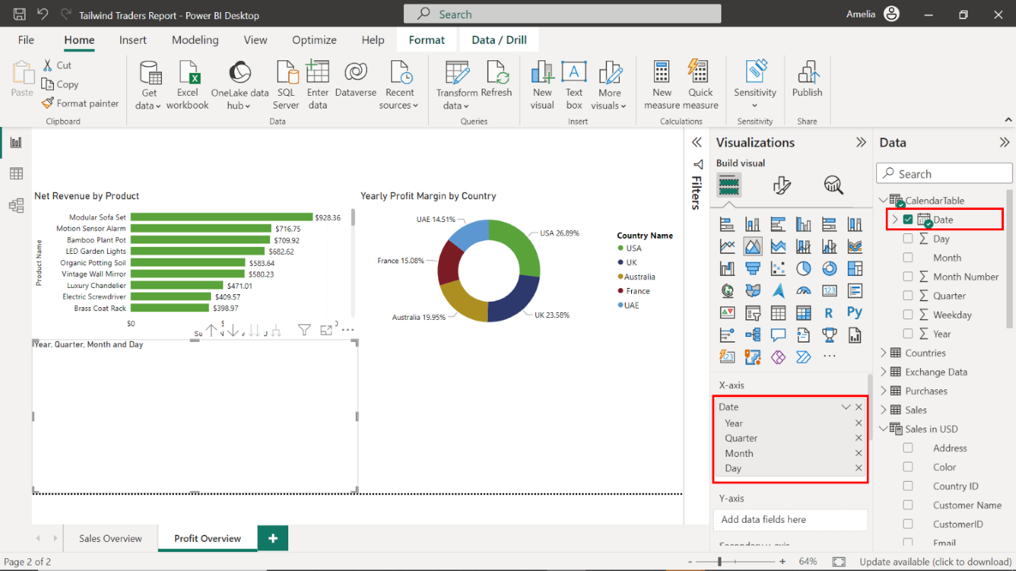

Locate the **Sales in USD** table and drag the **Yearly Profit Margin** field from the **Fields** pane to the **Y-axis** well in the **Visualizations** pane.

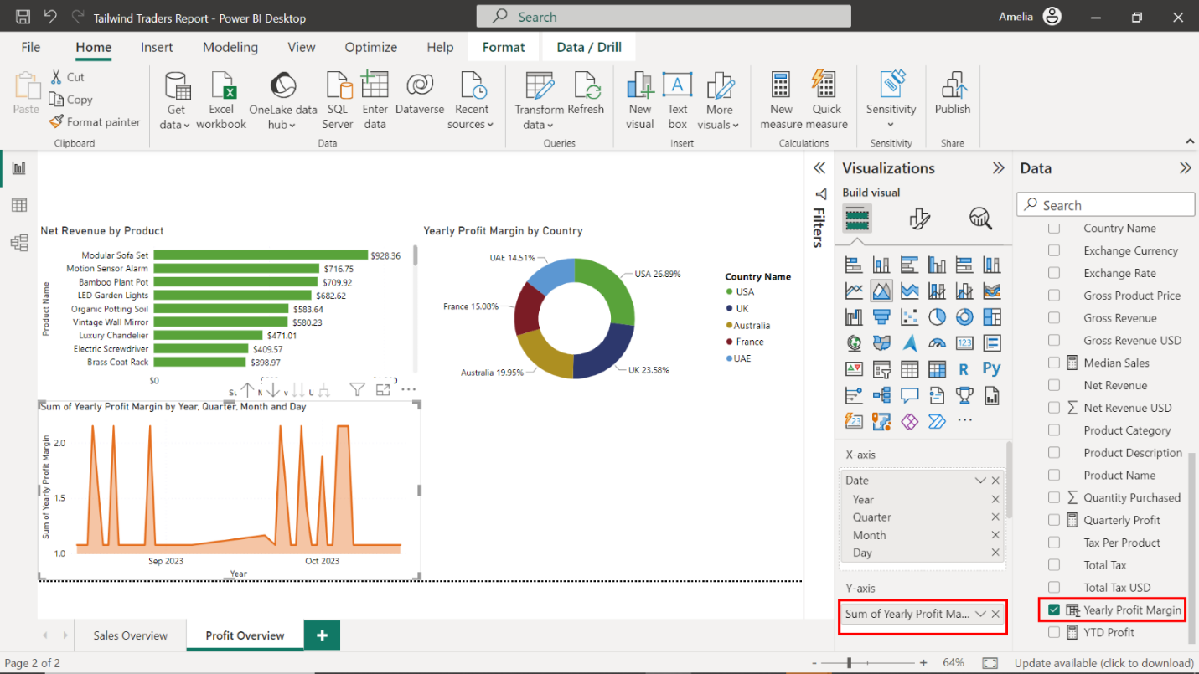

Select the edges of the visualization to resize it. Place it below the **Net Revenue by Product** bar chart and **Yearly Profit Margin by Country** donut chart.

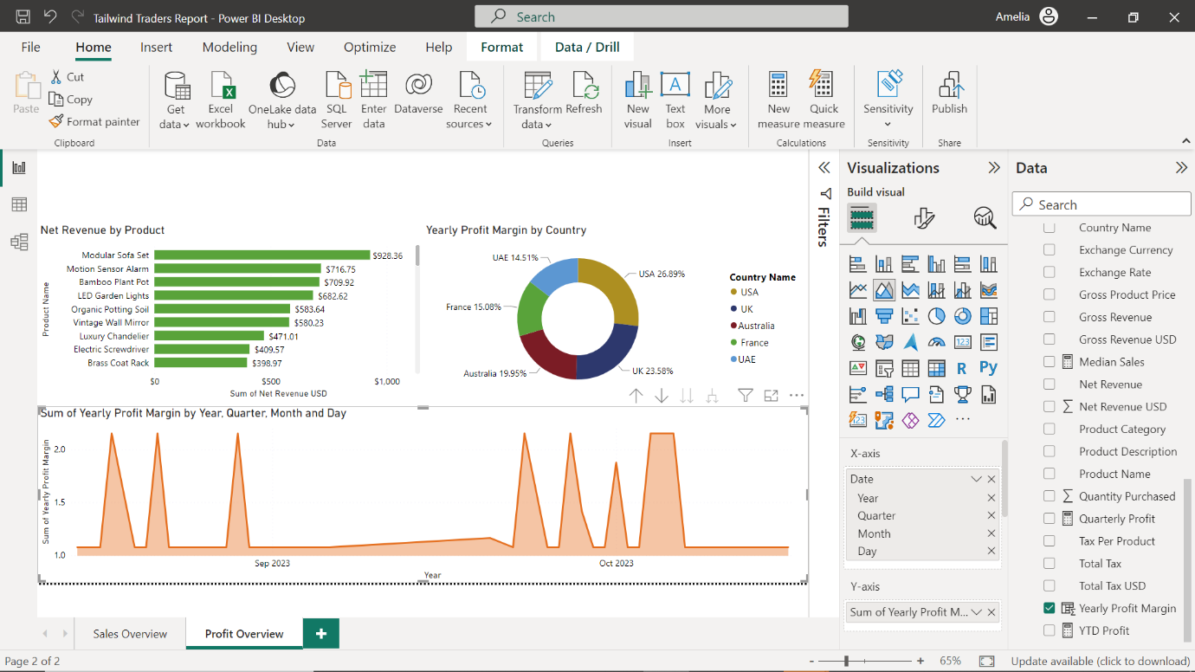

Using the **Format** tab, title the chart **Yearly Profit Margin over Time**.

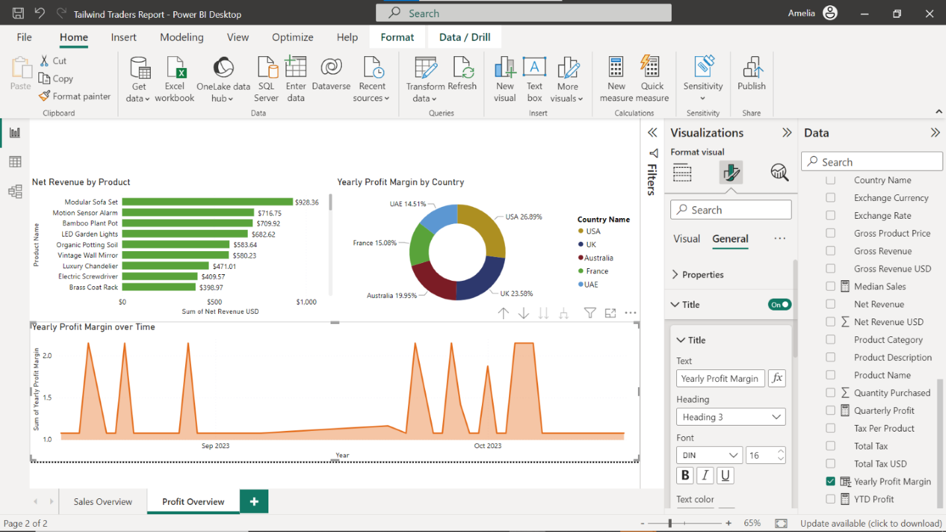

Select **Data labels** and toggle the switch **ON** to show the **Yearly Profit Margin** figures.

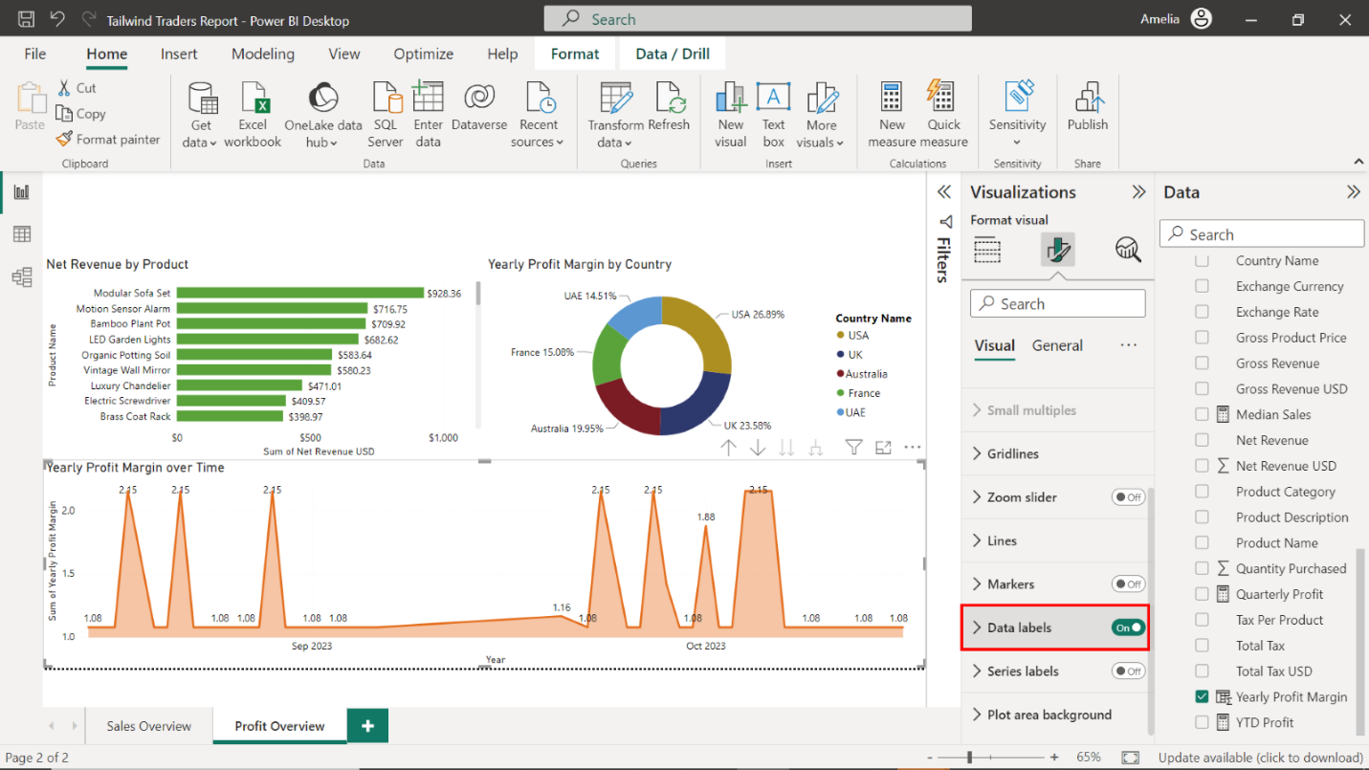

### Step 5: Create cards to visualize your measures

1. Create cards that visualize the following measures:

* **YTD Profit**
* **Net Revenue USD**

1. Position the cards above the **Net Revenue by Product** bar chart.

Select the **Card** icon in the **Visualizations** pane while ensuring nothing else is selected on the canvas. An empty card visual appears on the canvas.

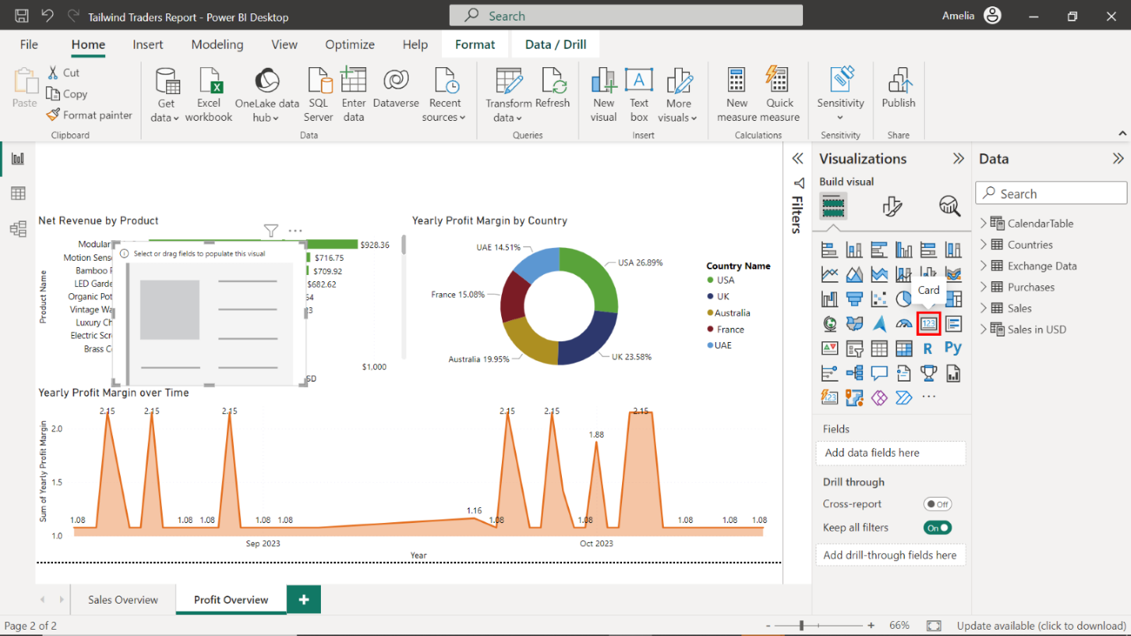

Locate the **Sales in USD** table and drag the **YTD Profit** field to the **Fields** well in the **Visualizations** pane.

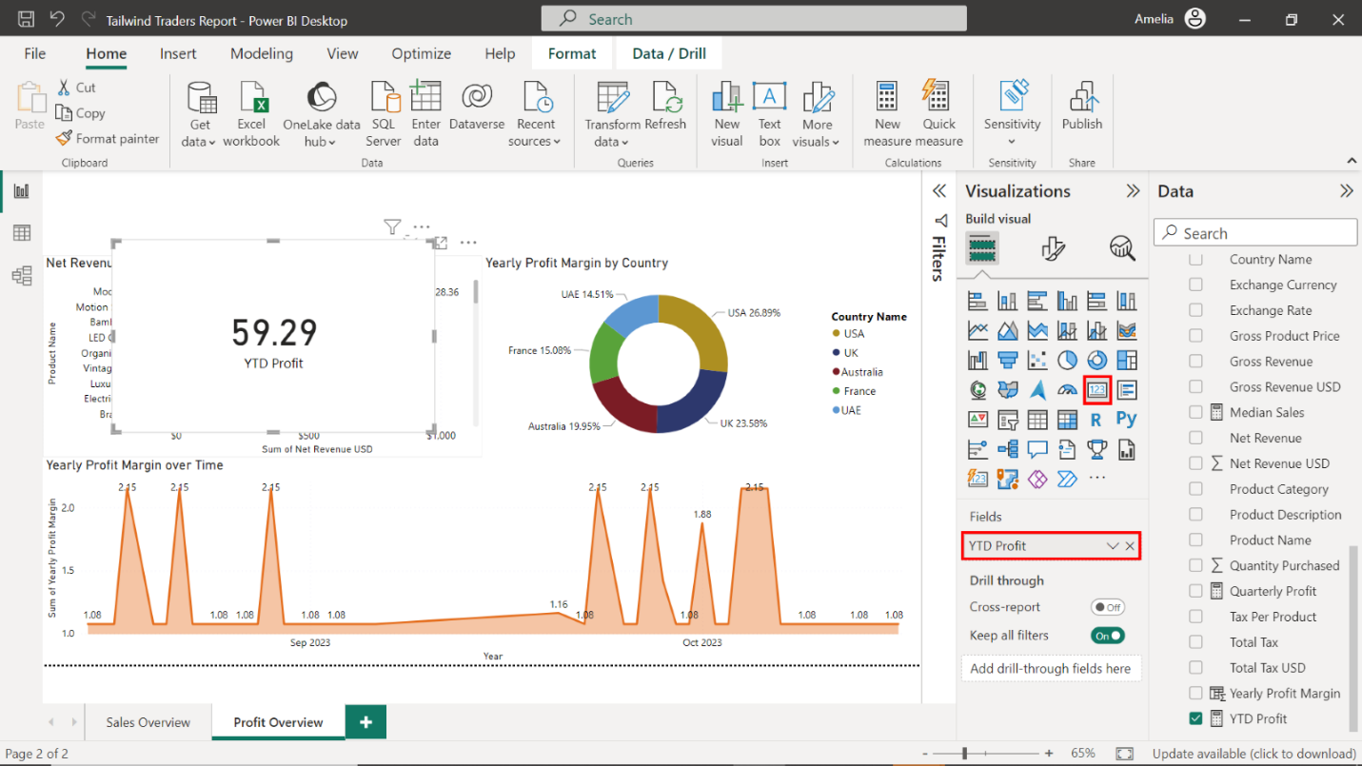

Select the edges of the card on your canvas to resize it. Place it above the **Net Revenue by Product** bar chart.

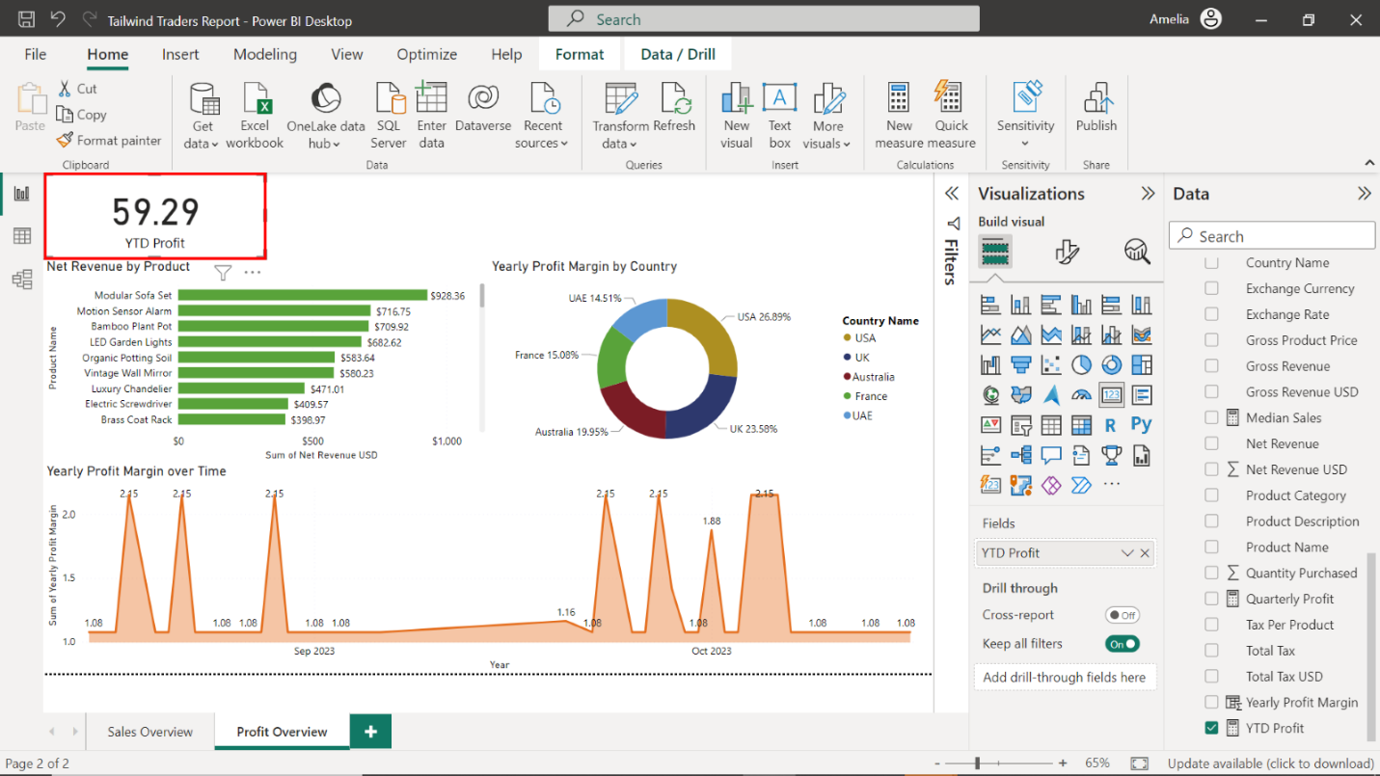

Select the **Card** icon in the **Visualizations** pane to create a second card visual for **Net Revenue USD**. Locate the **Sales in USD** table and drag the **Net Revenue USD** field to the **Fields** well in the **Visualizations** pane.

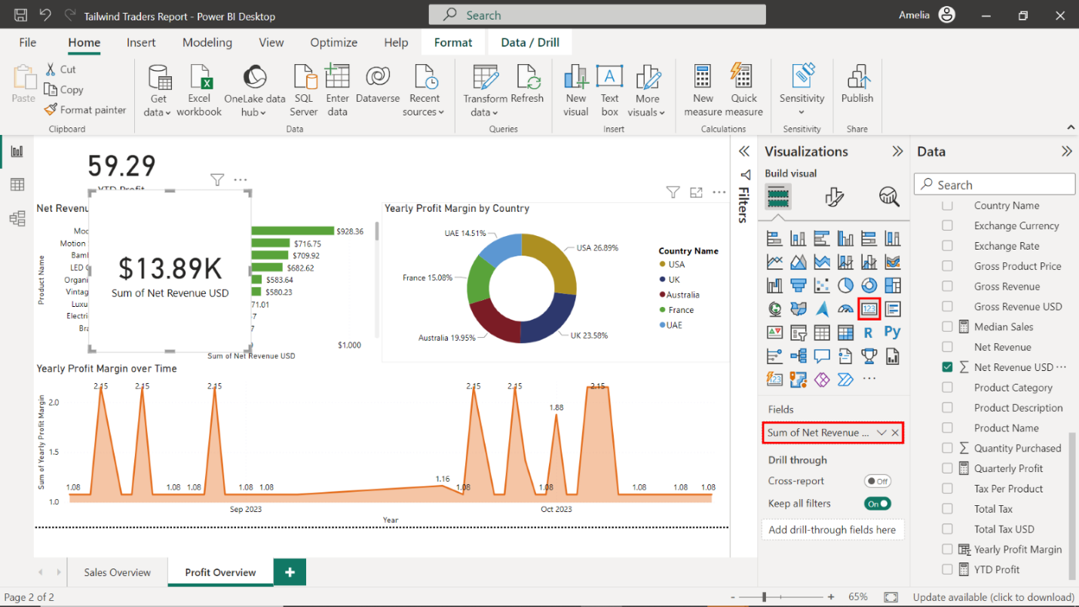

Select the edges of the card on your canvas to resize it. Place it above the **Net Revenue by Product** bar chart.

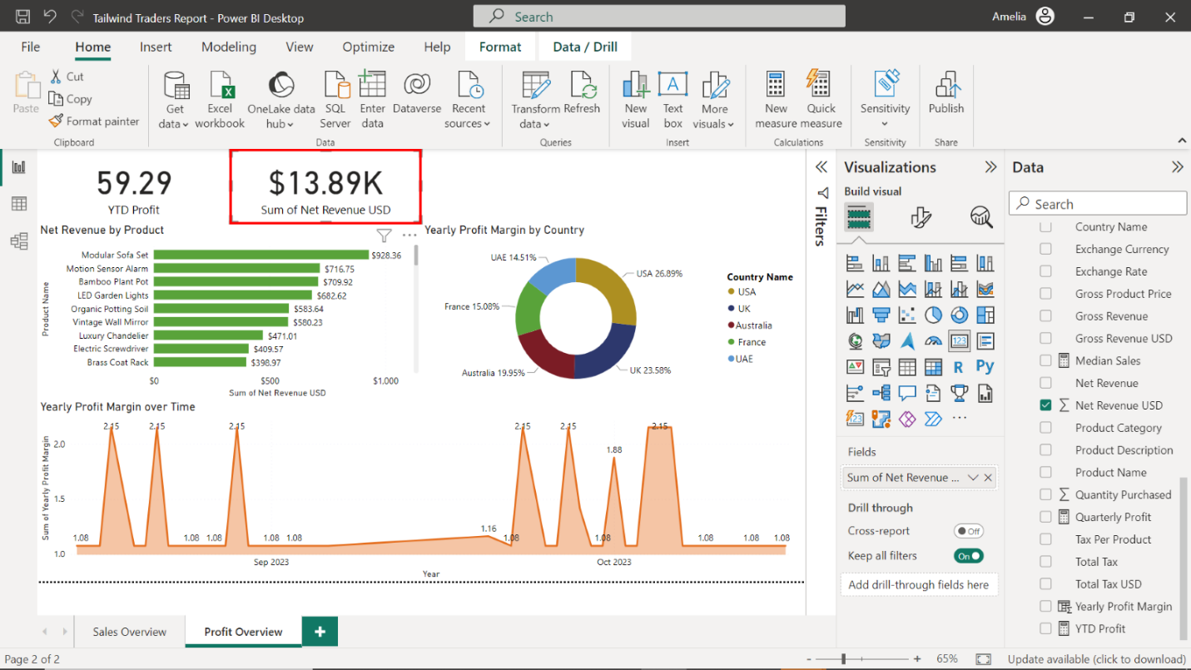

### Step 6: Create a KPI for Gross Revenue USD

1. Create a KPI for **Gross Revenue USD**.

Select the **KPI** icon in the **Visualizations** pane, ensuring nothing else is selected on the canvas. An empty KPI visual appears on the canvas.

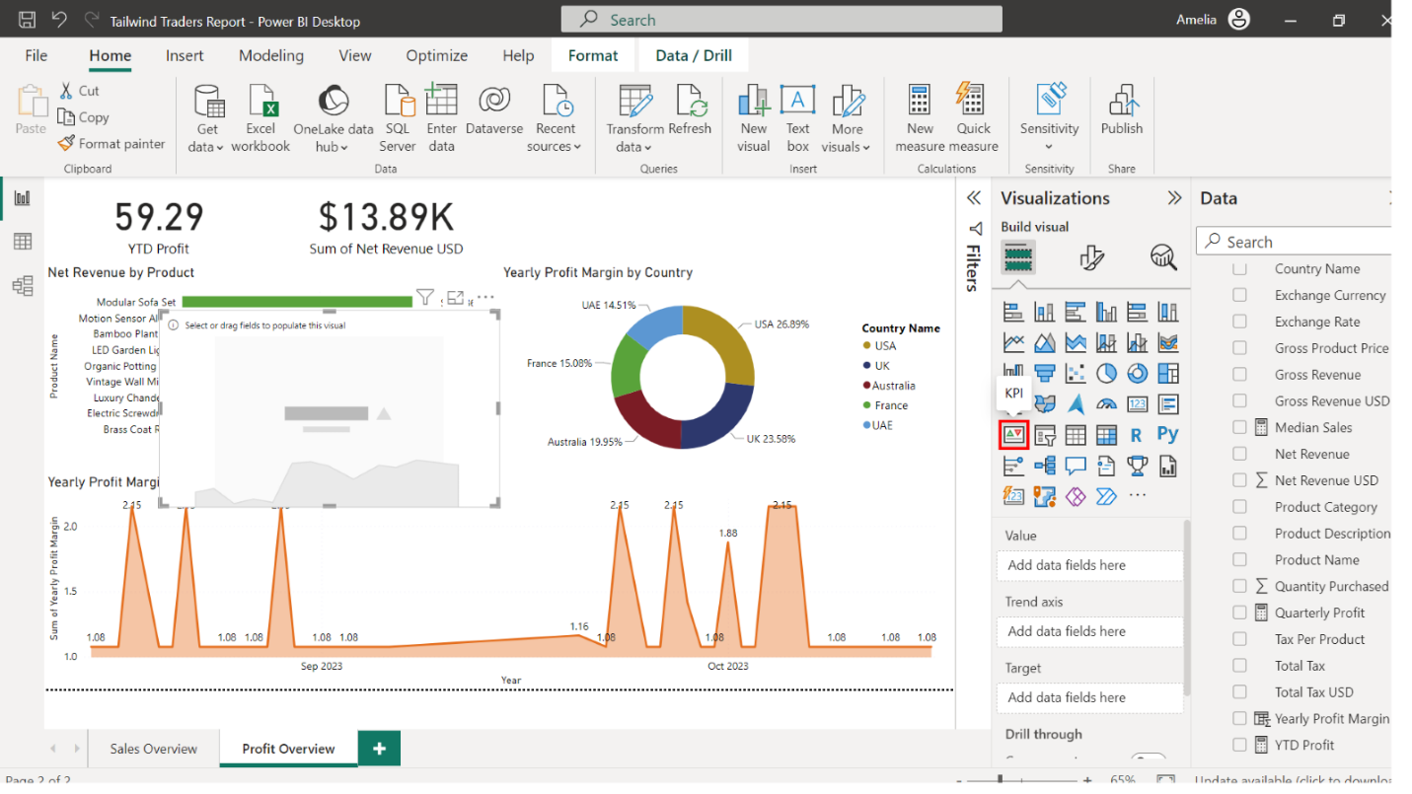

1. Configure the KPI as follows:

* Display the **Gross Revenue USD** in the value area
* Display the **Date** in the **Trend Axis** area.
* Resize and position the KPI next to the **Net Revenue USD card**.

Locate the **Sales in USD** table and drag the **Gross Revenue USD** field to the **Value** well in the **Visualizations** pane.

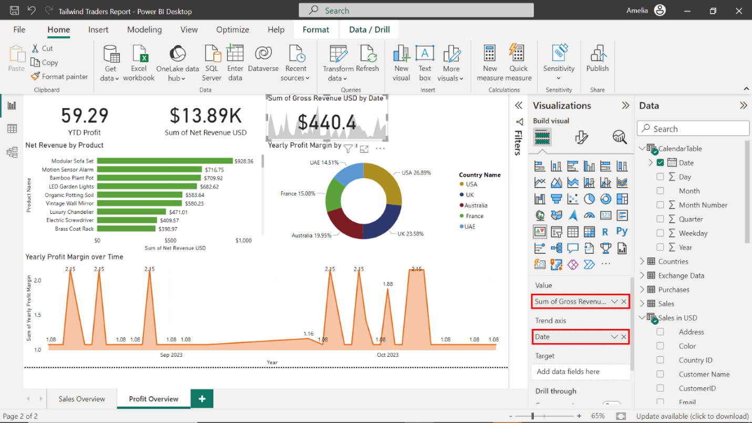

Next, locate the **CalendarTable** and drag the **Date** field to the **Trend Axis** well.

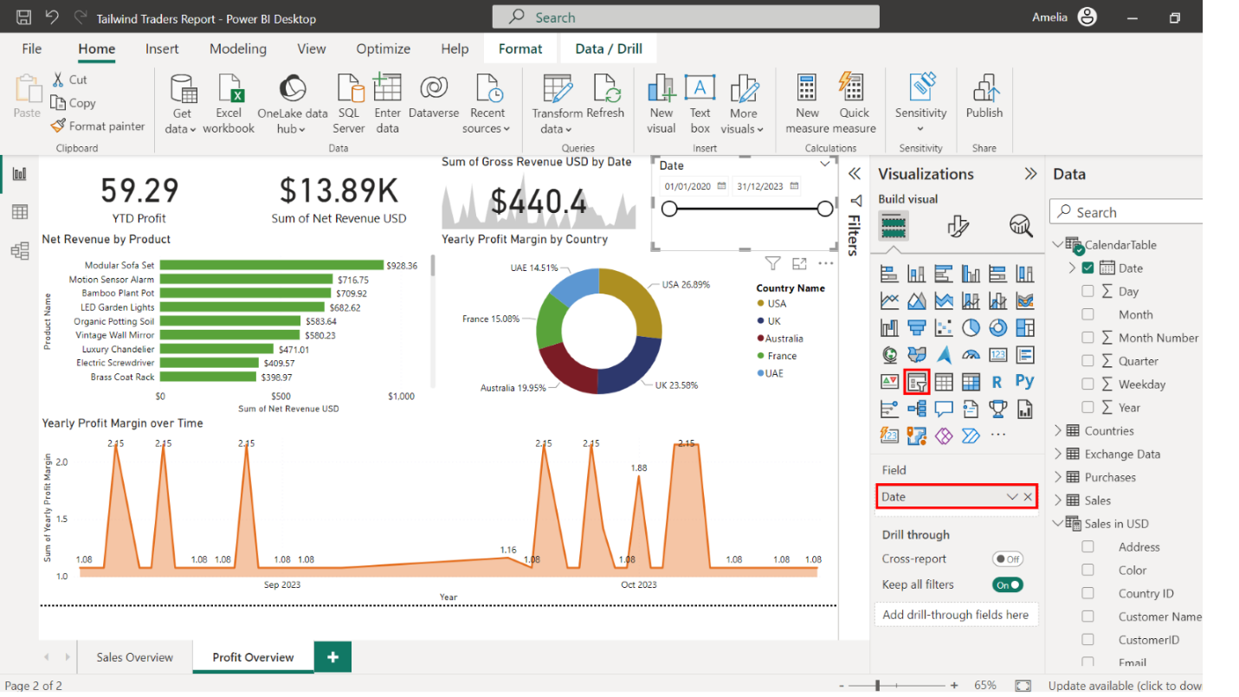

Select the edges of the canvas to resize it. Place it next to the **Net Revenue USD** card.

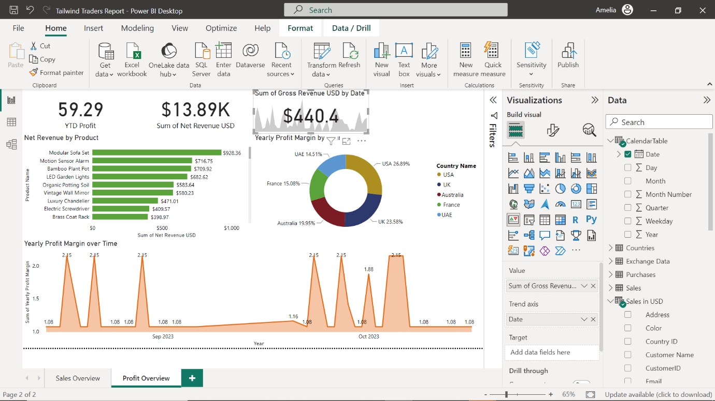

### Step 7: Add a slicer to the report

1. Create a slicer that displays the **Date**data from the **CalendarTable** table.

In the **Visualizations** pane, select the **Slicer** icon.



Drag the **Date** field from the **CalendarTable** to the **Field** area.

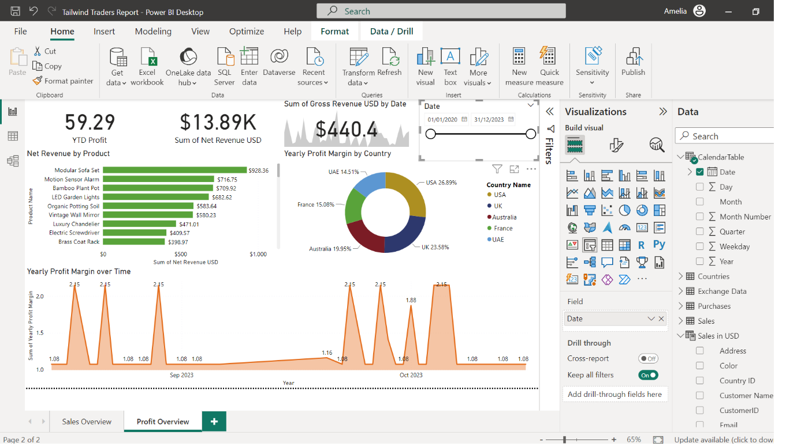

Select the edges of the Slicer to resize it. Place it next to the **Gross Revenue USD** KPI.



1. Save and publish your report.

Select **File** in the top-left corner of the Power BI Desktop interface, and then **Save** to save the report. In the dialog box, indicate where to save the report. Select **My Workspace** as your workspace and then the **Select** button.

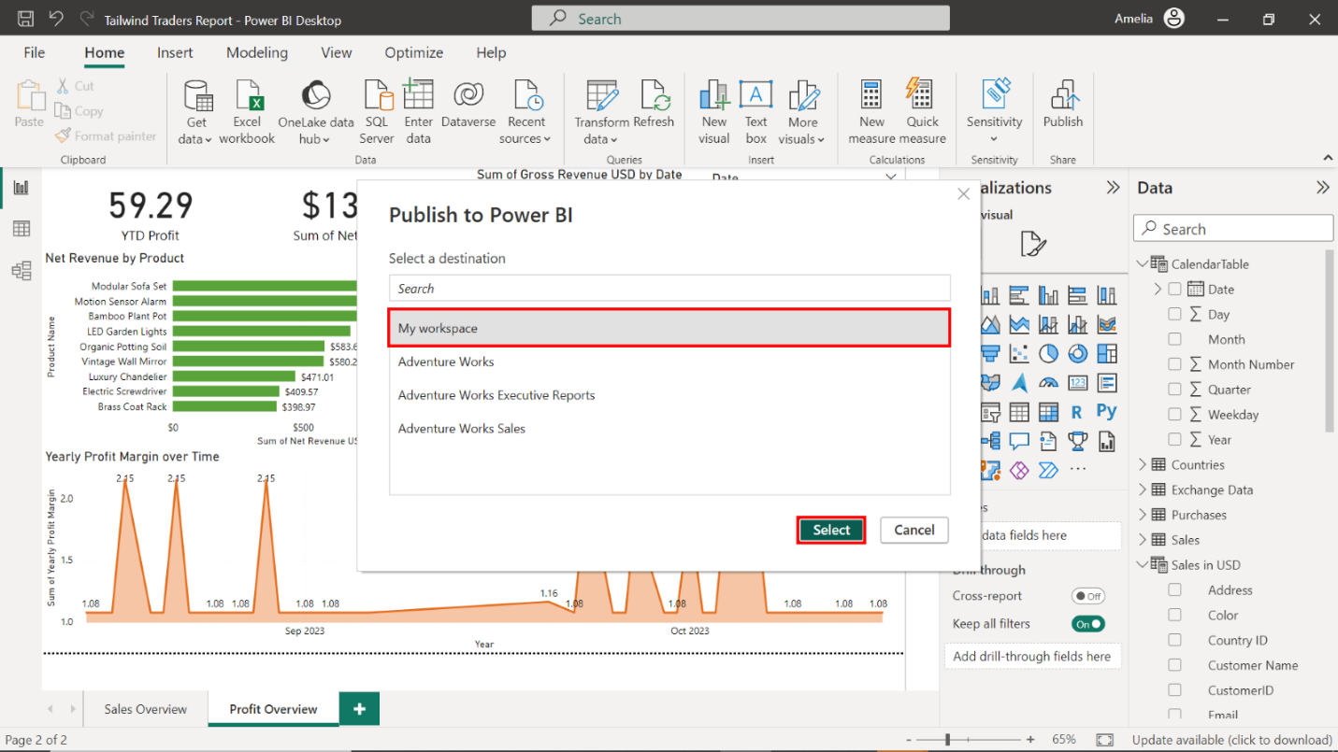

Once the destination is selected, Power BI publishes the report. Depending on the size of the report and your internet connection, this process could take a few moments.

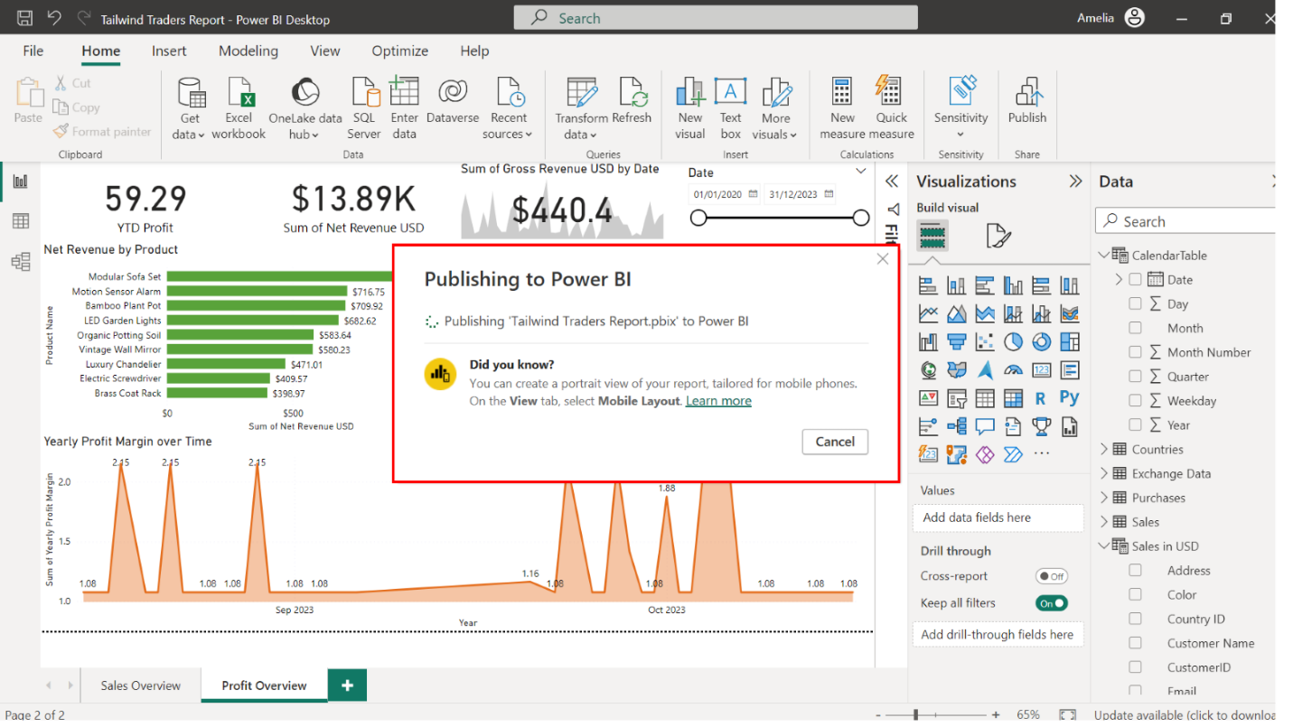

Once the report is published, a new window appears to confirm successful publication. It provides two options:

* Open the report in Power BI Service
* Or Cancel and open it later.

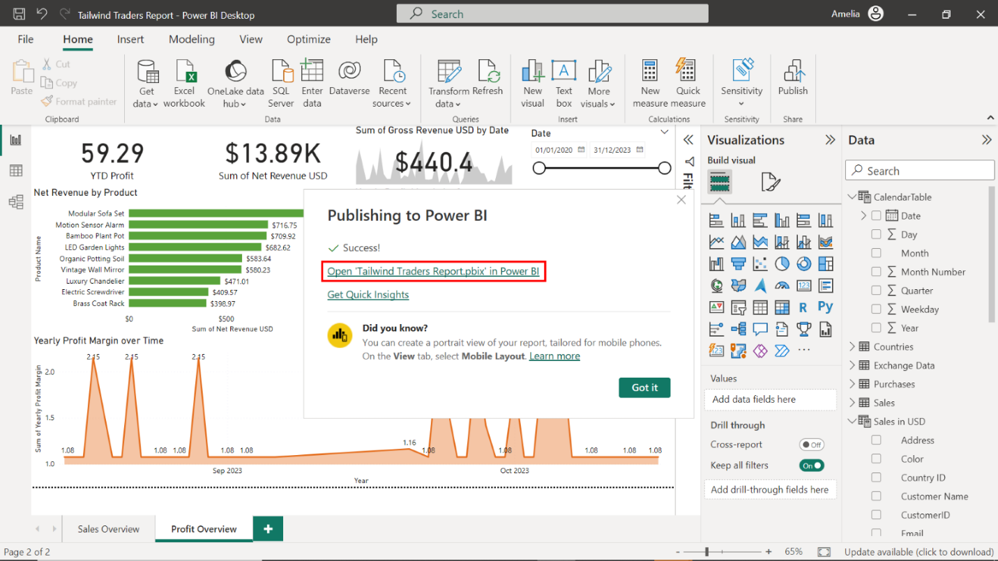

In this case, select **Open** to launch the default web browser on your computer and view your report in Power BI service.

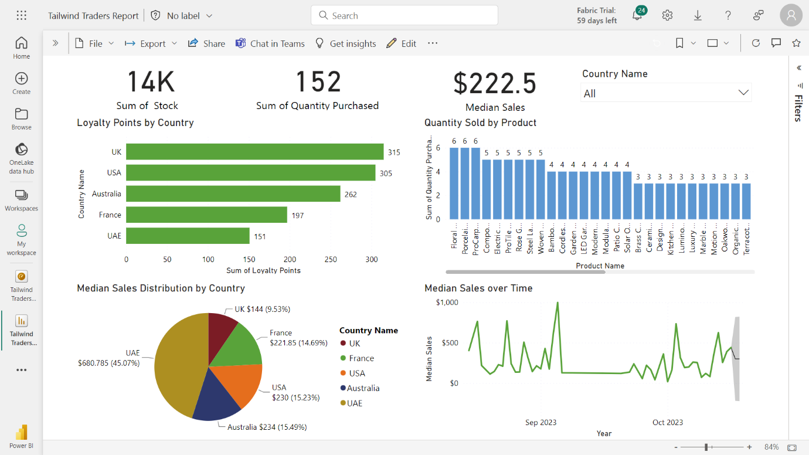

# Exemplar: Capstone project - Part 3

## Overview

In the third and final set of Capstone project exercises, you helped Tailwind Traders create a dashboard in which you could upload the reports you generated and configure the dashboard, so it notified the company in the form of alerts and subscriptions.

In this final set, you undertook the fifth and sixth exercises in the Capstone project:

* Create an executive dashboard.
* And configuring alerts and subscriptions.

This reading provides you with a step-by-step guide for completing these tasks. It also includes screenshots that you can compare against your work.

You can also review the learning materials provided in this course for more guidance.

## Exercise 6: Creating an executive dashboard

### Step 1: Create a new dashboard

1. Navigate to your workspace and create a new dashboard called **Tailwind Traders Executive Dashboard**.

In the **Navigation** view of **My Workspace**, locate and select the **+ New** button on the top left corner of the screen.

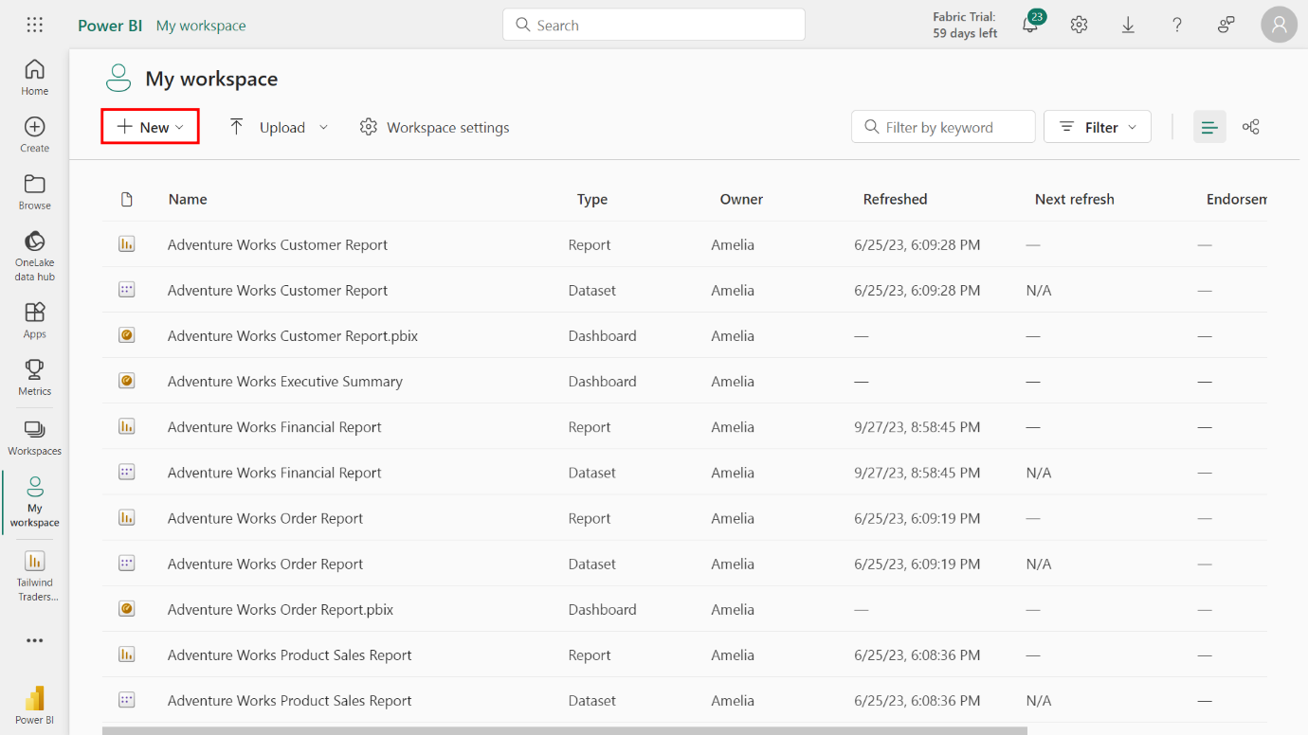

Select **Dashboard** from the list of options.

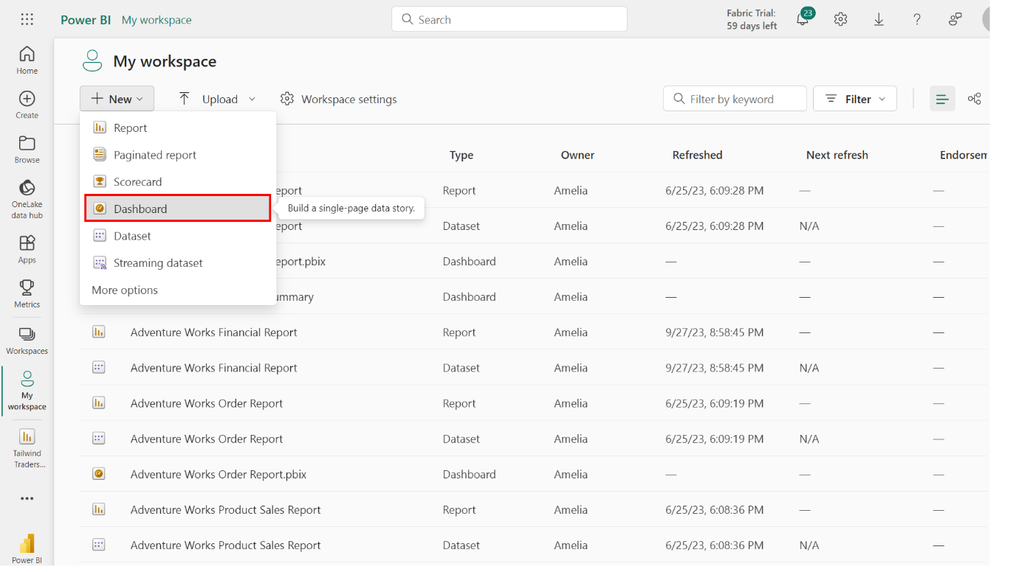

A pop-up window titled **Create a dashboard** appears. Type **Tailwind Traders Executive Dashboard** in the **Name** field.

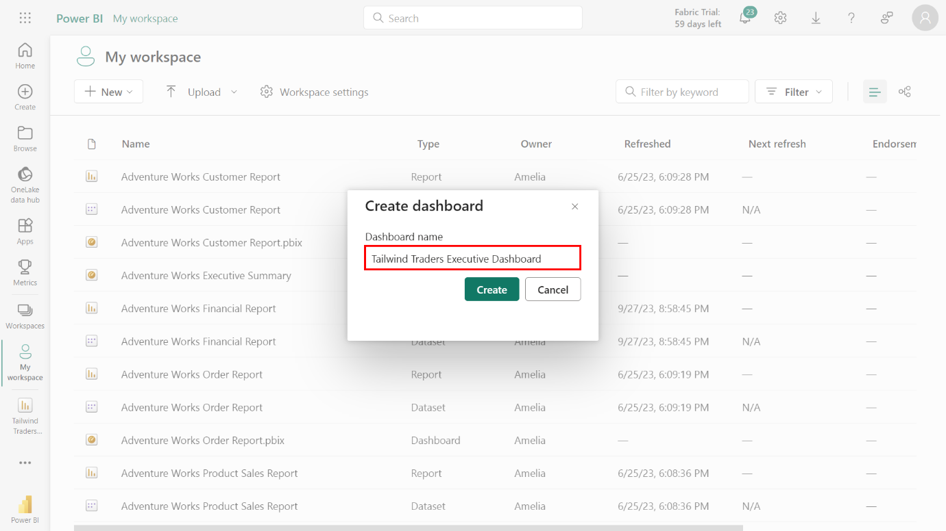

Select **Create**. This action creates a new dashboard shell to which you can add content.

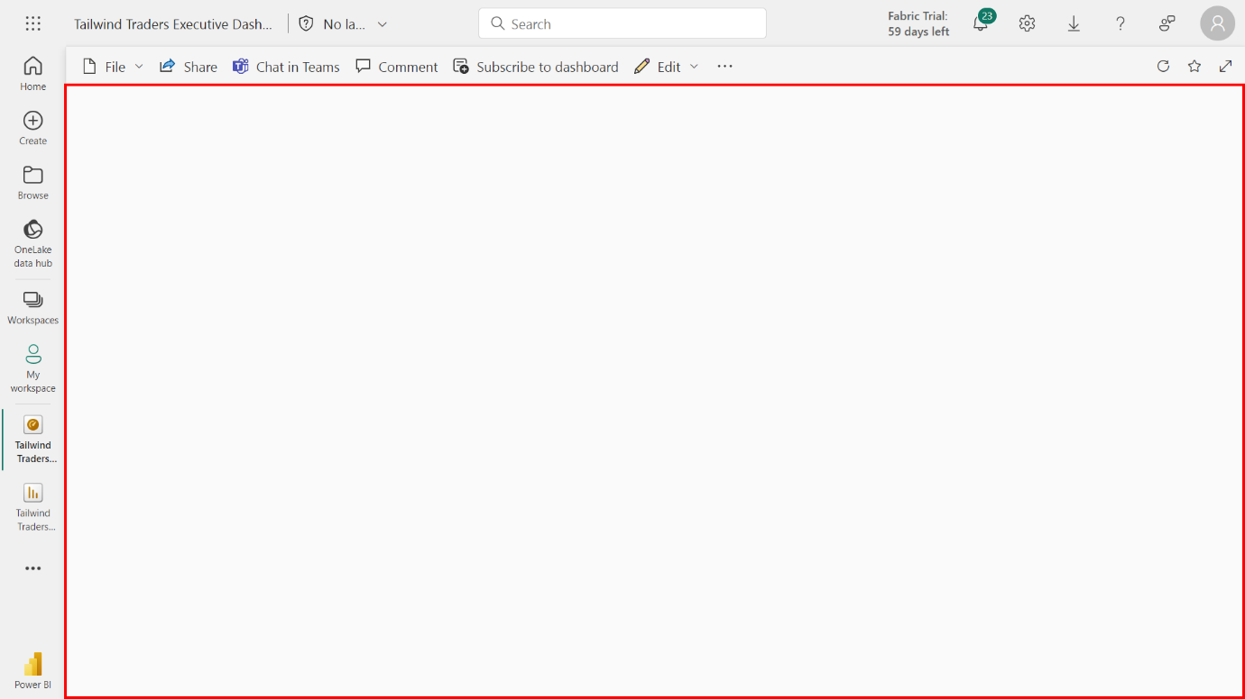

### Step 2: Pin Sales Overview core visualizations

1. Navigate to your Workspace and access the **Sales Overview** tab of the **Tailwind Traders Report**.

On the left side of your Power BI service screen, locate and select **Workspaces** > **My Workspace** again.

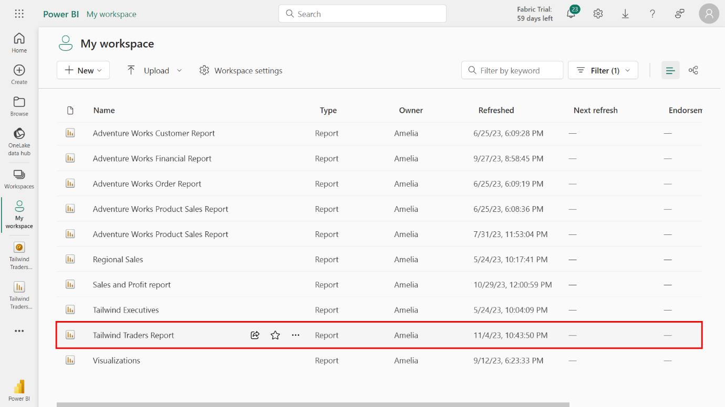

Navigate to the **Tailwind Traders Report** in the list of reports within the workspace. Select the report’s **Sales Overview** tab.

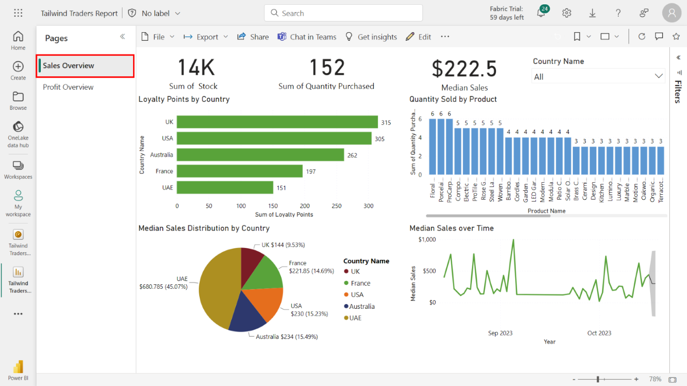

Within this tab, locate and select the pin icon on the **Loyalty Points by Country** bar chart. A **Pin to dashboard** dialog box appears onscreen. Select the **Tailwind Traders Executive Dashboard** and select **Pin** to confirm your choice.

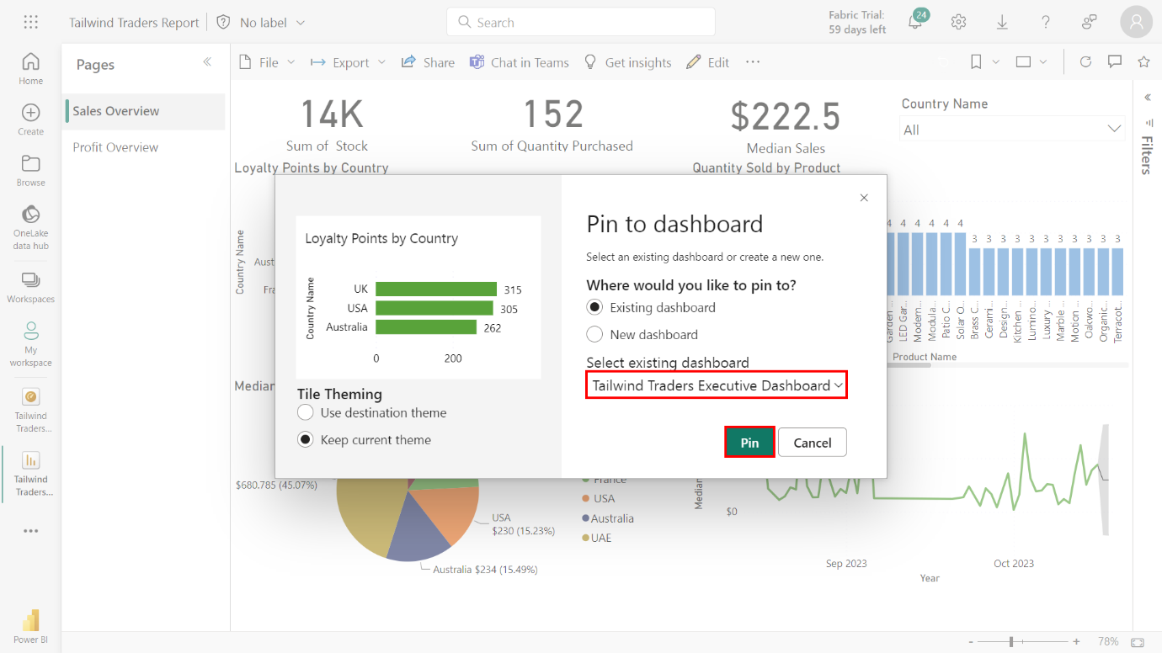

Repeat this action for the following charts:

**Quantity Sold by Product** column chart.

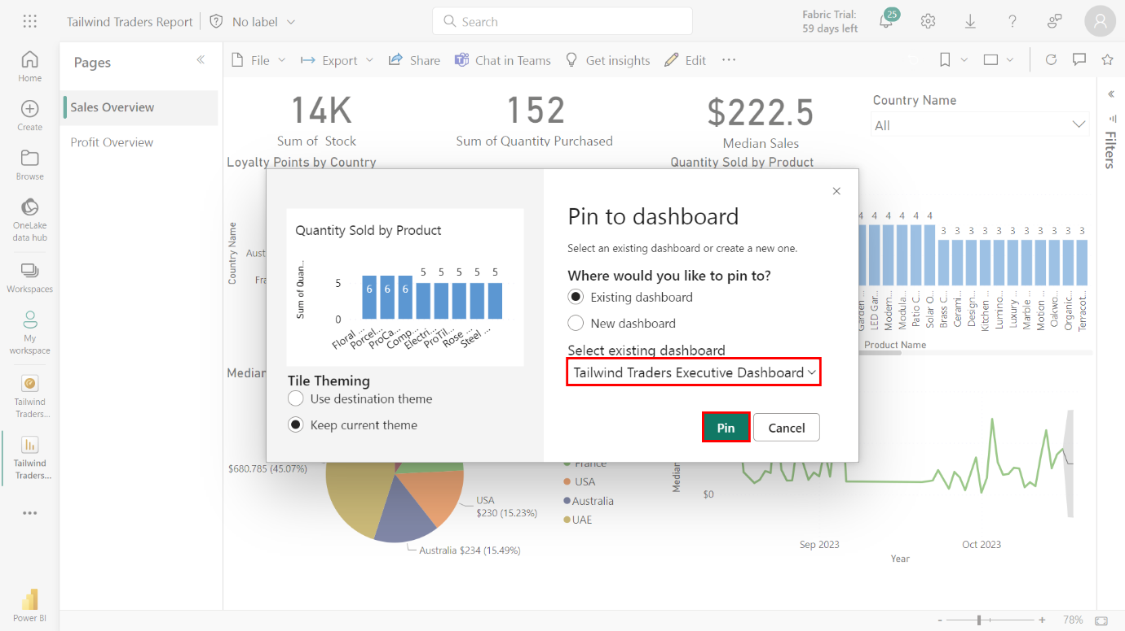

**Median Sales Distribution by Country** pie chart.

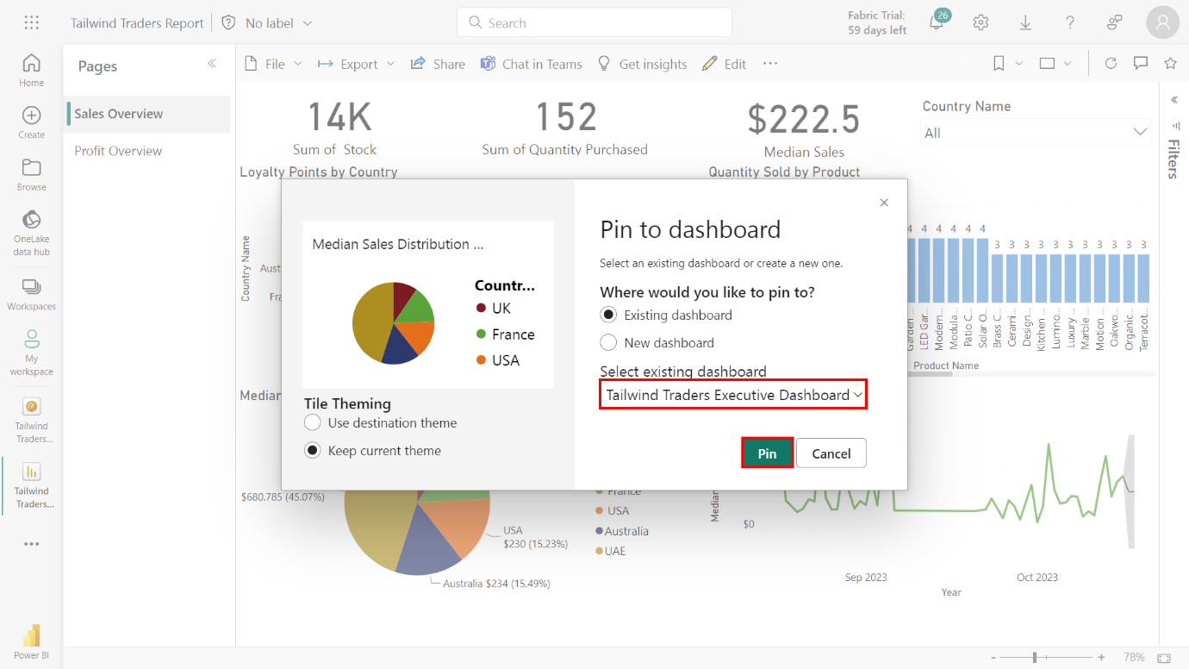

**Media Sales Over Time** line chart.

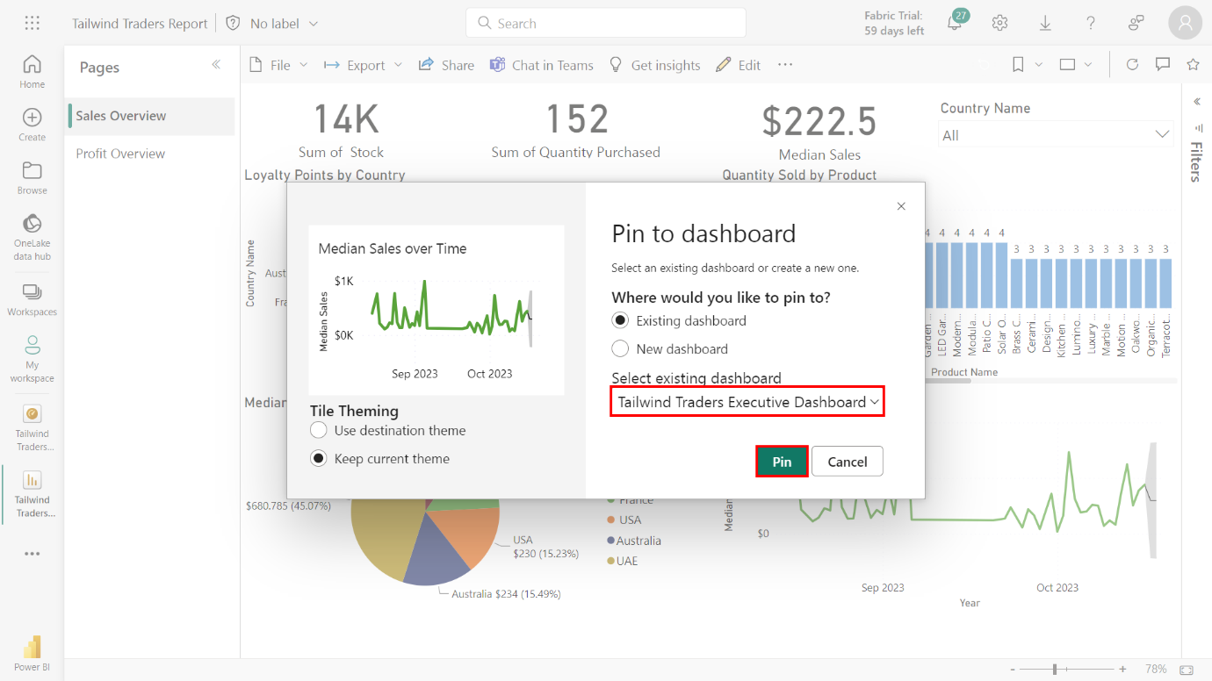

### Step 3: Pin the Sales Overview card visualizations

1. Locate and pin the following **Sales Overview** card visualizations to the **Tailwind Traders** dashboard:

* **Sum of Stock** card
* **Sum of Quantity Purchased**card
* **Median sales** card

Select the pin icon on the **Sum of Stock** card.

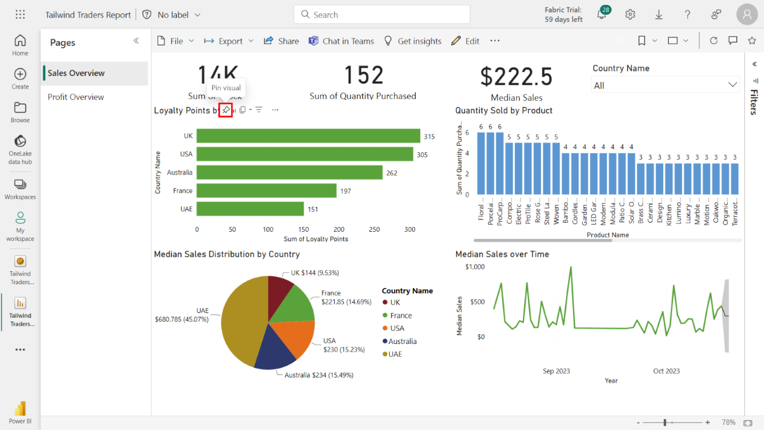

Pin the card to the **Tailwind Traders Executive Dashboard**.

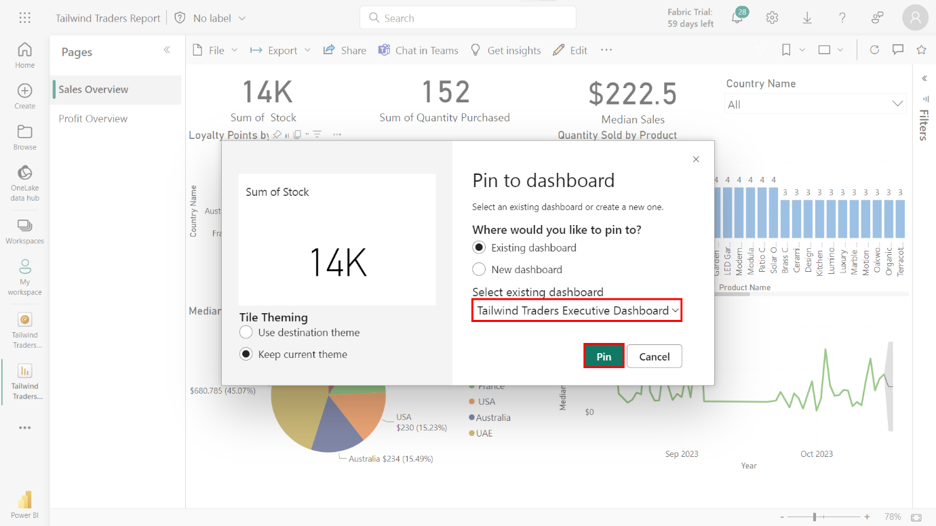

Repeat this process for the **Sum of Quantity Purchased** card.

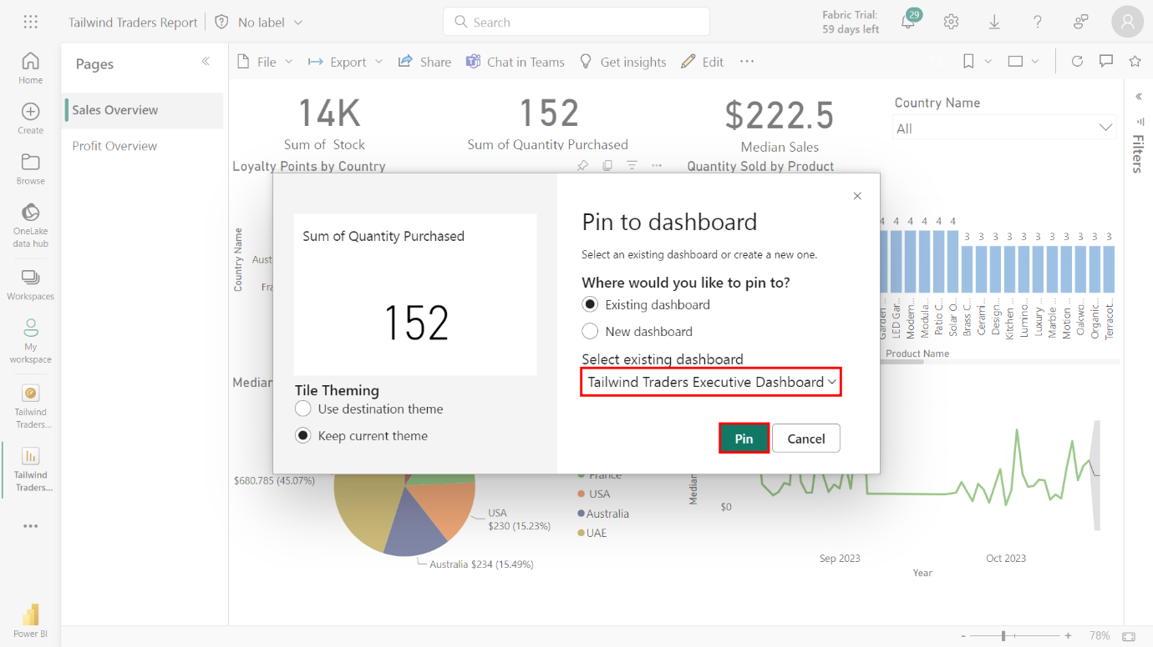

Repeat this process once again for the **Median Sales** card.

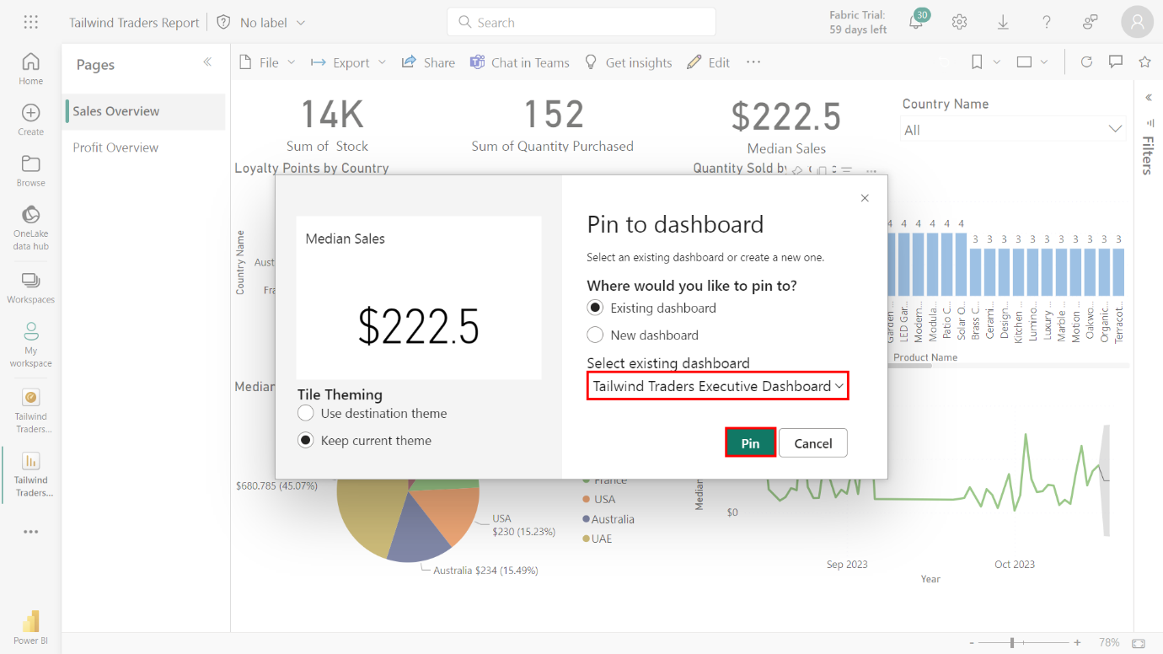

### Step 4: Pin the Profit Overview core visualizations

1. Select the **Profit Overview** tab.

Select the **Profit Overview** tab from the **Tailwind Traders Report**.

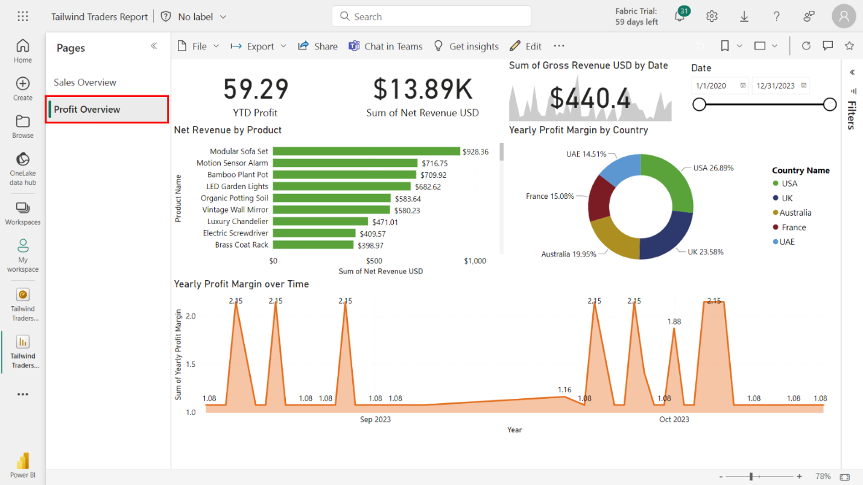

1. Locate and pin the following **Profit Overview** core visualization to the **Tailwind Traders Executive Dashboard**:

* **Net Revenue by Product** bar chart
* **Yearly Profit Margin by Country** donut chart
* **Year Profit Margin over Time** area chart

Select the pin icon on the **Net Revenue by Product**bar chart and pin the visualization to the **Tailwind Traders Executive Dashboard**.

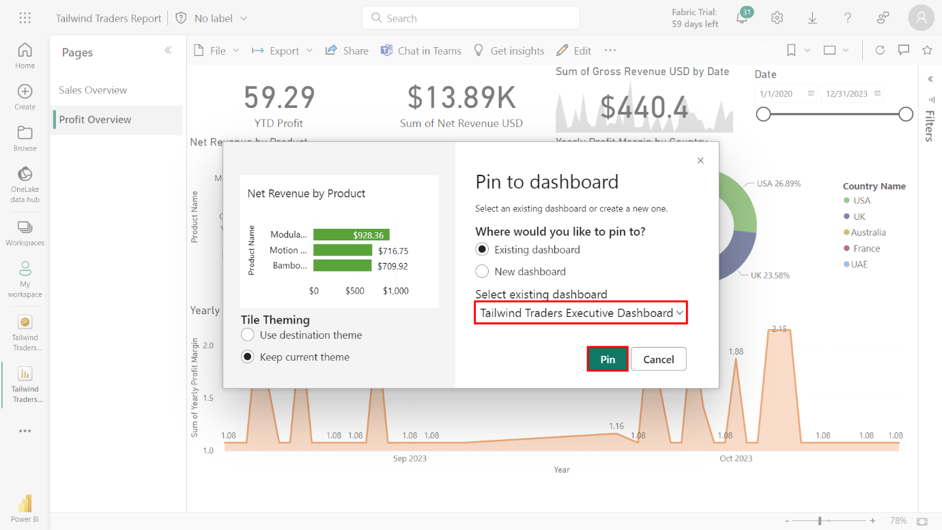

Repeat this process for the **Yearly Profit Margin by Country** donut chart.

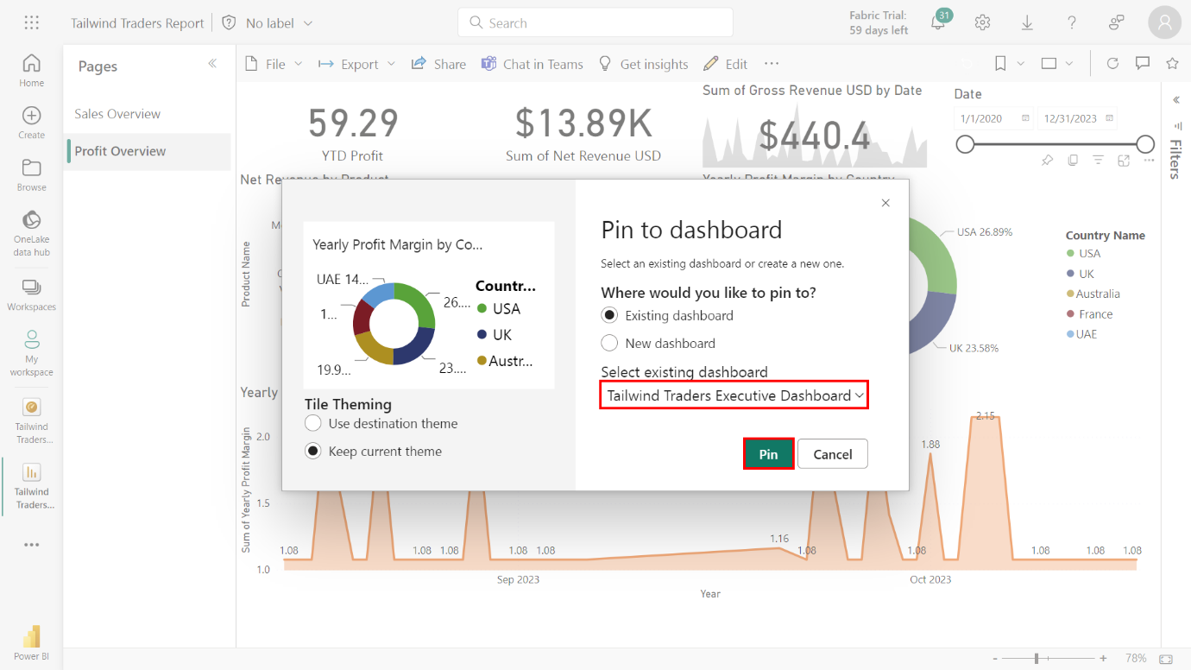

Repeat the process for the **Year profit Margin Over Time** area chart.

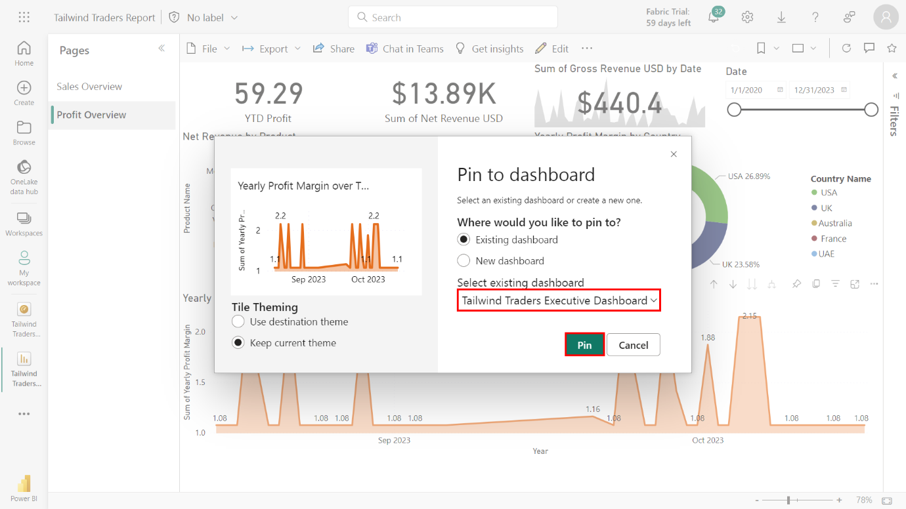

1. Note the product with the highest value in the **Net Revenue by Product** bar chart.

The **Modular Sofa Set** has the highest **Sum of Net Revenue USD**, which is precisely **928.36**.

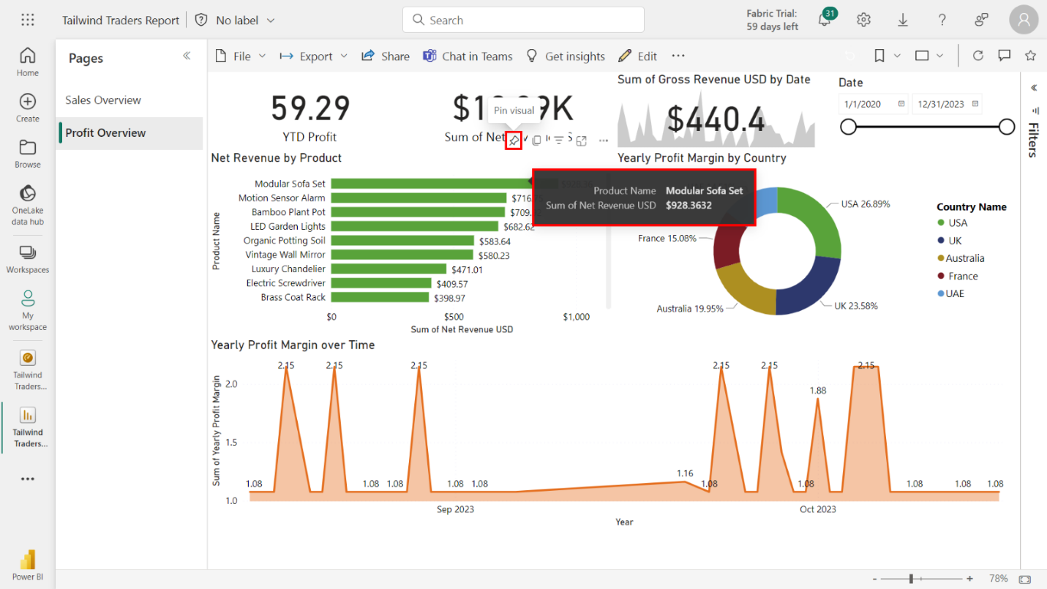

### Step 5: Pin Profit Overview Card and KPI Visualizations

1. Locate and pin the following items to the **Tailwind Traders Executive Dashboard**:

* **YTD Profit** card
* **Sum of Net Revenue USD** card
* **Sum of Gross Revenue USD** KPI

Select and pin the **YTD Profit Card** to the **Tailwind Traders Executive Dashboard**.

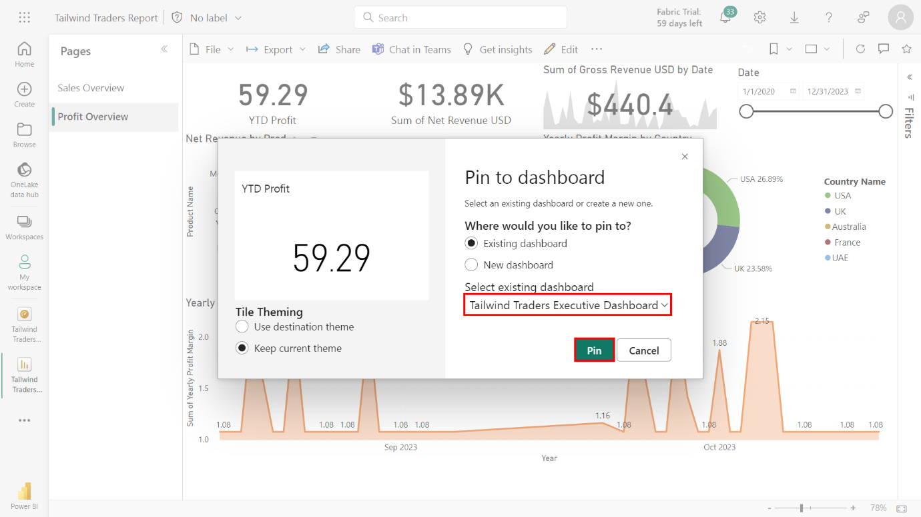

Repeat these actions for the **Sum of Net Revenue USD Card**.

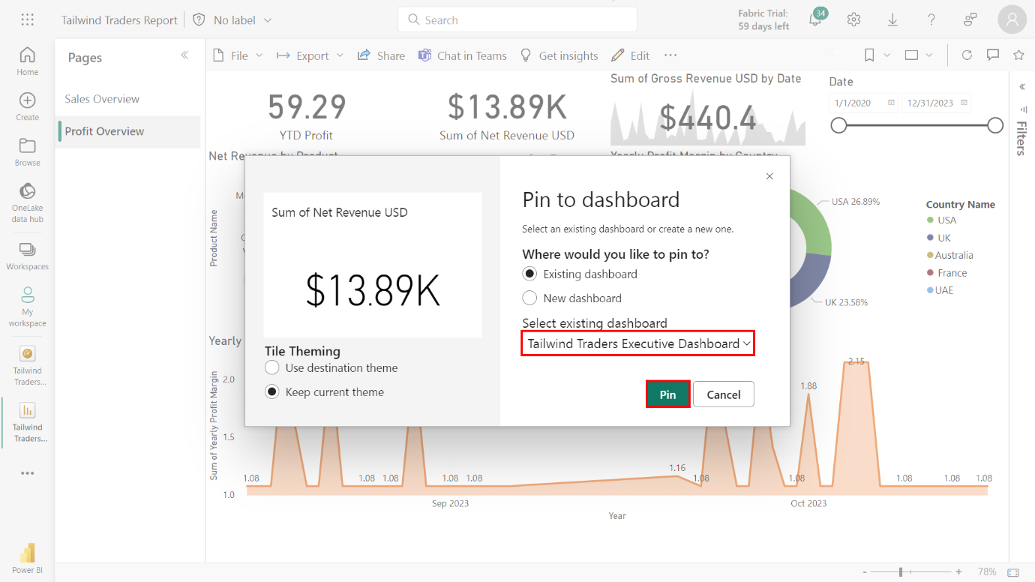

Repeat these actions for the **Sum of Gross Revenue USD KPI**.

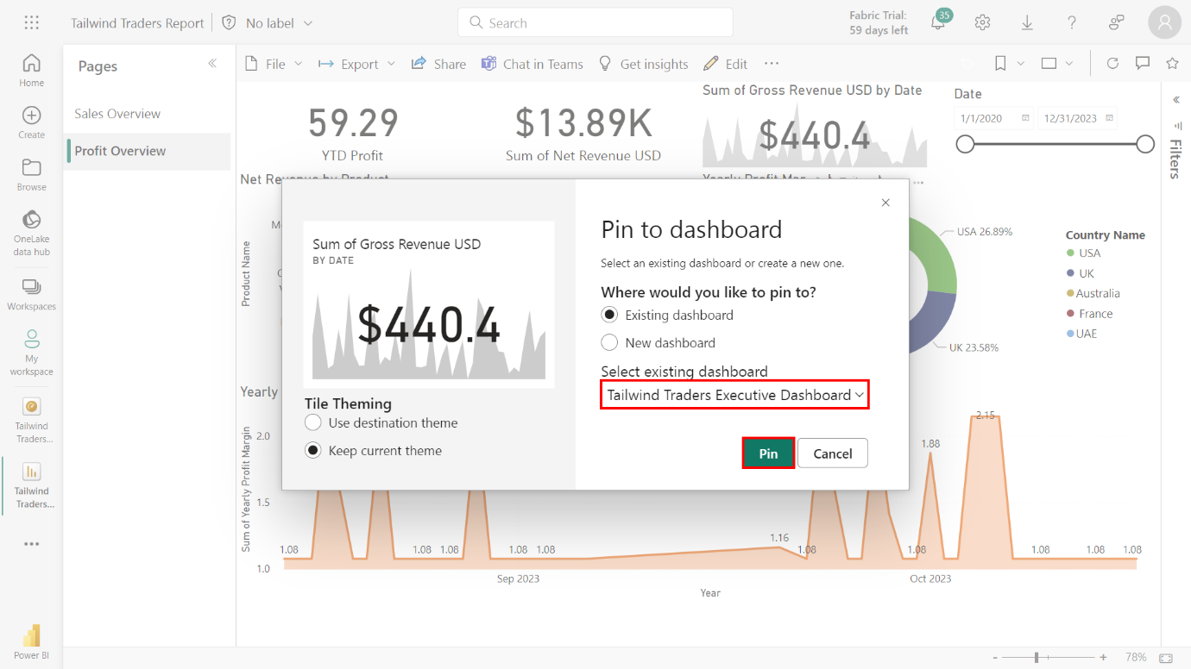

### Step7: Configure the Mobile View for the cards and KPI visuals

1. Locate and select the **Tailwind Traders Executive Dashboard** from the **Dashboards** list.

Select **Workspaces**, then **My Workspace**. Select the **Tailwind Traders Executive Dashboard** from the list of dashboards within the workspace.

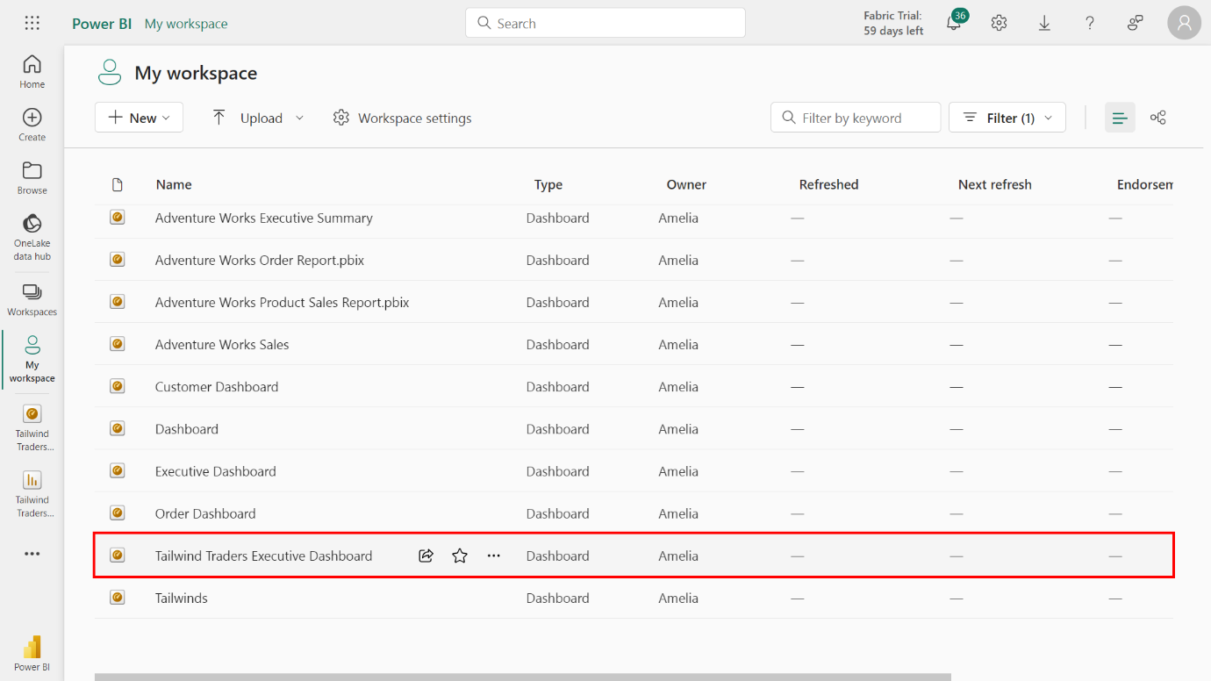

1. Select **Mobile Layout** from the **Edit** menu and pin your card visuals to the dashboard in the following order:

* **Sum of Net Revenue USD** to the left and **Sum of Quantity Purchased** cards to the right.
* **Median Sales** to the left and **YTD Profit** cards to the right.
* **Sum of Gross Revenue USD** KPI across the full width of the layout

Select **Edit** from the main navigation bar. Select **Mobile layout** from the list of options to switch the view from desktop to mobile.

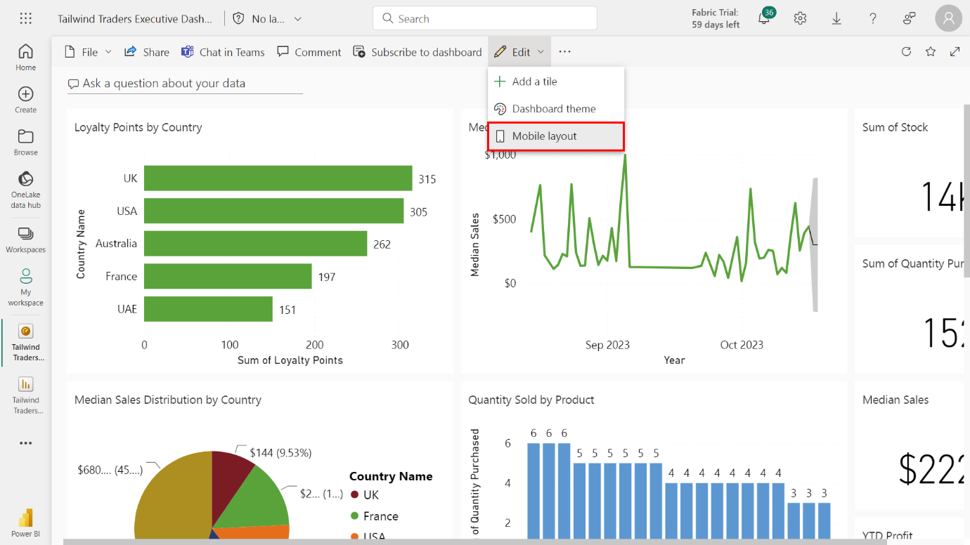

Once you select the **Mobile layout**, your screen adjusts to a vertical layout to replicate a mobile device's screen size. This canvas is blank. You must decide which visuals to show on the mobile layout and where to place them. A list of all the visualizations in your dashboard is displayed on the right side of your screen. Each visualization has a pin icon next to it.

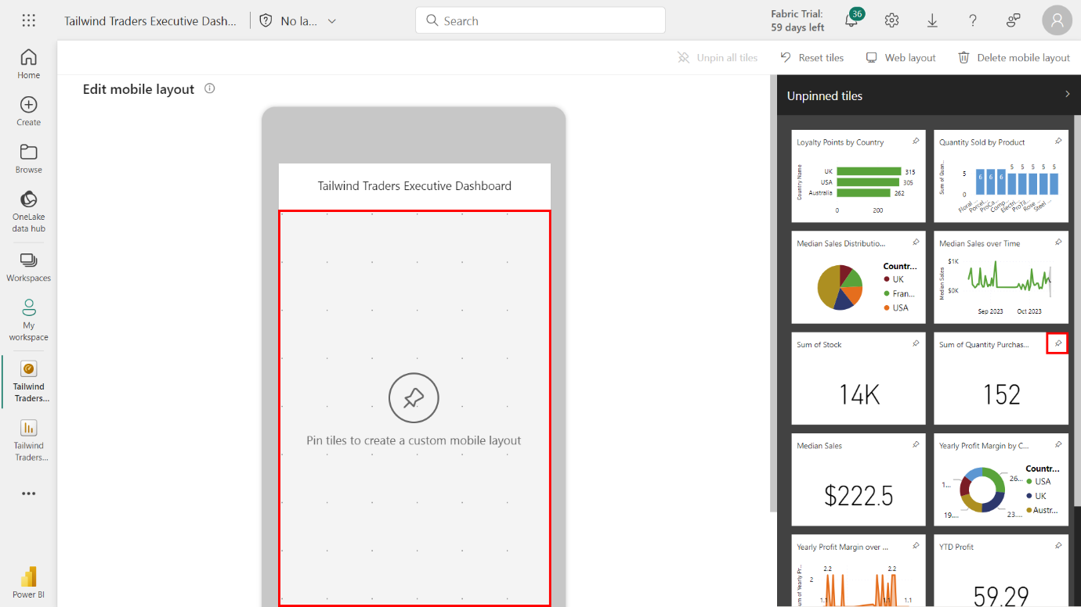

Select the **Pin** icon for the **Sum of Net Revenue USD** and **Sum of Quantity Purchased** cards. Arrange the card visuals on the mobile canvas side-by-side for a balanced look.

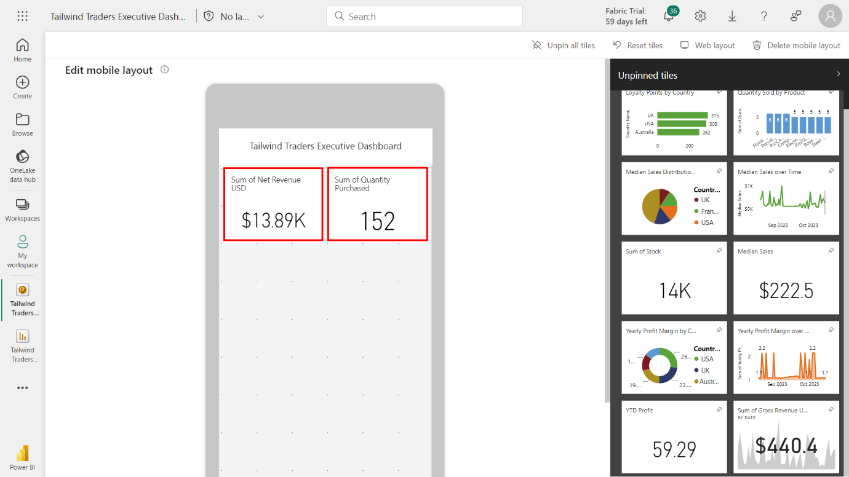

Repeat this process for the **Median Sales Card** and **YTD Profit Card**. Finally, pin the **Sum of Gross Revenue USD KPI** so that it’s the full width of the layout of the mobile canvas.

### Step 8: Configure the Mobile View for the core visualizations

1. Configure the mobile view for the core visualizations by pinning the **Sales Overview** visualizations in the following order:

* **Loyalty Points by Country** bar chart
* **Quantity Sold by Product** column chart
* **Median Sales Distribution by Country** pie chart
* **Median Sales over Time** line chart

Select the **Pin** icon for the **Loyalty Points by Country** bar chart to pin it to the mobile view. Repeat this process for the **Quantity Sold by Product** column chart.

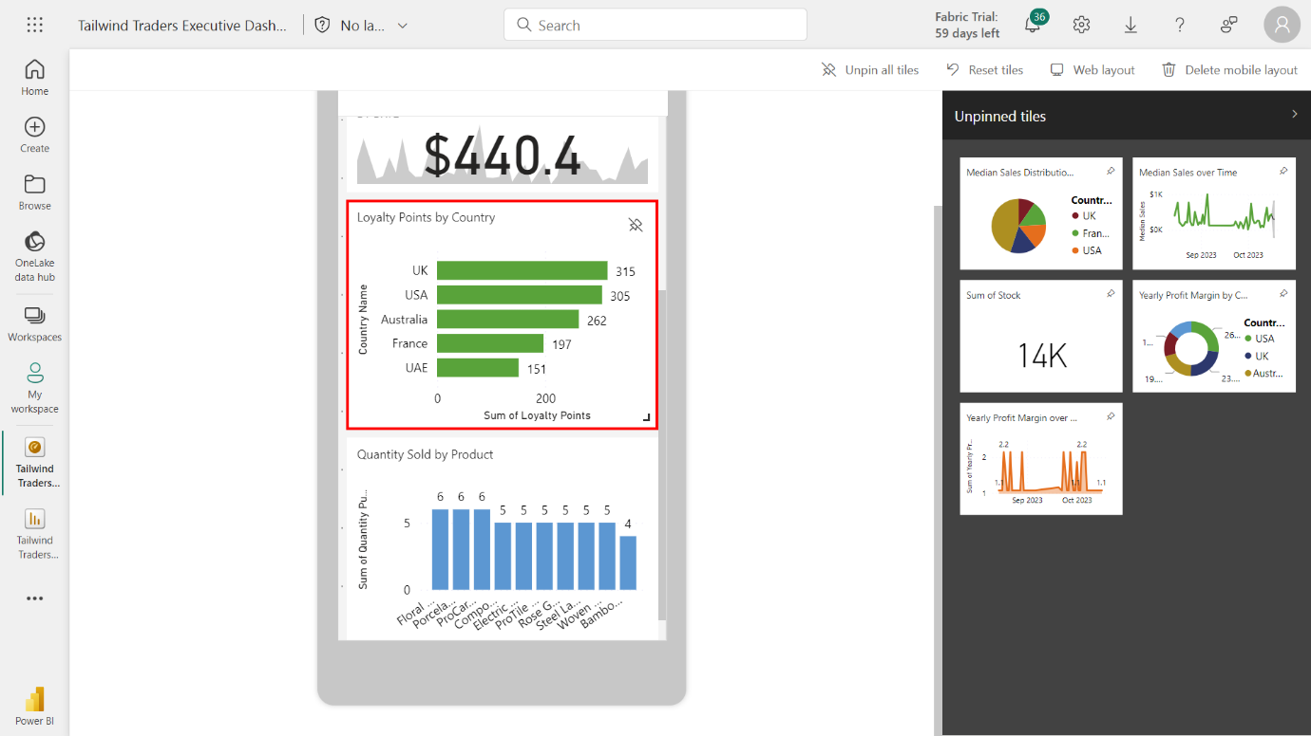

Repeat this process for the **Median Sales Distribution by Country** pie chart and **Median Sales over Time** line chart.

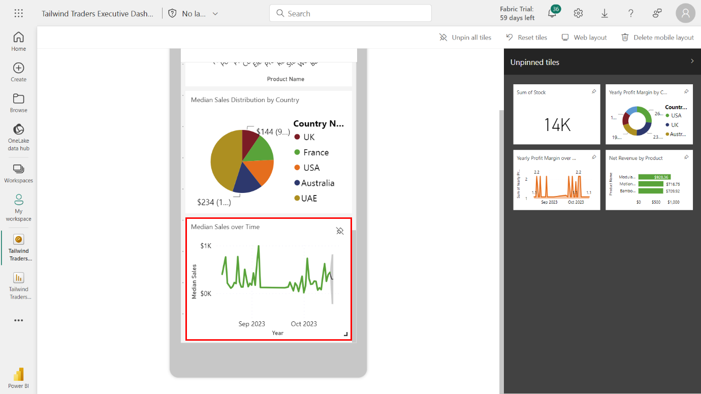

1. Pin the following **Profit Overview** visualizations in the following order:

* **Net Revenue by Product** bar chart
* **Yearly Profit Margin by Country** donut chart
* **Yearly Profit Margin over Time** area chart

Select the Pin icons for the **Net Revenue by Product** bar chart and **Yearly Profit Margin by Country** bar chart**.**

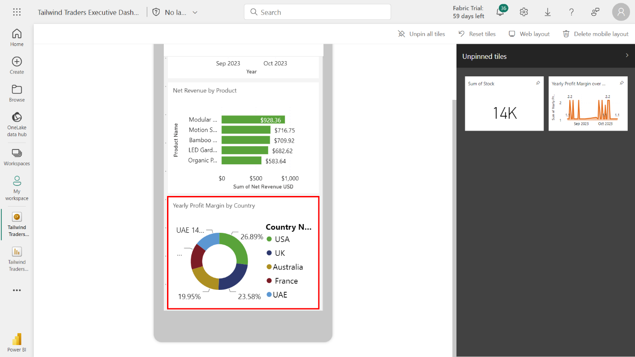

Pin the **Yearly Profit Margin over Time** area chart.

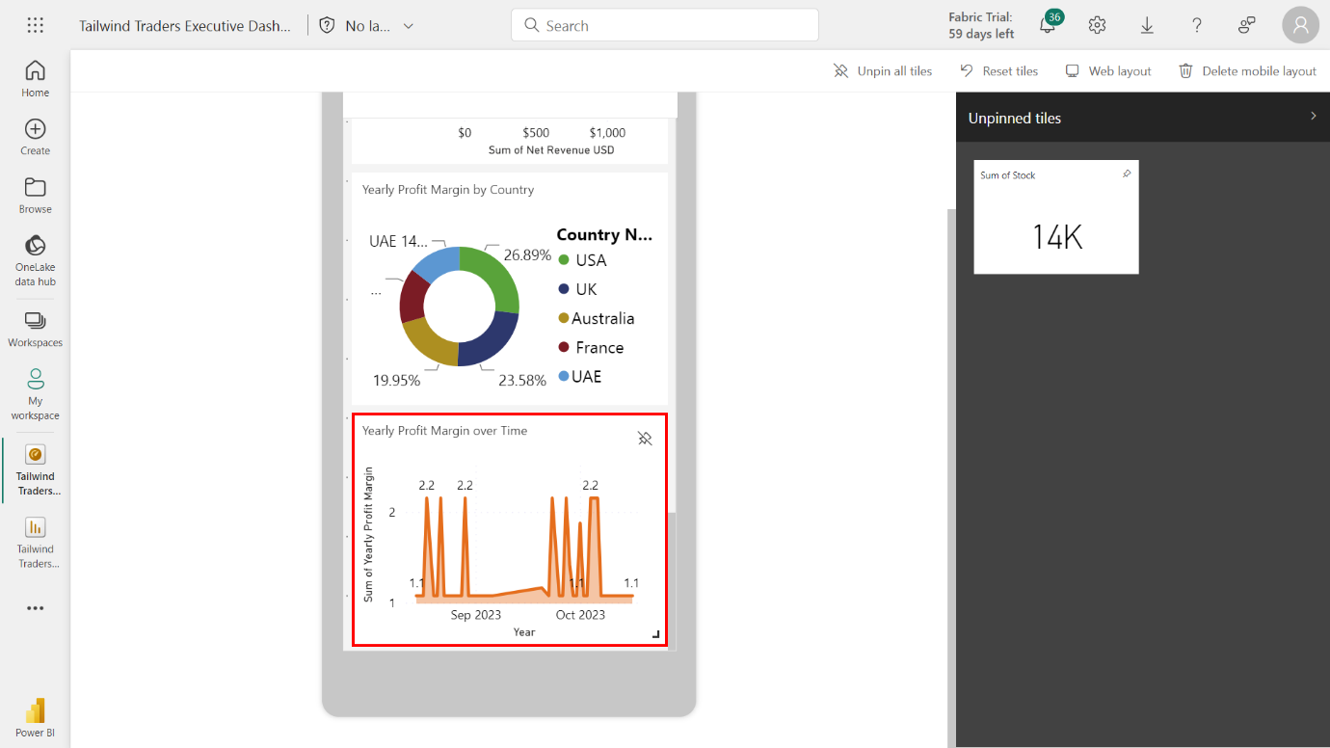

## Exercise 7: Configuring alerts and subscriptions

### Step 1: Create a daily alert for Gross Revenue USD

1. Access the **Mange Alerts** menu for the **Sum of Gross Revenue USD KPI** tile.

On the **Tailwind Traders Executive Dashboard**, locate the **Sum of Gross Revenue USD** KPI tile and select the ellipses icon.

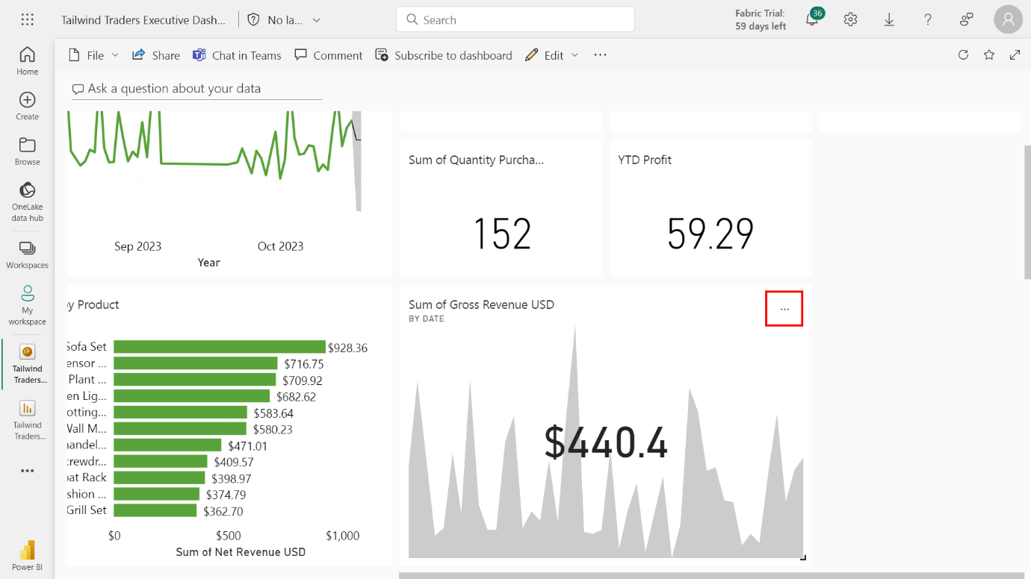

Select **Manage alerts** from the list of options that appear.

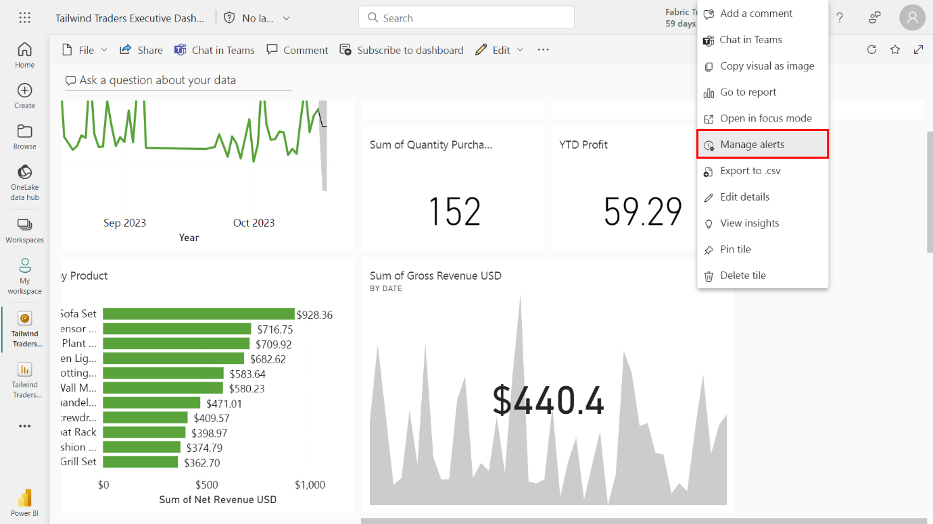

1. Create a new alert titled **Gross Revenue USD below $400** with the following configurations:

* In the **Condition** section, set the threshold at **$400**.
* Set a frequency of at most every 24 hours.

Within the **Manage alerts** screen, locate and select **+ New alert rule**.

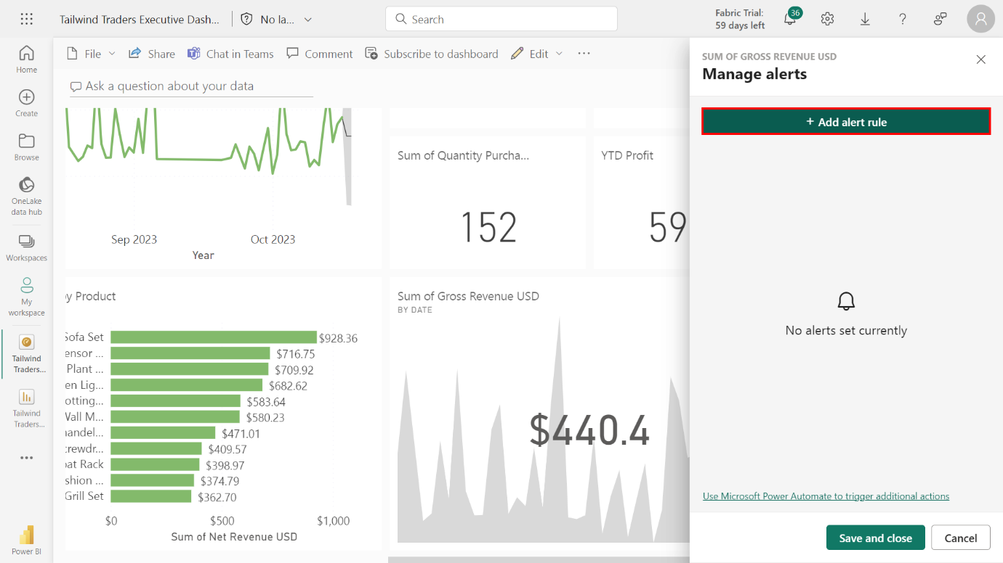

Enter **Gross Revenue USD below $400** in the **Alert title** field.

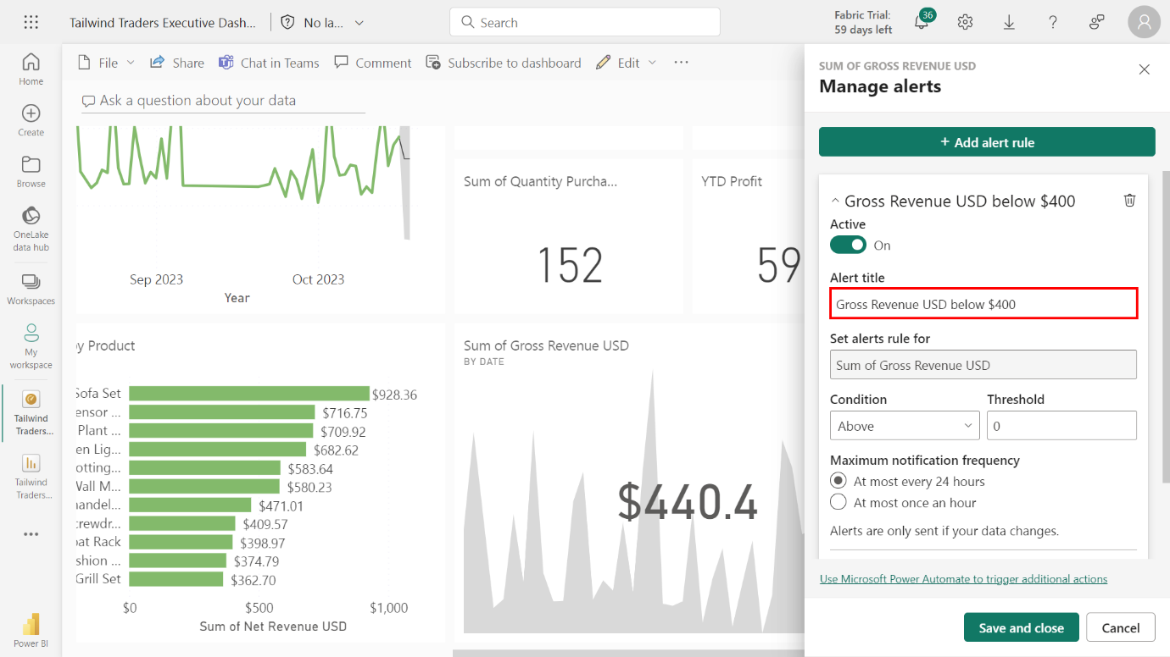

In the **Condition** section, locate the dropdown menu and select **Below**. In the adjacent field, type in **400** to set the threshold at $400.Navigate to the **Frequency** section to decide how often Power BI checks this condition. For critical metrics, like **Sum of Gross Revenue USD** that might require daily checks, selecting the **At most every 24 hours** setting is appropriate.

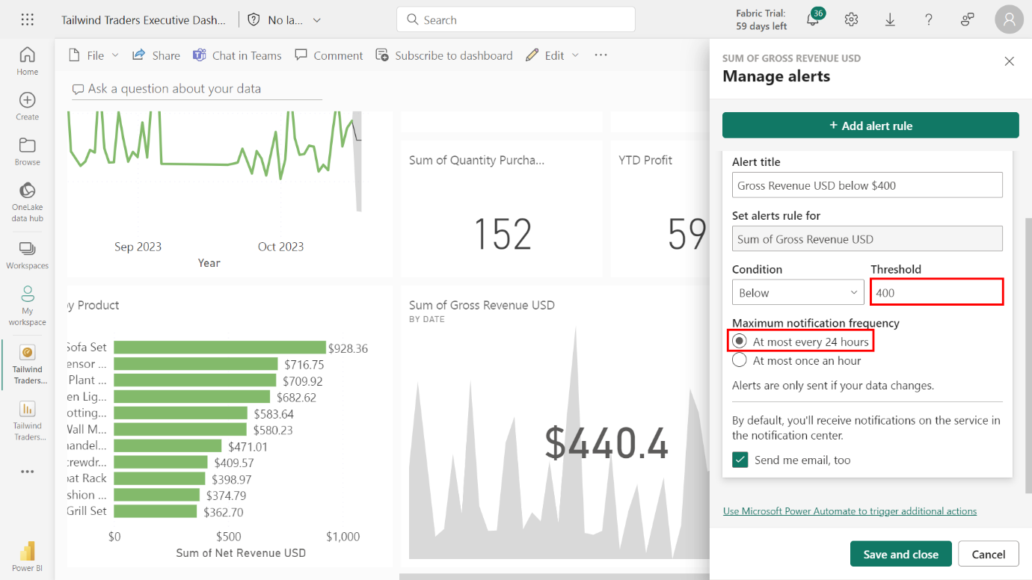

1. Save and close the alert.

Once you’ve set all required parameters, select **Save and close** to save your alert settings and activate the alert rule.

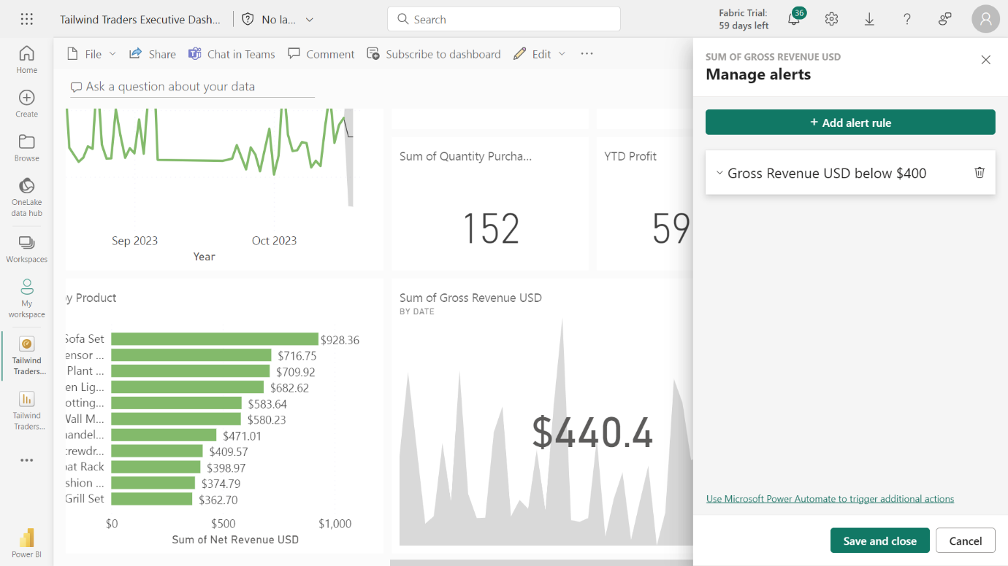

### Step 2: Create a subscription for Sales Overview

1. Access the report’s **Sales Overview** tab.

Locate and select Workspaces, then **My Workspace**. Find and select the **Tailwind Traders Report** in the list of reports within the workspace.

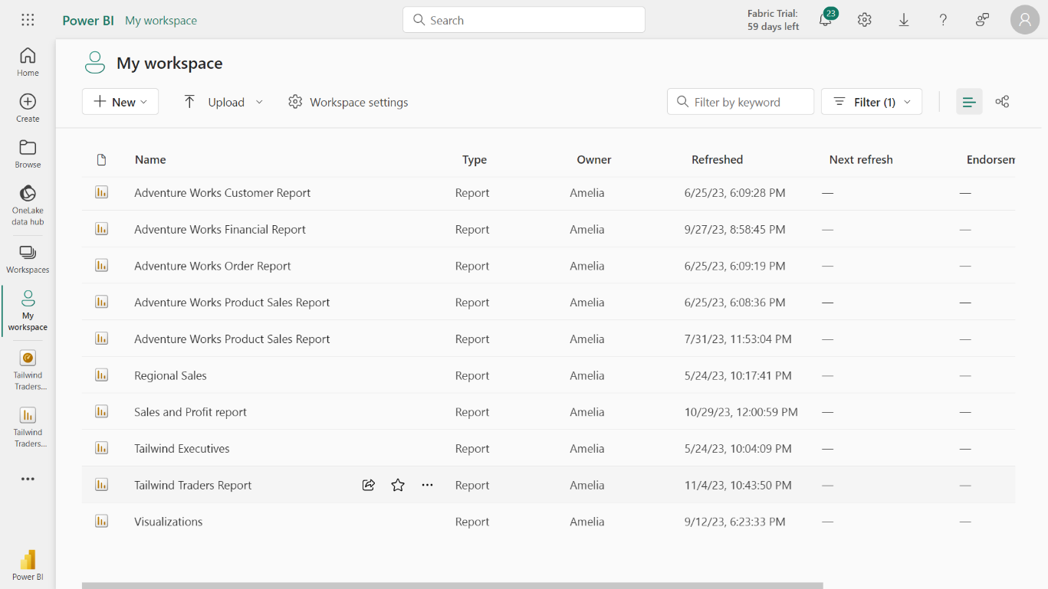

1. Access the **Median Sales Distribution by Country** pie chart and note down the country with the highest **Median Sales** value.

Select the **Median Sales Distribution by Country** pie chart from the canvas. **UAE** is the country with the highest Median Sales, measuring **680.785 USD**.

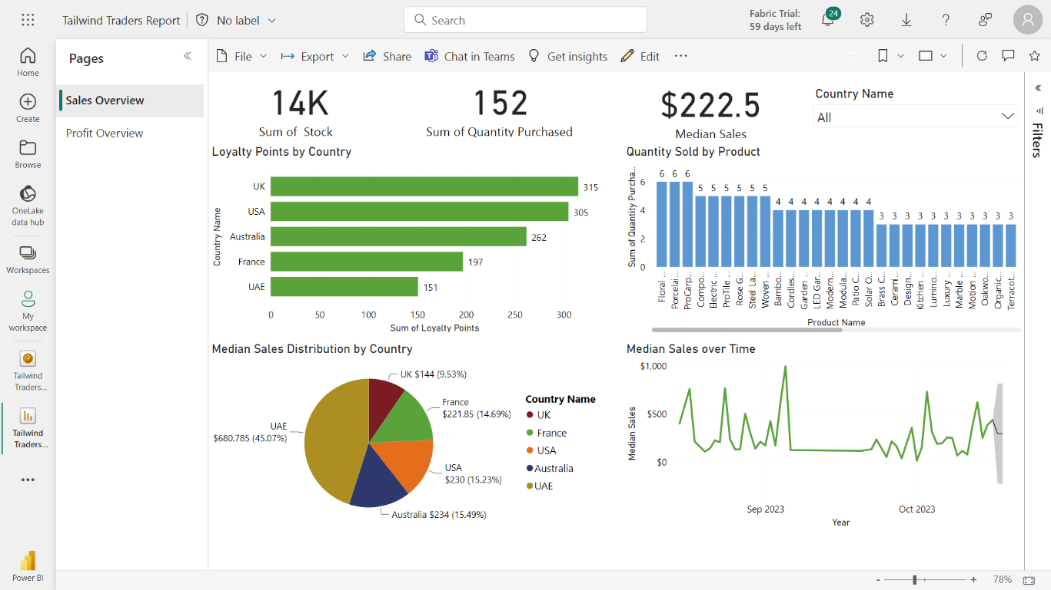

1. Create a subscription for the **Sales Overview** report with the following configurations:

Select the **ellipses** next to the **Edit** button. Select **Subscribe** from the list of options that appears.

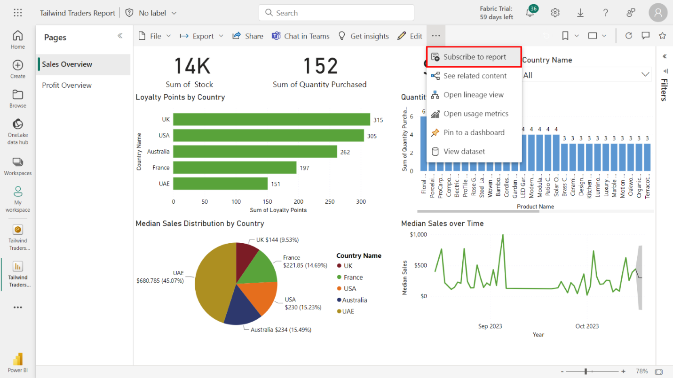

This action opens the **Subscription** pane. Name your subscription **Sales Weekly Summary**.

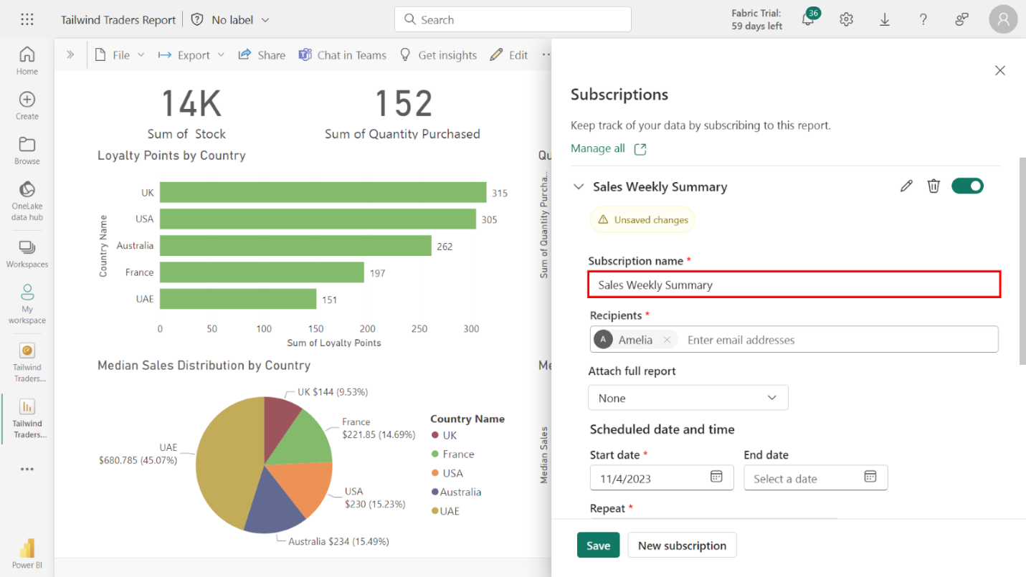

Set the **Start date** to the current date and the **End date** to **12/31/2025**. For the frequency, select **Weekly** and select **Monday**. Set the **Scheduled time** to **5:00 AM**.

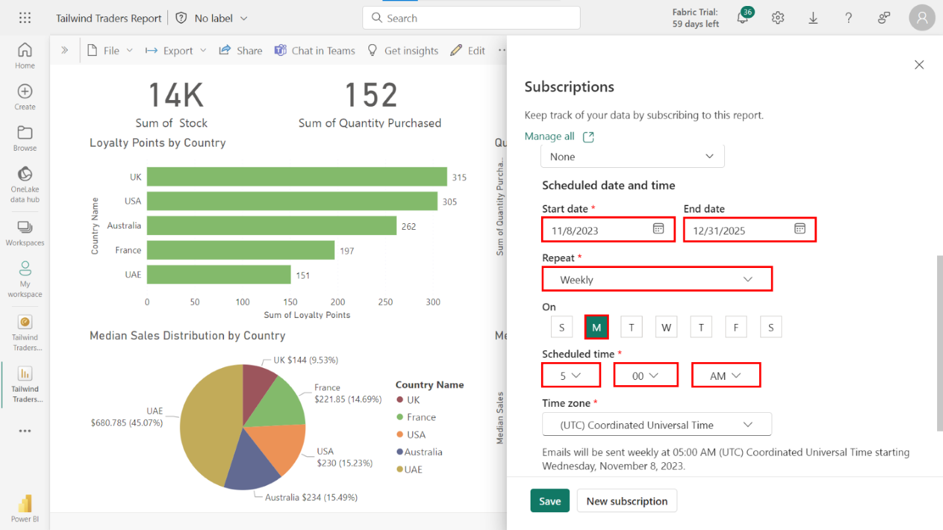

1. Access the **Sales Overview** report page in the **Report page** dropdown and ensure that the toggle switches for the following options are activated:

* **Permission to view the report in Power BI**
* **Link to report in Power BI**
* **Report page preview**

Expand **More options** to view the **Report page** dropdown. Select the **Sales Overview** report page from the dropdown. Check that the toggle for each of the following options is activated:

* **Permission to view the report in Power BI**
* **Link to report in Power BI**
* **Report page preview**

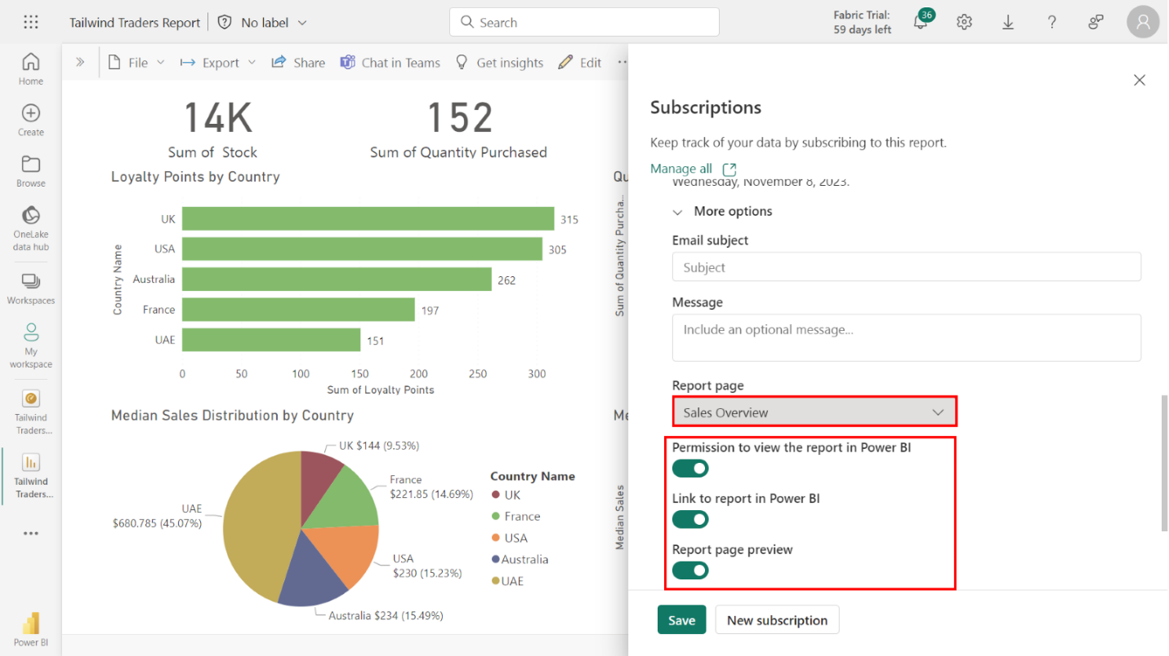

1. Activate the subscription.

Select **Save** to activate the **Sales Overview** subscription. You’ll receive a message confirming your subscription is now active.

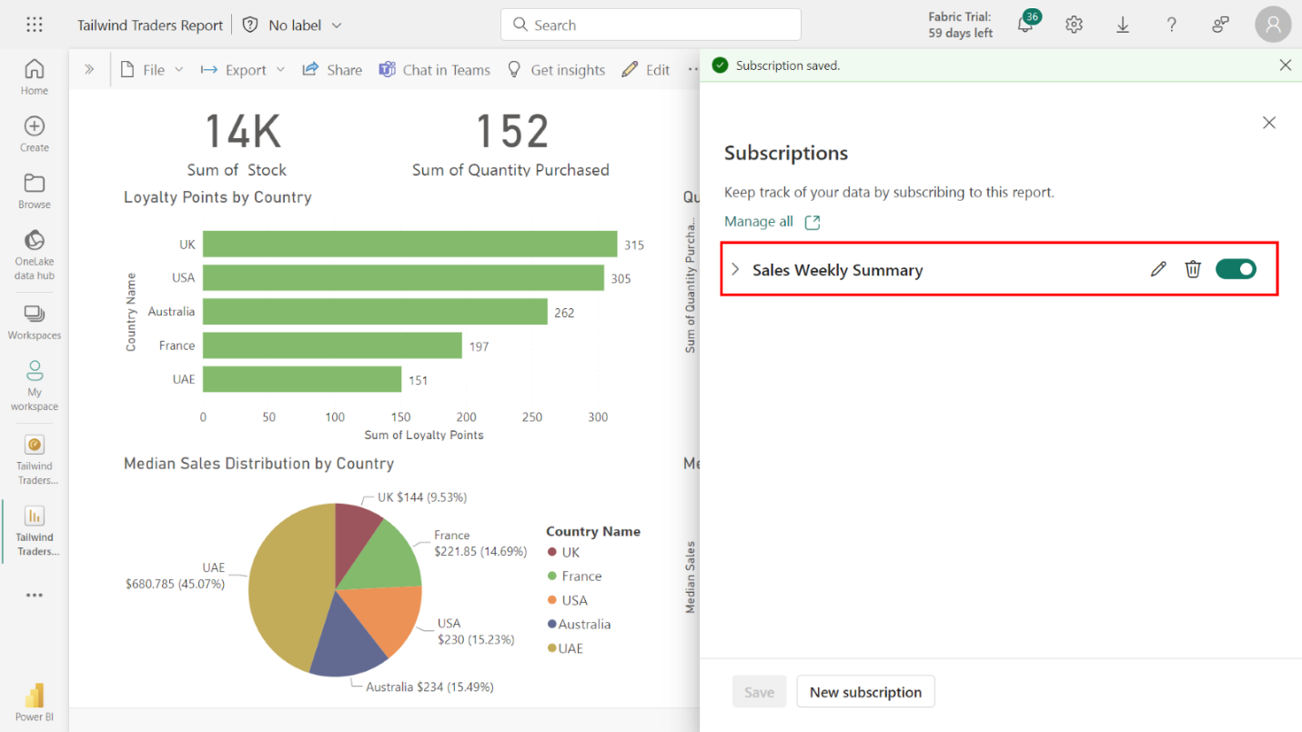

### Step 3: Create a subscription for Profit Overview

1. Access the report’s **Profit Overview** tab.

Navigate to the Profit Overview tab and access the **Susbcribe to Report** option.

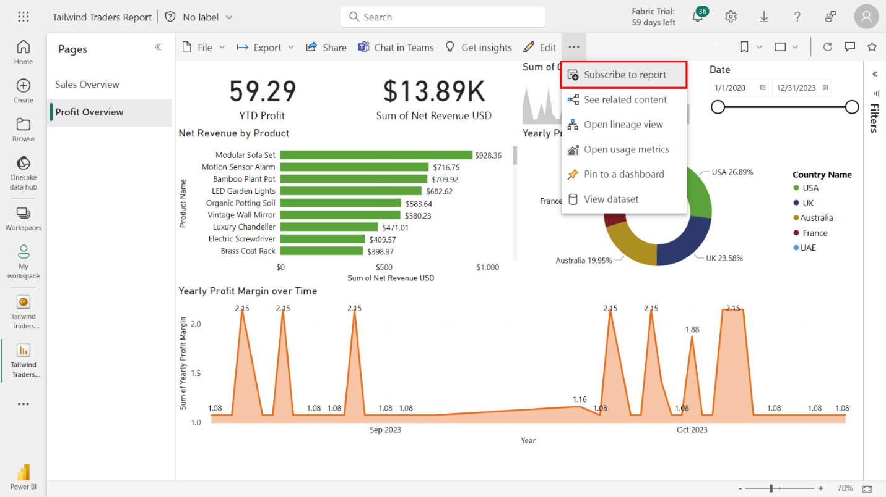

1. Create a subscription to the report with the following configurations:

* Name the subscription **Profit Weekly Summary**.
* Set the **Start date** to the current date and the **End date** to **12/31/2025**.
* Set the frequency to **Weekly** and select **Monday**, **Wednesday** and **Friday** as the days of the week.
* Set the **Scheduled time** to **6:00 AM**.

Name your report **Profit Weekly Summary**. Set the **Start date** to the current date and the **End date** to **12/31/2025**. Select **Weekly** as your frequency, and select **Monday**, **Wednesday**, and **Friday** as the days of the week.

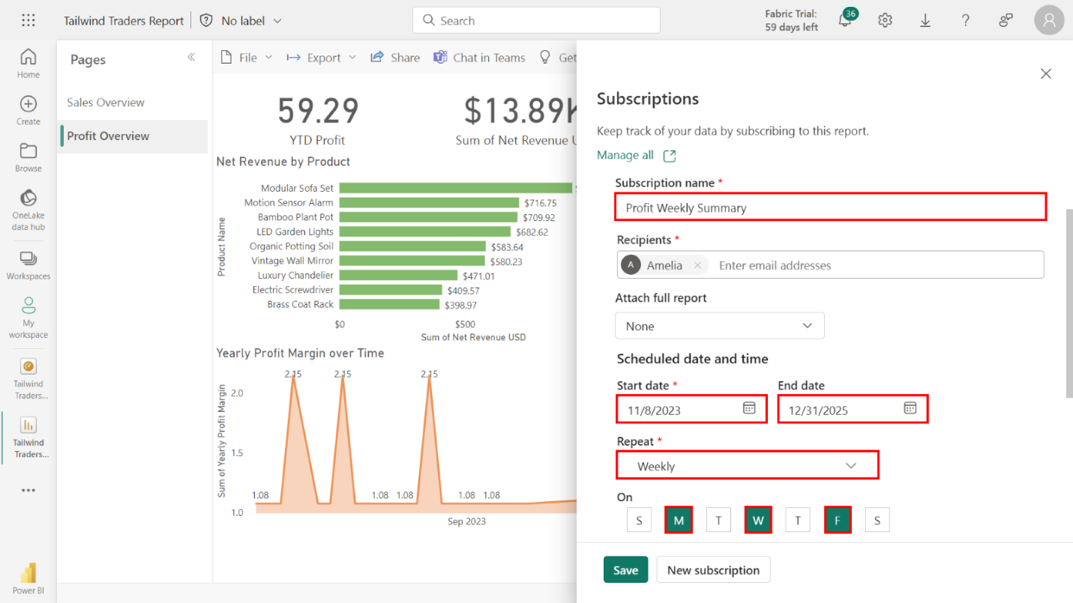

Set the **Scheduled time** to 6:00 AM.

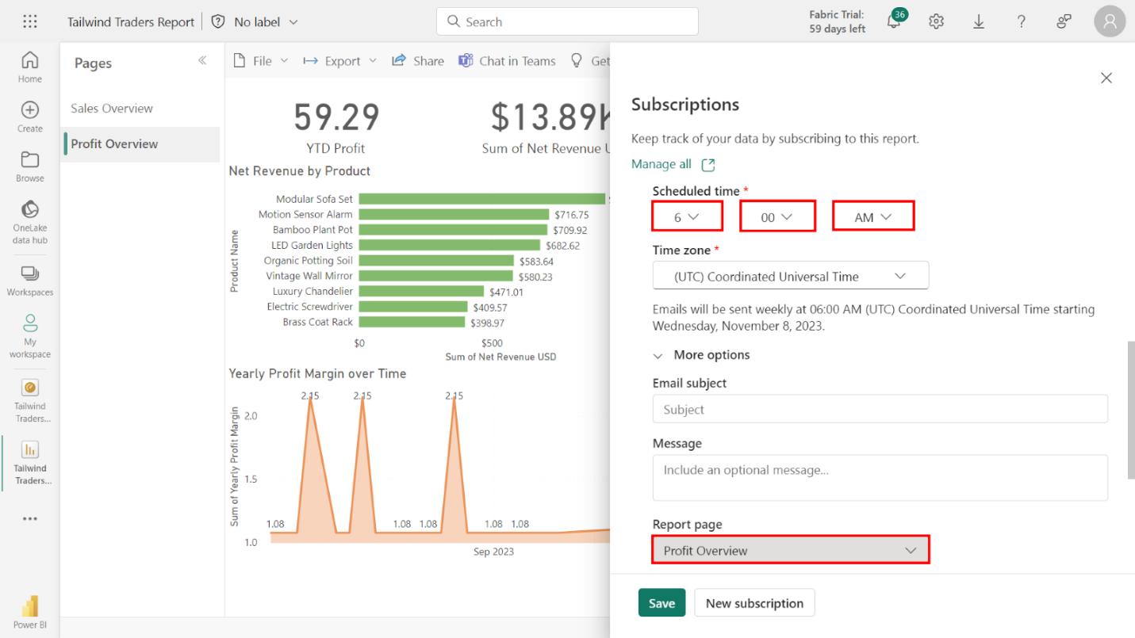

1. Access the **Profit Overview** report page in the **Report page** dropdown and ensure that the toggle switches for the following options are switched on:

* **Permission to view the report in Power BI**
* **Link to report in Power BI**
* **Report page preview**

Expand **More options** and select the **Profit Overview report page** in the **Report page** dropdown. Ensure that the toggle switches for the following options are switched on:

* **Permission to view the report in Power BI**
* **Link to report in Power BI**
* **Report page preview**

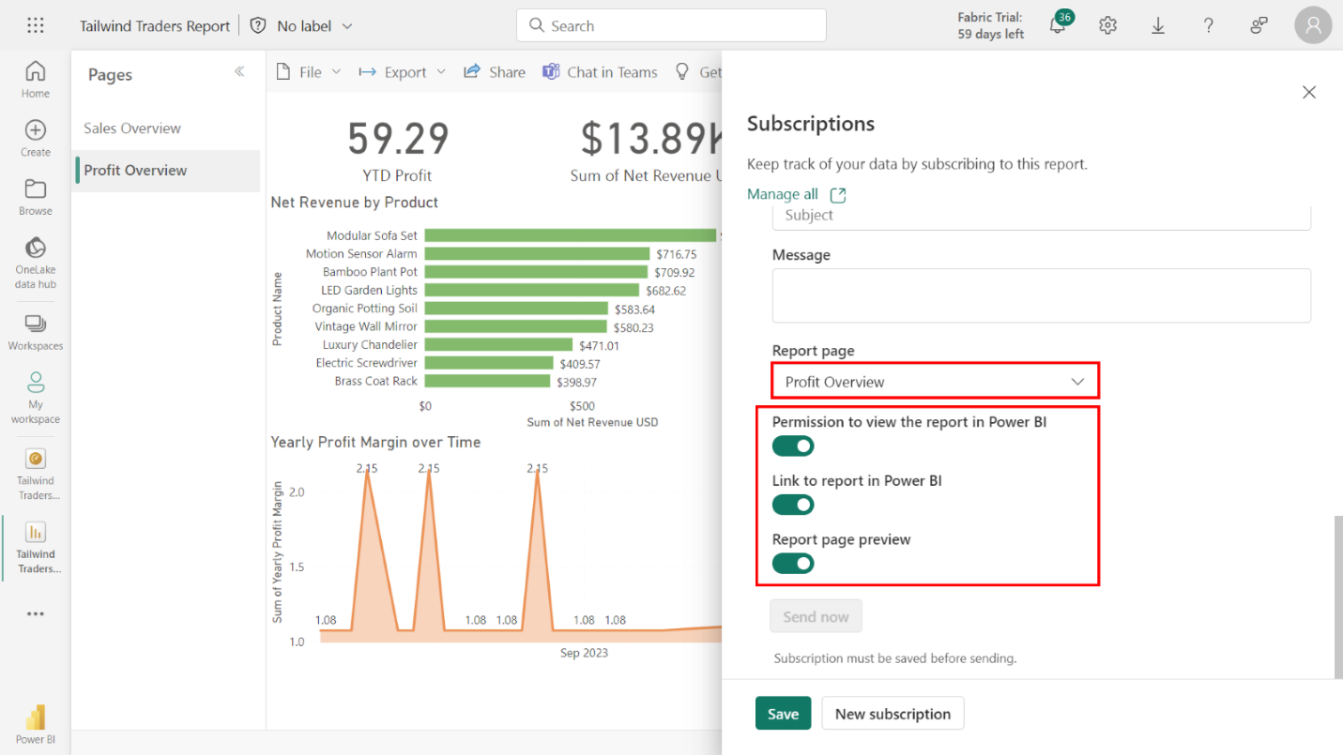

1. Activate the subscription.

Select **Save** to activate the **Profit Overview** subscription.

